**ESP-WIFI-MESH**[**ℑ**](https://docs.espressif.com/projects/esp-idf/en/stable/esp32/api-guides/esp-wifi-mesh.html#esp-wifi-mesh)

[[中文]](https://docs.espressif.com/projects/esp-idf/zh_CN/v5.2.1/esp32/api-guides/esp-wifi-mesh.html)

This guide provides information regarding the ESP-WIFI-MESH protocol. Please see the [ESP-WIFI-MESH API Reference](https://docs.espressif.com/projects/esp-idf/en/stable/esp32/api-reference/network/esp-wifi-mesh.html) for more information about API usage.

**Overview**[**ℑ**](https://docs.espressif.com/projects/esp-idf/en/stable/esp32/api-guides/esp-wifi-mesh.html#overview)

ESP-WIFI-MESH is a networking protocol built atop the Wi-Fi protocol. ESP-WIFI-MESH allows numerous devices (henceforth referred to as nodes) spread over a large physical area (both indoors and outdoors) to be interconnected under a single WLAN (Wireless Local-Area Network). ESP-WIFI-MESH is self-organizing and self-healing meaning the network can be built and maintained autonomously.

The ESP-WIFI-MESH guide is split into the following sections:

1. [Introduction](https://docs.espressif.com/projects/esp-idf/en/stable/esp32/api-guides/esp-wifi-mesh.html#mesh-introduction)
2. [ESP-WIFI-MESH Concepts](https://docs.espressif.com/projects/esp-idf/en/stable/esp32/api-guides/esp-wifi-mesh.html#mesh-concepts)
3. [Building a Network](https://docs.espressif.com/projects/esp-idf/en/stable/esp32/api-guides/esp-wifi-mesh.html#mesh-building-a-network)
4. [Managing a Network](https://docs.espressif.com/projects/esp-idf/en/stable/esp32/api-guides/esp-wifi-mesh.html#mesh-managing-a-network)
5. [Data Transmission](https://docs.espressif.com/projects/esp-idf/en/stable/esp32/api-guides/esp-wifi-mesh.html#mesh-data-transmission)
6. [Channel Switching](https://docs.espressif.com/projects/esp-idf/en/stable/esp32/api-guides/esp-wifi-mesh.html#mesh-channel-switching)
7. [Performance](https://docs.espressif.com/projects/esp-idf/en/stable/esp32/api-guides/esp-wifi-mesh.html#mesh-network-performance)
8. [Further Notes](https://docs.espressif.com/projects/esp-idf/en/stable/esp32/api-guides/esp-wifi-mesh.html#mesh-further-notes)

**Introduction**[**ℑ**](https://docs.espressif.com/projects/esp-idf/en/stable/esp32/api-guides/esp-wifi-mesh.html#introduction)

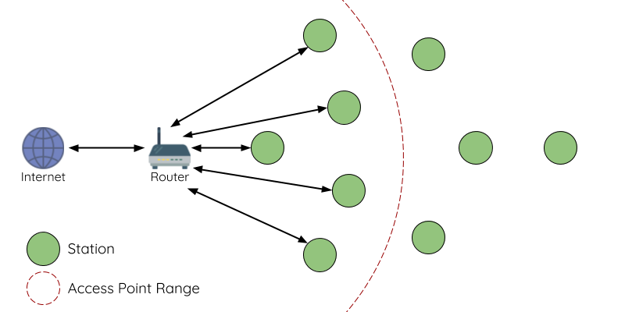

*Traditional Wi-Fi Network Architecture*[ℑ](https://docs.espressif.com/projects/esp-idf/en/stable/esp32/api-guides/esp-wifi-mesh.html#id1)

A traditional infrastructure Wi-Fi network is a point-to-multipoint network where a single central node known as the access point (AP) is directly connected to all other nodes known as stations. The AP is responsible for arbitrating and forwarding transmissions between the stations. Some APs also relay transmissions to/from an external IP network via a router. Traditional infrastructure Wi-Fi networks suffer the disadvantage of limited coverage area due to the requirement that every station must be in range to directly connect with the AP. Furthermore, traditional Wi-Fi networks are susceptible to overloading as the maximum number of stations permitted in the network is limited by the capacity of the AP.

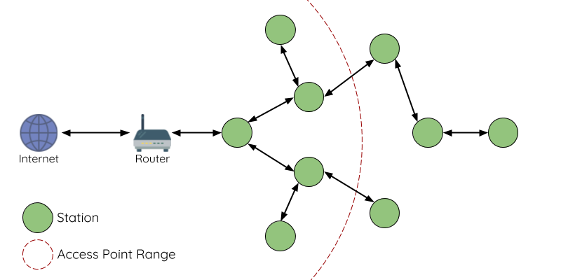

*ESP-WIFI-MESH Network Architecture*[ℑ](https://docs.espressif.com/projects/esp-idf/en/stable/esp32/api-guides/esp-wifi-mesh.html#id2)

ESP-WIFI-MESH differs from traditional infrastructure Wi-Fi networks in that nodes are not required to connect to a central node. Instead, nodes are permitted to connect with neighboring nodes. Nodes are mutually responsible for relaying each others transmissions. This allows an ESP-WIFI-MESH network to have much greater coverage area as nodes can still achieve interconnectivity without needing to be in range of the central node. Likewise, ESP-WIFI-MESH is also less susceptible to overloading as the number of nodes permitted on the network is no longer limited by a single central node.

**ESP-WIFI-MESH Concepts**[**ℑ**](https://docs.espressif.com/projects/esp-idf/en/stable/esp32/api-guides/esp-wifi-mesh.html#esp-wifi-mesh-concepts)

**Terminology**[**ℑ**](https://docs.espressif.com/projects/esp-idf/en/stable/esp32/api-guides/esp-wifi-mesh.html#terminology)

| **Term** | **Description** |
| --- | --- |
| Node | Any device that **is** or **can be** part of an ESP-WIFI-MESH network |
| Root Node | The top node in the network |
| Child Node | A node X is a child node when it is connected to another node Y where the connection makes node X more distant from the root node than node Y (in terms of number of connections). |
| Parent Node | The converse notion of a child node |
| Descendant Node | Any node reachable by repeated proceeding from parent to child |
| Sibling Nodes | Nodes that share the same parent node |
| Connection | A traditional Wi-Fi association between an AP and a station. A node in ESP-WIFI-MESH will use its station interface to associate with the softAP interface of another node, thus forming a connection. The connection process includes the authentication and association processes in Wi-Fi. |
| Upstream Connection | The connection from a node to its parent node |
| Downstream Connection | The connection from a node to one of its child nodes |
| Wireless Hop | The portion of the path between source and destination nodes that corresponds to a single wireless connection. A data packet that traverses a single connection is known as **single-hop** whereas traversing multiple connections is known as **multi-hop**. |
| Subnetwork | A subnetwork is subdivision of an ESP-WIFI-MESH network which consists of a node and all of its descendant nodes. Therefore the subnetwork of the root node consists of all nodes in an ESP-WIFI-MESH network. |
| MAC Address | Media Access Control Address used to uniquely identify each node or router within an ESP-WIFI-MESH network. |
| DS | Distribution System (External IP Network) |

**Tree Topology**[**ℑ**](https://docs.espressif.com/projects/esp-idf/en/stable/esp32/api-guides/esp-wifi-mesh.html#tree-topology)

ESP-WIFI-MESH is built atop the infrastructure Wi-Fi protocol and can be thought of as a networking protocol that combines many individual Wi-Fi networks into a single WLAN. In Wi-Fi, stations are limited to a single connection with an AP (upstream connection) at any time, whilst an AP can be simultaneously connected to multiple stations (downstream connections). However ESP-WIFI-MESH allows nodes to simultaneously act as a station and an AP. Therefore a node in ESP-WIFI-MESH can have **multiple downstream connections using its softAP interface**, whilst simultaneously having **a single upstream connection using its station interface**. This naturally results in a tree network topology with a parent-child hierarchy consisting of multiple layers.

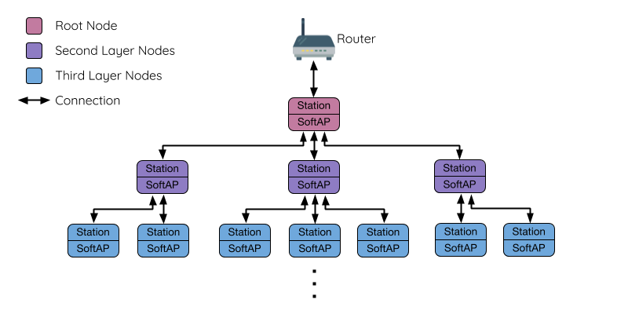

*ESP-WIFI-MESH Tree Topology*[ℑ](https://docs.espressif.com/projects/esp-idf/en/stable/esp32/api-guides/esp-wifi-mesh.html#id3)

ESP-WIFI-MESH is a multiple hop (multi-hop) network meaning nodes can transmit packets to other nodes in the network through one or more wireless hops. Therefore, nodes in ESP-WIFI-MESH not only transmit their own packets, but simultaneously serve as relays for other nodes. Provided that a path exists between any two nodes on the physical layer (via one or more wireless hops), any pair of nodes within an ESP-WIFI-MESH network can communicate.

**Note**

The size (total number of nodes) in an ESP-WIFI-MESH network is dependent on the maximum number of layers permitted in the network, and the maximum number of downstream connections each node can have. Both of these variables can be configured to limit the size of the network.

**Node Types**[**ℑ**](https://docs.espressif.com/projects/esp-idf/en/stable/esp32/api-guides/esp-wifi-mesh.html#node-types)

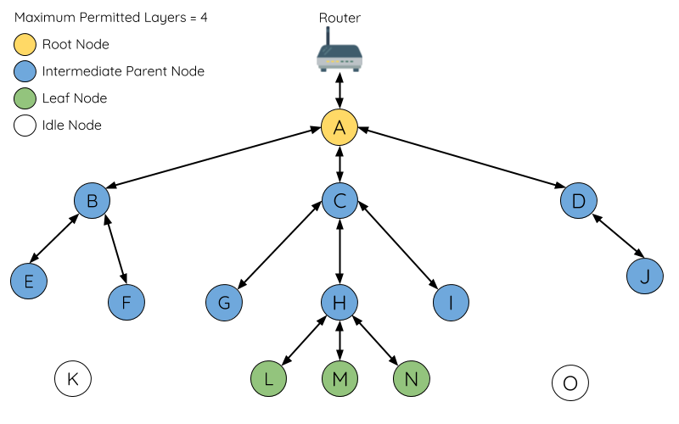

*ESP-WIFI-MESH Node Types*[ℑ](https://docs.espressif.com/projects/esp-idf/en/stable/esp32/api-guides/esp-wifi-mesh.html#id4)

**Root Node:** The root node is the top node in the network and serves as the only interface between the ESP-WIFI-MESH network and an external IP network. The root node is connected to a conventional Wi-Fi router and relays packets to/from the external IP network to nodes within the ESP-WIFI-MESH network. **There can only be one root node within an ESP-WIFI-MESH network** and the root node's upstream connection may only be with the router. Referring to the diagram above, node A is the root node of the network.

**Leaf Nodes:** A leaf node is a node that is not permitted to have any child nodes (no downstream connections). Therefore a leaf node can only transmit or receive its own packets, but cannot forward the packets of other nodes. If a node is situated on the network's maximum permitted layer, it will be assigned as a leaf node. This prevents the node from forming any downstream connections thus ensuring the network does not add an extra layer. Some nodes without a softAP interface (station only) will also be assigned as leaf nodes due to the requirement of a softAP interface for any downstream connections. Referring to the diagram above, nodes L/M/N are situated on the networks maximum permitted layer hence have been assigned as leaf nodes .

**Intermediate Parent Nodes:** Connected nodes that are neither the root node or a leaf node are intermediate parent nodes. An intermediate parent node must have a single upstream connection (a single parent node), but can have zero to multiple downstream connections (zero to multiple child nodes). Therefore an intermediate parent node can transmit and receive packets, but also forward packets sent from its upstream and downstream connections. Referring to the diagram above, nodes B to J are intermediate parent nodes. **Intermediate parent nodes without downstream connections such as nodes E/F/G/I/J are not equivalent to leaf nodes** as they are still permitted to form downstream connections in the future.

**Idle Nodes:** Nodes that have yet to join the network are assigned as idle nodes. Idle nodes will attempt to form an upstream connection with an intermediate parent node or attempt to become the root node under the correct circumstances (see [Automatic Root Node Selection](https://docs.espressif.com/projects/esp-idf/en/stable/esp32/api-guides/esp-wifi-mesh.html#automatic-root-node-selection)). Referring to the diagram above, nodes K and O are idle nodes.

**Beacon Frames & RSSI Thresholding**[**ℑ**](https://docs.espressif.com/projects/esp-idf/en/stable/esp32/api-guides/esp-wifi-mesh.html#beacon-frames-rssi-thresholding)

Every node in ESP-WIFI-MESH that is able to form downstream connections (i.e., has a softAP interface) will periodically transmit Wi-Fi beacon frames. A node uses beacon frames to allow other nodes to detect its presence and know of its status. Idle nodes will listen for beacon frames to generate a list of potential parent nodes, one of which the idle node will form an upstream connection with. ESP-WIFI-MESH uses the Vendor Information Element to store metadata such as:

* Node Type (Root, Intermediate Parent, Leaf, Idle)
* Current layer of Node
* Maximum number of layers permitted in the network
* Current number of child nodes
* Maximum number of downstream connections to accept

The signal strength of a potential upstream connection is represented by RSSI (Received Signal Strength Indication) of the beacon frames of the potential parent node. To prevent nodes from forming a weak upstream connection, ESP-WIFI-MESH implements an RSSI threshold mechanism for beacon frames. If a node detects a beacon frame with an RSSI below a preconfigured threshold, the transmitting node will be disregarded when forming an upstream connection.

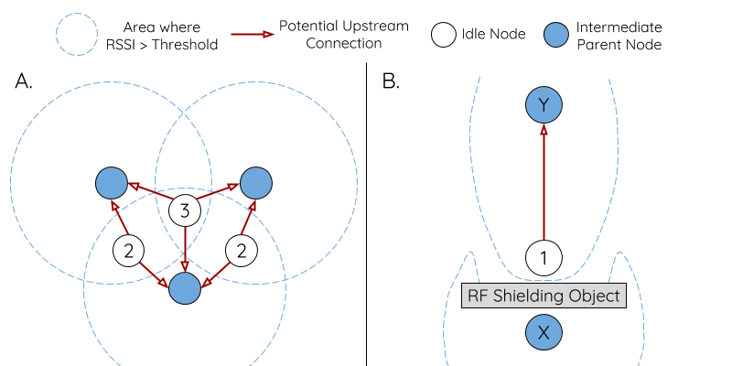

*Effects of RSSI Thresholding*[ℑ](https://docs.espressif.com/projects/esp-idf/en/stable/esp32/api-guides/esp-wifi-mesh.html#id5)

**Panel A** of the illustration above demonstrates how the RSSI threshold affects the number of parent node candidates an idle node has.

**Panel B** of the illustration above demonstrates how an RF shielding object can lower the RSSI of a potential parent node. Due to the RF shielding object, the area in which the RSSI of node X is above the threshold is significantly reduced. This causes the idle node to disregard node X even though node X is physically adjacent. The idle node will instead form an upstream connection with the physically distant node Y due to a stronger RSSI.

**Note**

Nodes technically still receive all beacon frames on the MAC layer. The RSSI threshold is an ESP-WIFI-MESH feature that simply filters out all received beacon frames that are below the preconfigured threshold.

**Preferred Parent Node**[**ℑ**](https://docs.espressif.com/projects/esp-idf/en/stable/esp32/api-guides/esp-wifi-mesh.html#preferred-parent-node)

When an idle node has multiple parent nodes candidates (potential parent nodes), the idle node will form an upstream connection with the **preferred parent node**. The preferred parent node is determined based on the following criteria:

* Which layer the parent node candidate is situated on
* The number of downstream connections (child nodes) the parent node candidate currently has

The selection of the preferred parent node will always prioritize the parent node candidate on the shallowest layer of the network (including the root node). This helps minimize the total number of layers in an ESP-WIFI-MESH network when upstream connections are formed. For example, given a second layer node and a third layer node, the second layer node will always be preferred.

If there are multiple parent node candidates within the same layer, the parent node candidate with the least child nodes will be preferred. This criteria has the effect of balancing the number of downstream connections amongst nodes of the same layer.

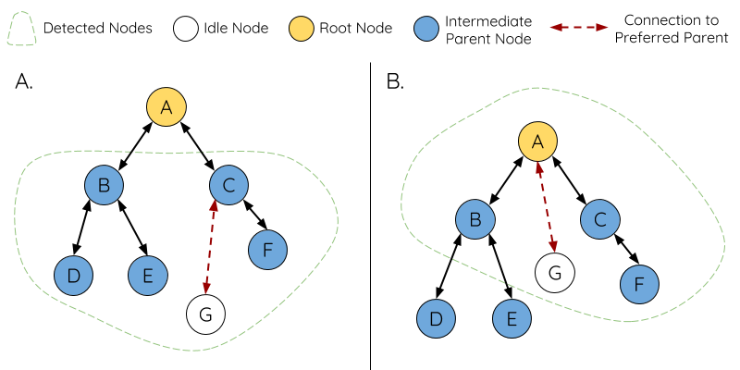

*Preferred Parent Node Selection*[ℑ](https://docs.espressif.com/projects/esp-idf/en/stable/esp32/api-guides/esp-wifi-mesh.html#id6)

**Panel A** of the illustration above demonstrates an example of how the idle node G selects a preferred parent node given the five parent node candidates B/C/D/E/F. Nodes on the shallowest layer are preferred, hence nodes B/C are prioritized since they are second layer nodes whereas nodes D/E/F are on the third layer. Node C is selected as the preferred parent node due it having fewer downstream connections (fewer child nodes) compared to node B.

**Panel B** of the illustration above demonstrates the case where the root node is within range of the idle node G. In other words, the root node's beacon frames are above the RSSI threshold when received by node G. The root node is always the shallowest node in an ESP-WIFI-MESH network hence is always the preferred parent node given multiple parent node candidates.

**Note**

Users may also define their own algorithm for selecting a preferred parent node, or force a node to only connect with a specific parent node (see the [Mesh Manual Networking Example](https://github.com/espressif/esp-idf/tree/v5.2.1/examples/mesh/manual_networking)).

**Routing Tables**[**ℑ**](https://docs.espressif.com/projects/esp-idf/en/stable/esp32/api-guides/esp-wifi-mesh.html#routing-tables)

Each node within an ESP-WIFI-MESH network will maintain its individual routing table used to correctly route ESP-WIFI-MESH packets (see [ESP-WIFI-MESH Packet](https://docs.espressif.com/projects/esp-idf/en/stable/esp32/api-guides/esp-wifi-mesh.html#esp-wifi-mesh-packet)) to the correct destination node. The routing table of a particular node will **consist of the MAC addresses of all nodes within the particular node's subnetwork** (including the MAC address of the particular node itself). Each routing table is internally partitioned into multiple subtables with each subtable corresponding to the subnetwork of each child node.

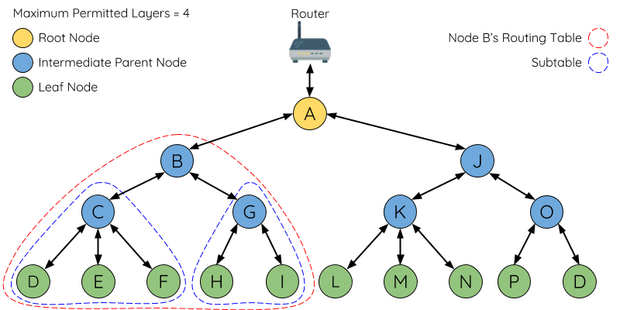

*ESP-WIFI-MESH Routing Tables Example*[ℑ](https://docs.espressif.com/projects/esp-idf/en/stable/esp32/api-guides/esp-wifi-mesh.html#id7)

Using the diagram above as an example, the routing table of node B would consist of the MAC addresses of nodes B to I (i.e., equivalent to the subnetwork of node B). Node B's routing table is internally partitioned into two subtables containing of nodes C to F and nodes G to I (i.e., equivalent to the subnetworks of nodes C and G respectively).

**ESP-WIFI-MESH utilizes routing tables to determine whether an ESP-WIFI-MESH packet should be forwarded upstream or downstream based on the following rules.**

**1.** If the packet's destination MAC address is within the current node's routing table and is not the current node, select the subtable that contains the destination MAC address and forward the data packet downstream to the child node corresponding to the subtable.

**2.** If the destination MAC address is not within the current node's routing table, forward the data packet upstream to the current node's parent node. Doing so repeatedly will result in the packet arriving at the root node where the routing table should contain all nodes within the network.

**Note**

Users can call [**esp_mesh_get_routing_table()**](https://docs.espressif.com/projects/esp-idf/en/stable/esp32/api-reference/network/esp-wifi-mesh.html#_CPPv426esp_mesh_get_routing_tableP11mesh_addr_tiPi) to obtain a node's routing table, or [**esp_mesh_get_routing_table_size()**](https://docs.espressif.com/projects/esp-idf/en/stable/esp32/api-reference/network/esp-wifi-mesh.html#_CPPv431esp_mesh_get_routing_table_sizev) to obtain the size of a node's routing table. [**esp_mesh_get_subnet_nodes_list()**](https://docs.espressif.com/projects/esp-idf/en/stable/esp32/api-reference/network/esp-wifi-mesh.html#_CPPv430esp_mesh_get_subnet_nodes_listPK11mesh_addr_tP11mesh_addr_ti) can be used to obtain the corresponding subtable of a specific child node. Likewise [**esp_mesh_get_subnet_nodes_num()**](https://docs.espressif.com/projects/esp-idf/en/stable/esp32/api-reference/network/esp-wifi-mesh.html#_CPPv429esp_mesh_get_subnet_nodes_numPK11mesh_addr_tPi) can be used to obtain the size of the subtable.

**Building a Network**[**ℑ**](https://docs.espressif.com/projects/esp-idf/en/stable/esp32/api-guides/esp-wifi-mesh.html#building-a-network)

**General Process**[**ℑ**](https://docs.espressif.com/projects/esp-idf/en/stable/esp32/api-guides/esp-wifi-mesh.html#general-process)

**Warning**

Before the ESP-WIFI-MESH network building process can begin, certain parts of the configuration must be uniform across each node in the network (see [**mesh_cfg_t**](https://docs.espressif.com/projects/esp-idf/en/stable/esp32/api-reference/network/esp-wifi-mesh.html#_CPPv410mesh_cfg_t)). Each node must be configured with **the same Mesh Network ID, router configuration, and softAP configuration**.

An ESP-WIFI-MESH network building process involves selecting a root node, then forming downstream connections layer by layer until all nodes have joined the network. The exact layout of the network can be dependent on factors such as root node selection, parent node selection, and asynchronous power-on reset. However, the ESP-WIFI-MESH network building process can be generalized into the following steps:

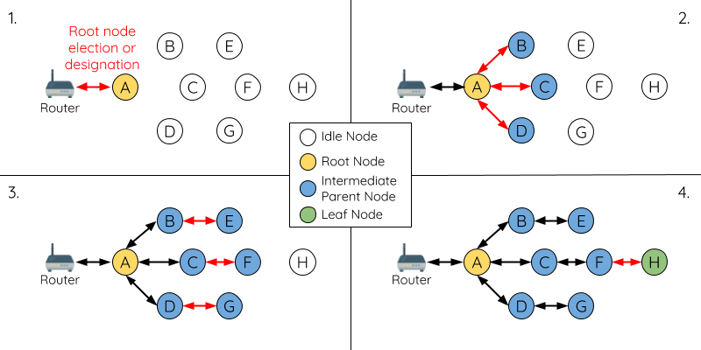

*ESP-WIFI-MESH Network Building Process*[ℑ](https://docs.espressif.com/projects/esp-idf/en/stable/esp32/api-guides/esp-wifi-mesh.html#id8)

**1. Root Node Selection**[**ℑ**](https://docs.espressif.com/projects/esp-idf/en/stable/esp32/api-guides/esp-wifi-mesh.html#root-node-selection)

The root node can be designated during configuration (see section on [User Designated Root Node](https://docs.espressif.com/projects/esp-idf/en/stable/esp32/api-guides/esp-wifi-mesh.html#user-designated-root-node)), or dynamically elected based on the signal strength between each node and the router (see [Automatic Root Node Selection](https://docs.espressif.com/projects/esp-idf/en/stable/esp32/api-guides/esp-wifi-mesh.html#automatic-root-node-selection)). Once selected, the root node will connect with the router and begin allowing downstream connections to form. Referring to the figure above, node A is selected to be the root node hence node A forms an upstream connection with the router.

**2. Second Layer Formation**[**ℑ**](https://docs.espressif.com/projects/esp-idf/en/stable/esp32/api-guides/esp-wifi-mesh.html#second-layer-formation)

Once the root node has connected to the router, idle nodes in range of the root node will begin connecting with the root node thereby forming the second layer of the network. Once connected, the second layer nodes become intermediate parent nodes (assuming maximum permitted layers > 2) hence the next layer to form. Referring to the figure above, nodes B to D are in range of the root node. Therefore nodes B to D form upstream connections with the root node and become intermediate parent nodes.

**3. Formation of Remaining Layers**[**ℑ**](https://docs.espressif.com/projects/esp-idf/en/stable/esp32/api-guides/esp-wifi-mesh.html#formation-of-remaining-layers)

The remaining idle nodes will connect with intermediate parent nodes within range thereby forming a new layer in the network. Once connected, the idles nodes become intermediate parent node or leaf nodes depending on the networks maximum permitted layers. This step is repeated until there are no more idle nodes within the network or until the maximum permitted layer of the network has been reached. Referring to the figure above, nodes E/F/G connect with nodes B/C/D respectively and become intermediate parent nodes themselves.

**4. Limiting Tree Depth**[**ℑ**](https://docs.espressif.com/projects/esp-idf/en/stable/esp32/api-guides/esp-wifi-mesh.html#limiting-tree-depth)

To prevent the network from exceeding the maximum permitted number of layers, nodes on the maximum layer will automatically become leaf nodes once connected. This prevents any other idle node from connecting with the leaf node thereby prevent a new layer form forming. However if an idle node has no other potential parent node, it will remain idle indefinitely. Referring to the figure above, the network's number of maximum permitted layers is set to four. Therefore when node H connects, it becomes a leaf node to prevent any downstream connections from forming.

**Automatic Root Node Selection**[**ℑ**](https://docs.espressif.com/projects/esp-idf/en/stable/esp32/api-guides/esp-wifi-mesh.html#automatic-root-node-selection)

The automatic selection of a root node involves an election process amongst all idle nodes based on their signal strengths with the router. Each idle node will transmit their MAC addresses and router RSSI values via Wi-Fi beacon frames. **The MAC address is used to uniquely identify each node in the network** whilst the **router RSSI** is used to indicate a node's signal strength with reference to the router.

Each node will then simultaneously scan for the beacon frames from other idle nodes. If a node detects a beacon frame with a stronger router RSSI, the node will begin transmitting the contents of that beacon frame (i.e., voting for the node with the stronger router RSSI). The process of transmission and scanning will repeat for a preconfigured minimum number of iterations (10 iterations by default) and result in the beacon frame with the strongest router RSSI being propagated throughout the network.

After all iterations, each node will individually check for its **vote percentage** (number of votes/number of nodes participating in election) to determine if it should become the root node. **If a node has a vote percentage larger than a preconfigured threshold (90% by default), the node will become a root node**.

The following diagram demonstrates how an ESP-WIFI-MESH network is built when the root node is automatically selected.

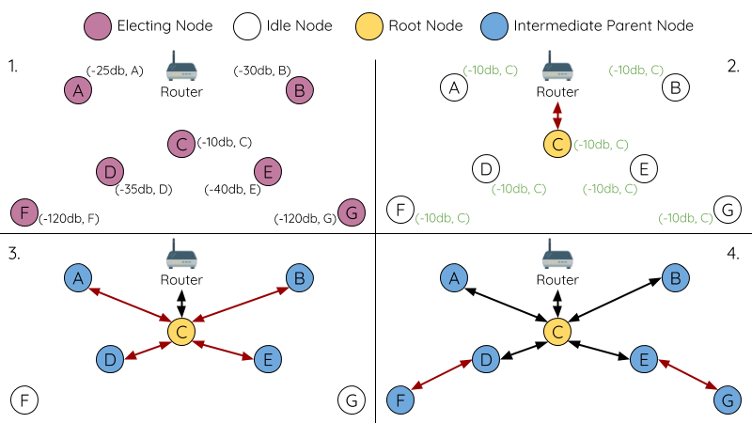

*Root Node Election Example*[ℑ](https://docs.espressif.com/projects/esp-idf/en/stable/esp32/api-guides/esp-wifi-mesh.html#id9)

**1.** On power-on reset, each node begins transmitting beacon frames consisting of their own MAC addresses and their router RSSIs.

**2.** Over multiple iterations of transmission and scanning, the beacon frame with the strongest router RSSI is propagated throughout the network. Node C has the strongest router RSSI (-10 dB) hence its beacon frame is propagated throughout the network. All nodes participating in the election vote for node C thus giving node C a vote percentage of 100%. Therefore node C becomes a root node and connects with the router.

**3.** Once Node C has connected with the router, nodes A/B/D/E connectwith node C as it is the preferred parent node (i.e., the shallowest node). Nodes A/B/D/E form the second layer of the network.

**4.** Node F and G connect with nodes D and E respectively and the network building process is complete.

**Note**

The minimum number of iterations for the election process can be configured using **esp_mesh_set_attempts()**. Users should adjust the number of iterations based on the number of nodes within the network (i.e., the larger the network the larger number of scan iterations required).

**Warning**

**Vote percentage threshold** can also be configured using [**esp_mesh_set_vote_percentage()**](https://docs.espressif.com/projects/esp-idf/en/stable/esp32/api-reference/network/esp-wifi-mesh.html#_CPPv428esp_mesh_set_vote_percentagef). Setting a low vote percentage threshold **can result in two or more nodes becoming root nodes** within the same ESP-WIFI-MESH network leading to the building of multiple networks. If such is the case, ESP-WIFI-MESH has internal mechanisms to autonomously resolve the **root node conflict**. The networks of the multiple root nodes will be combined into a single network with a single root node. However, root node conflicts where two or more root nodes have the same router SSID but different router BSSID are not handled.

**User Designated Root Node**[**ℑ**](https://docs.espressif.com/projects/esp-idf/en/stable/esp32/api-guides/esp-wifi-mesh.html#user-designated-root-node)

The root node can also be designated by user which will entail the designated root node to directly connect with the router and forgo the election process. When a root node is designated, all other nodes within the network must also forgo the election process to prevent the occurrence of a root node conflict. The following diagram demonstrates how an ESP-WIFI-MESH network is built when the root node is designated by the user.

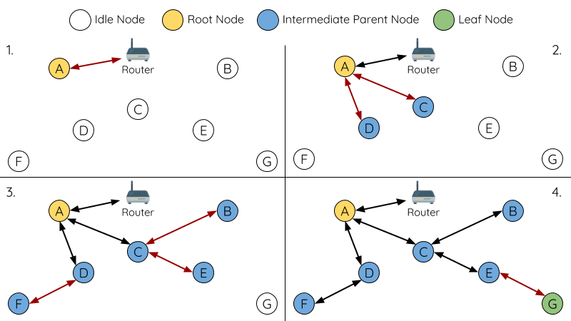

*Root Node Designation Example (Root Node = A, Max Layers = 4)*[ℑ](https://docs.espressif.com/projects/esp-idf/en/stable/esp32/api-guides/esp-wifi-mesh.html#id10)

**1.** Node A is designated the root node by the user therefore directly connects with the router. All other nodes forgo the election process.

**2.** Nodes C/D connect with node A as their preferred parent node. Both nodes form the second layer of the network.

**3.** Likewise, nodes B/E connect with node C, and node F connects with node D. Nodes B/E/F form the third layer of the network.

**4.** Node G connects with node E, forming the fourth layer of the network. However the maximum permitted number of layers in this network is configured as four, therefore node G becomes a leaf node to prevent any new layers from forming.

**Note**

When designating a root node, the root node should call [**esp_mesh_set_parent()**](https://docs.espressif.com/projects/esp-idf/en/stable/esp32/api-reference/network/esp-wifi-mesh.html#_CPPv419esp_mesh_set_parentPK13wifi_config_tPK11mesh_addr_t11mesh_type_ti) in order to directly connect with the router. Likewise, all other nodes should call [**esp_mesh_fix_root()**](https://docs.espressif.com/projects/esp-idf/en/stable/esp32/api-reference/network/esp-wifi-mesh.html#_CPPv417esp_mesh_fix_rootb) to forgo the election process.

**Parent Node Selection**[**ℑ**](https://docs.espressif.com/projects/esp-idf/en/stable/esp32/api-guides/esp-wifi-mesh.html#parent-node-selection)

By default, ESP-WIFI-MESH is self organizing meaning that each node will autonomously select which potential parent node to form an upstream connection with. The autonomously selected parent node is known as the preferred parent node. The criteria used for selecting the preferred parent node is designed to reduce the number of layers in the ESP-WIFI-MESH network and to balance the number of downstream connections between potential parent nodes (see section on [Preferred Parent Node](https://docs.espressif.com/projects/esp-idf/en/stable/esp32/api-guides/esp-wifi-mesh.html#preferred-parent-node)).

However ESP-WIFI-MESH also allows users to disable self-organizing behavior which will allow users to define their own criteria for parent node selection, or to configure nodes to have designated parent nodes (see the [Mesh Manual Networking Example](https://github.com/espressif/esp-idf/tree/v5.2.1/examples/mesh/manual_networking)).

**Asynchronous Power-on Reset**[**ℑ**](https://docs.espressif.com/projects/esp-idf/en/stable/esp32/api-guides/esp-wifi-mesh.html#asynchronous-power-on-reset)

ESP-WIFI-MESH network building can be affected by the order in which nodes power-on. If certain nodes within the network power-on asynchronously (i.e., separated by several minutes), **the final structure of the network could differ from the ideal case where all nodes are powered on synchronously**. Nodes that are delayed in powering on will adhere to the following rules:

**Rule 1:** If a root node already exists in the network, the delayed node will not attempt to elect a new root node, even if it has a stronger RSSI with the router. The delayed node will instead join the network like any other idle node by connecting with a preferred parent node. If the delayed node is the designated root node, all other nodes in the network will remain idle until the delayed node powers-on.

**Rule 2:** If a delayed node forms an upstream connection and becomes an intermediate parent node, it may also become the new preferred parent of other nodes (i.e., being a shallower node). This will cause the other nodes to switch their upstream connections to connect with the delayed node (see [Parent Node Switching](https://docs.espressif.com/projects/esp-idf/en/stable/esp32/api-guides/esp-wifi-mesh.html#parent-node-switching)).

**Rule 3:** If an idle node has a designated parent node which is delayed in powering-on, the idle node will not attempt to form any upstream connections in the absence of its designated parent node. The idle node will remain idle indefinitely until its designated parent node powers-on.

The following example demonstrates the effects of asynchronous power-on with regards to network building.

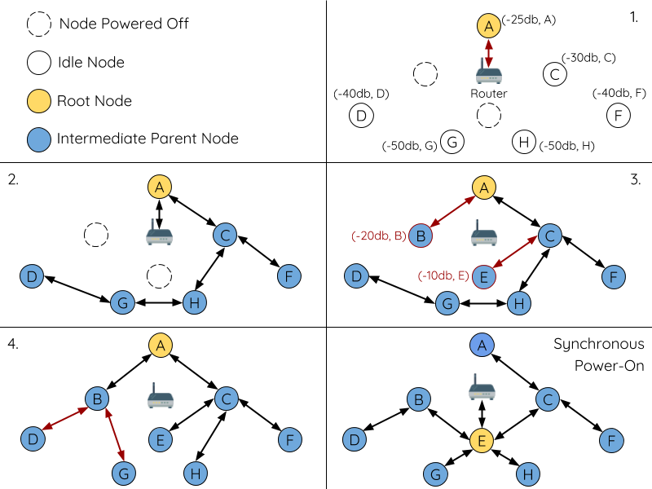

*Network Building with Asynchronous Power On Example*[ℑ](https://docs.espressif.com/projects/esp-idf/en/stable/esp32/api-guides/esp-wifi-mesh.html#id11)

**1.** Nodes A/C/D/F/G/H are powered-on synchronously and begin the root node election process by broadcasting their MAC addresses and router RSSIs. Node A is elected as the root node as it has the strongest RSSI.

**2.** Once node A becomes the root node, the remaining nodes begin forming upstream connections layer by layer with their preferred parent nodes. The result is a network with five layers.

**3.** Node B/E are delayed in powering-on but neither attempt to become the root node even though they have stronger router RSSIs (-20 dB and -10 dB) compared to node A. Instead both delayed nodes form upstream connections with their preferred parent nodes A and C respectively. Both nodes B/E become intermediate parent nodes after connecting.

**4.** Nodes D/G switch their upstream connections as node B is the new preferred parent node due to it being on a shallower layer (second layer node). Due to the switch, the resultant network has three layers instead of the original five layers.

**Synchronous Power-On:** Had all nodes powered-on synchronously, node E would have become the root node as it has the strongest router RSSI (-10 dB). This would result in a significantly different network layout compared to the network formed under the conditions of asynchronous power-on. **However the synchronous power-on network layout can still be reached if the user manually switches the root node** (see [**esp_mesh_waive_root()**](https://docs.espressif.com/projects/esp-idf/en/stable/esp32/api-reference/network/esp-wifi-mesh.html#_CPPv419esp_mesh_waive_rootPK11mesh_vote_ti)).

**Note**

Differences in parent node selection caused by asynchronous power-on are autonomously corrected for to some extent in ESP-WIFI-MESH (see [Parent Node Switching](https://docs.espressif.com/projects/esp-idf/en/stable/esp32/api-guides/esp-wifi-mesh.html#parent-node-switching))

**Loop-back Avoidance, Detection, and Handling**[**ℑ**](https://docs.espressif.com/projects/esp-idf/en/stable/esp32/api-guides/esp-wifi-mesh.html#loop-back-avoidance-detection-and-handling)

A loop-back is the situation where a particular node forms an upstream connection with one of its descendant nodes (a node within the particular node's subnetwork). This results in a circular connection path thereby breaking the tree topology. ESP-WIFI-MESH prevents loop-back during parent selection by excluding nodes already present in the selecting node's routing table (see [Routing Tables](https://docs.espressif.com/projects/esp-idf/en/stable/esp32/api-guides/esp-wifi-mesh.html#routing-tables)) thus prevents a particular node from attempting to connect to any node within its subnetwork.

In the event that a loop-back occurs, ESP-WIFI-MESH utilizes a path verification mechanism and energy transfer mechanism to detect the loop-back occurrence. The parent node of the upstream connection that caused the loop-back will then inform the child node of the loop-back and initiate a disconnection.

**Managing a Network**[**ℑ**](https://docs.espressif.com/projects/esp-idf/en/stable/esp32/api-guides/esp-wifi-mesh.html#managing-a-network)

**ESP-WIFI-MESH is a self healing network meaning it can detect and correct for failures in network routing**. Failures occur when a parent node with one or more child nodes breaks down, or when the connection between a parent node and its child nodes becomes unstable. Child nodes in ESP-WIFI-MESH will autonomously select a new parent node and form an upstream connection with it to maintain network interconnectivity. ESP-WIFI-MESH can handle both Root Node Failures and Intermediate Parent Node Failures.

**Root Node Failure**[**ℑ**](https://docs.espressif.com/projects/esp-idf/en/stable/esp32/api-guides/esp-wifi-mesh.html#root-node-failure)

If the root node breaks down, the nodes connected with it (second layer nodes) will promptly detect the failure of the root node. The second layer nodes will initially attempt to reconnect with the root node. However after multiple failed attempts, the second layer nodes will initialize a new round of root node election. **The second layer node with the strongest router RSSI will be elected as the new root node** whilst the remaining second layer nodes will form an upstream connection with the new root node (or a neighboring parent node if not in range).

If the root node and multiple downstream layers simultaneously break down (e.g., root node, second layer, and third layer), the shallowest layer that is still functioning will initialize the root node election. The following example illustrates an example of self healing from a root node break down.

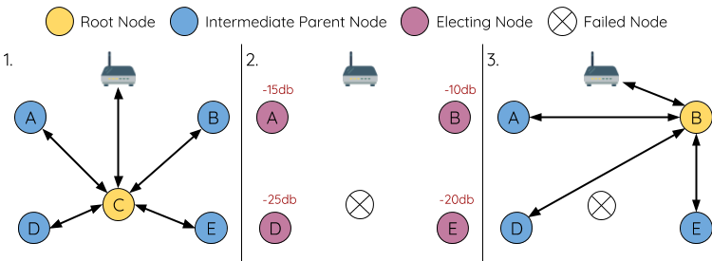

*Self Healing From Root Node Failure*[ℑ](https://docs.espressif.com/projects/esp-idf/en/stable/esp32/api-guides/esp-wifi-mesh.html#id12)

**1.** Node C is the root node of the network. Nodes A/B/D/E are second layer nodes connected to node C.

**2.** Node C breaks down. After multiple failed attempts to reconnect, the second layer nodes begin the election process by broadcasting their router RSSIs. Node B has the strongest router RSSI.

**3.** Node B is elected as the root node and begins accepting downstream connections. The remaining second layer nodes A/D/E form upstream connections with node B thus the network is healed and can continue operating normally.

**Note**

If a designated root node breaks down, the remaining nodes **will not autonomously attempt to elect a new root node** as an election process will never be attempted whilst a designated root node is used.

**Intermediate Parent Node Failure**[**ℑ**](https://docs.espressif.com/projects/esp-idf/en/stable/esp32/api-guides/esp-wifi-mesh.html#intermediate-parent-node-failure)

If an intermediate parent node breaks down, the disconnected child nodes will initially attempt to reconnect with the parent node. After multiple failed attempts to reconnect, each child node will begin to scan for potential parent nodes (see [Beacon Frames & RSSI Thresholding](https://docs.espressif.com/projects/esp-idf/en/stable/esp32/api-guides/esp-wifi-mesh.html#beacon-frames-rssi-thresholding)).

If other potential parent nodes are available, each child node will individually select a new preferred parent node (see [Preferred Parent Node](https://docs.espressif.com/projects/esp-idf/en/stable/esp32/api-guides/esp-wifi-mesh.html#preferred-parent-node)) and form an upstream connection with it. If there are no other potential parent nodes for a particular child node, it will remain idle indefinitely.

The following diagram illustrates an example of self healing from an Intermediate Parent Node break down.

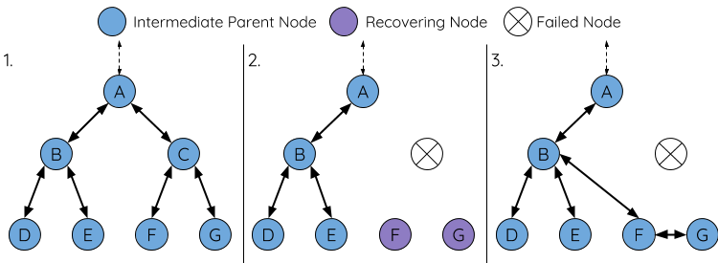

*Self Healing From Intermediate Parent Node Failure*[ℑ](https://docs.espressif.com/projects/esp-idf/en/stable/esp32/api-guides/esp-wifi-mesh.html#id13)

**1.** The following branch of the network consists of nodes A to G.

**2.** Node C breaks down. Nodes F/G detect the break down and attempt to reconnect with node C. After multiple failed attempts to reconnect, nodes F/G begin to select a new preferred parent node.

**3.** Node G is out of range from any other parent node hence remains idle for the time being. Node F is in range of nodes B/E, however node B is selected as it is the shallower node. Node F becomes an intermediate parent node after connecting with Node B thus node G can connect with node F. The network is healed, however the network routing as been affected and an extra layer has been added.

**Note**

If a child node has a designated parent node that breaks down, the child node will make no attempt to connect with a new parent node. The child node will remain idle indefinitely.

**Root Node Switching**[**ℑ**](https://docs.espressif.com/projects/esp-idf/en/stable/esp32/api-guides/esp-wifi-mesh.html#root-node-switching)

ESP-WIFI-MESH does not automatically switch the root node unless the root node breaks down. Even if the root node's router RSSI degrades to the point of disconnection, the root node will remain unchanged. Root node switching is the act of explicitly starting a new election such that a node with a stronger router RSSI will be elected as the new root node. This can be a useful method of adapting to degrading root node performance.

To trigger a root node switch, the current root node must explicitly call [**esp_mesh_waive_root()**](https://docs.espressif.com/projects/esp-idf/en/stable/esp32/api-reference/network/esp-wifi-mesh.html#_CPPv419esp_mesh_waive_rootPK11mesh_vote_ti) to trigger a new election. The current root node will signal all nodes within the network to begin transmitting and scanning for beacon frames (see [Automatic Root Node Selection](https://docs.espressif.com/projects/esp-idf/en/stable/esp32/api-guides/esp-wifi-mesh.html#automatic-root-node-selection)) **whilst remaining connected to the network (i.e., not idle)**. If another node receives more votes than the current root node, a root node switch will be initiated. **The root node will remain unchanged otherwise**.

A newly elected root node sends a **switch request** to the current root node which in turn will respond with an acknowledgment signifying both nodes are ready to switch. Once the acknowledgment is received, the newly elected root node will disconnect from its parent and promptly form an upstream connection with the router thereby becoming the new root node of the network. The previous root node will disconnect from the router **whilst maintaining all of its downstream connections** and enter the idle state. The previous root node will then begin scanning for potential parent nodes and selecting a preferred parent.

The following diagram illustrates an example of a root node switch.

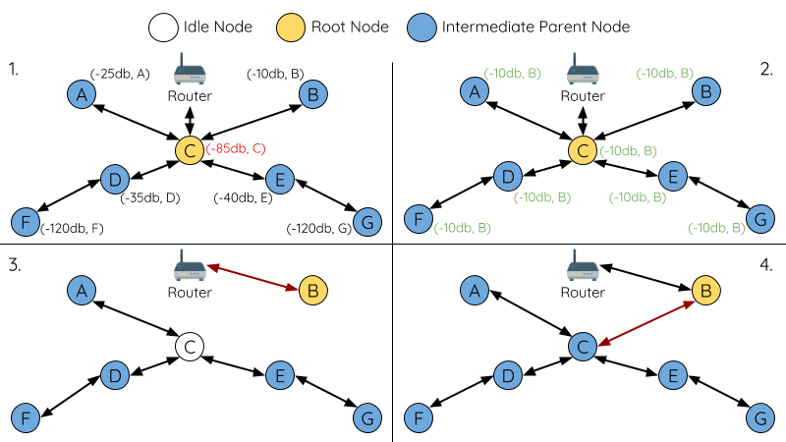

*Root Node Switch Example*[ℑ](https://docs.espressif.com/projects/esp-idf/en/stable/esp32/api-guides/esp-wifi-mesh.html#id14)

**1.** Node C is the current root node but has degraded signal strength with the router (-85db). The node C triggers a new election and all nodes begin transmitting and scanning for beacon frames **whilst still being connected**.

**2.** After multiple rounds of transmission and scanning, node B is elected as the new root node. Node B sends node C a **switch request** and node C responds with an acknowledgment.

**3.** Node B disconnects from its parent and connects with the router becoming the network's new root node. Node C disconnects from the router, enters the idle state, and begins scanning for and selecting a new preferred parent node. **Node C maintains all its downstream connections throughout this process**.

**4.** Node C selects node B as its preferred parent node, forms an upstream connection, and becomes a second layer node. The network layout is similar after the switch as node C still maintains the same subnetwork. However each node in node C's subnetwork has been placed one layer deeper as a result of the switch. [Parent Node Switching](https://docs.espressif.com/projects/esp-idf/en/stable/esp32/api-guides/esp-wifi-mesh.html#parent-node-switching) may adjust the network layout afterwards if any nodes have a new preferred parent node as a result of the root node switch.

**Note**

Root node switching must require an election hence is only supported when using a self-organized ESP-WIFI-MESH network. In other words, root node switching cannot occur if a designated root node is used.

**Parent Node Switching**[**ℑ**](https://docs.espressif.com/projects/esp-idf/en/stable/esp32/api-guides/esp-wifi-mesh.html#parent-node-switching)

Parent Node Switching entails a child node switching its upstream connection to another parent node of a shallower layer. **Parent Node Switching occurs autonomously** meaning that a child node will change its upstream connection automatically if a potential parent node of a shallower layer becomes available (i.e., due to a [Asynchronous Power-on Reset](https://docs.espressif.com/projects/esp-idf/en/stable/esp32/api-guides/esp-wifi-mesh.html#asynchronous-power-on-reset)).

All potential parent nodes periodically transmit beacon frames (see [Beacon Frames & RSSI Thresholding](https://docs.espressif.com/projects/esp-idf/en/stable/esp32/api-guides/esp-wifi-mesh.html#beacon-frames-rssi-thresholding)) allowing for a child node to scan for the availability of a shallower parent node. Due to parent node switching, a self-organized ESP-WIFI-MESH network can dynamically adjust its network layout to ensure each connection has a good RSSI and that the number of layers in the network is minimized.

**Data Transmission**[**ℑ**](https://docs.espressif.com/projects/esp-idf/en/stable/esp32/api-guides/esp-wifi-mesh.html#data-transmission)

**ESP-WIFI-MESH Packet**[**ℑ**](https://docs.espressif.com/projects/esp-idf/en/stable/esp32/api-guides/esp-wifi-mesh.html#esp-wifi-mesh-packet)

ESP-WIFI-MESH network data transmissions use ESP-WIFI-MESH packets. ESP-WIFI-MESH packets are **entirely contained within the frame body of a Wi-Fi data frame**. A multi-hop data transmission in an ESP-WIFI-MESH network will involve a single ESP-WIFI-MESH packet being carried over each wireless hop by a different Wi-Fi data frame.

The following diagram shows the structure of an ESP-WIFI-MESH packet and its relation with a Wi-Fi data frame.

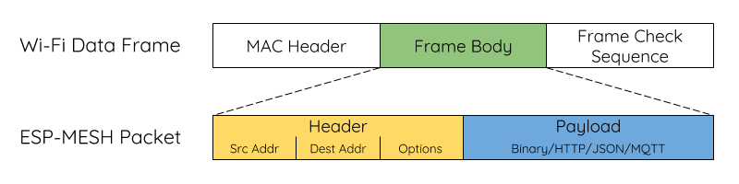

*ESP-WIFI-MESH Packet*[ℑ](https://docs.espressif.com/projects/esp-idf/en/stable/esp32/api-guides/esp-wifi-mesh.html#id15)

**The header** of an ESP-WIFI-MESH packet contains the MAC addresses of the source and destination nodes. The options field contains information pertaining to the special types of ESP-WIFI-MESH packets such as a group transmission or a packet originating from the external IP network (see [**MESH_OPT_SEND_GROUP**](https://docs.espressif.com/projects/esp-idf/en/stable/esp32/api-reference/network/esp-wifi-mesh.html#c.MESH_OPT_SEND_GROUP) and [**MESH_OPT_RECV_DS_ADDR**](https://docs.espressif.com/projects/esp-idf/en/stable/esp32/api-reference/network/esp-wifi-mesh.html#c.MESH_OPT_RECV_DS_ADDR)).

**The payload** of an ESP-WIFI-MESH packet contains the actual application data. This data can be raw binary data, or encoded under an application layer protocol such as HTTP, MQTT, and JSON (see [**mesh_proto_t**](https://docs.espressif.com/projects/esp-idf/en/stable/esp32/api-reference/network/esp-wifi-mesh.html#_CPPv412mesh_proto_t)).

**Note**

When sending an ESP-WIFI-MESH packet to the external IP network, the destination address field of the header will contain the IP address and port of the target server rather than the MAC address of a node (see [**mesh_addr_t**](https://docs.espressif.com/projects/esp-idf/en/stable/esp32/api-reference/network/esp-wifi-mesh.html#_CPPv411mesh_addr_t)). Furthermore the root node will handle the formation of the outgoing TCP/IP packet.

**Group Control & Multicasting**[**ℑ**](https://docs.espressif.com/projects/esp-idf/en/stable/esp32/api-guides/esp-wifi-mesh.html#group-control-multicasting)

Multicasting is a feature that allows a single ESP-WIFI-MESH packet to be transmitted simultaneously to multiple nodes within the network. Multicasting in ESP-WIFI-MESH can be achieved by either specifying a list of target nodes, or specifying a preconfigured group of nodes. Both methods of multicasting are called via [**esp_mesh_send()**](https://docs.espressif.com/projects/esp-idf/en/stable/esp32/api-reference/network/esp-wifi-mesh.html#_CPPv413esp_mesh_sendPK11mesh_addr_tPK11mesh_data_tiA_K10mesh_opt_ti).

To multicast by specifying a list of target nodes, users must first set the ESP-WIFI-MESH packet's destination address to the **Multicast-Group Address** (01:00:5E:xx:xx:xx). This signifies that the ESP-WIFI-MESH packet is a multicast packet with a group of addresses, and that the address should be obtained from the header options. Users must then list the MAC addresses of the target nodes as options (see [**mesh_opt_t**](https://docs.espressif.com/projects/esp-idf/en/stable/esp32/api-reference/network/esp-wifi-mesh.html#_CPPv410mesh_opt_t) and [**MESH_OPT_SEND_GROUP**](https://docs.espressif.com/projects/esp-idf/en/stable/esp32/api-reference/network/esp-wifi-mesh.html#c.MESH_OPT_SEND_GROUP)). This method of multicasting requires no prior setup but can incur a large amount of overhead data as each target node's MAC address must be listed in the options field of the header.

Multicasting by group allows a ESP-WIFI-MESH packet to be transmitted to a preconfigured group of nodes. Each grouping is identified by a unique ID, and a node can be placed into a group via [**esp_mesh_set_group_id()**](https://docs.espressif.com/projects/esp-idf/en/stable/esp32/api-reference/network/esp-wifi-mesh.html#_CPPv421esp_mesh_set_group_idPK11mesh_addr_ti). Multicasting to a group involves setting the destination address of the ESP-WIFI-MESH packet to the target group ID. Furthermore, the [**MESH_DATA_GROUP**](https://docs.espressif.com/projects/esp-idf/en/stable/esp32/api-reference/network/esp-wifi-mesh.html#c.MESH_DATA_GROUP) flag must set. Using groups to multicast incurs less overhead, but requires nodes to previously added into groups.

**Note**

During a multicast, all nodes within the network still receive the ESP-WIFI-MESH packet on the MAC layer. However, nodes not included in the MAC address list or the target group will simply filter out the packet.

**Broadcasting**[**ℑ**](https://docs.espressif.com/projects/esp-idf/en/stable/esp32/api-guides/esp-wifi-mesh.html#broadcasting)

Broadcasting is a feature that allows a single ESP-WIFI-MESH packet to be transmitted simultaneously to all nodes within the network. Each node essentially forwards a broadcast packet to all of its upstream and downstream connections such that the packet propagates throughout the network as quickly as possible. However, ESP-WIFI-MESH utilizes the following methods to avoid wasting bandwidth during a broadcast.

**1.** When an intermediate parent node receives a broadcast packet from its parent, it will forward the packet to each of its child nodes whilst storing a copy of the packet for itself.

**2.** When an intermediate parent node is the source node of the broadcast, it will transmit the broadcast packet upstream to is parent node and downstream to each of its child nodes.

**3.** When an intermediate parent node receives a broadcast packet from one of its child nodes, it will forward the packet to its parent node and each of its remaining child nodes whilst storing a copy of the packet for itself.

**4.** When a leaf node is the source node of a broadcast, it will directly transmit the packet to its parent node.

**5.** When the root node is the source node of a broadcast, the root node will transmit the packet to all of its child nodes.

**6.** When the root node receives a broadcast packet from one of its child nodes, it will forward the packet to each of its remaining child nodes whilst storing a copy of the packet for itself.

**7.** When a node receives a broadcast packet with a source address matching its own MAC address, the node will discard the broadcast packet.

**8.** When an intermediate parent node receives a broadcast packet from its parent node which was originally transmitted from one of its child nodes, it will discard the broadcast packet

**Upstream Flow Control**[**ℑ**](https://docs.espressif.com/projects/esp-idf/en/stable/esp32/api-guides/esp-wifi-mesh.html#upstream-flow-control)

ESP-WIFI-MESH relies on parent nodes to control the upstream data flow of their immediate child nodes. To prevent a parent node's message buffer from overflowing due to an overload of upstream transmissions, a parent node will allocate a quota for upstream transmissions known as a **receiving window** for each of its child nodes. **Each child node must apply for a receiving window before it is permitted to transmit upstream**. The size of a receiving window can be dynamically adjusted. An upstream transmission from a child node to the parent node consists of the following steps:

**1.** Before each transmission, the child node sends a window request to its parent node. The window request consists of a sequence number which corresponds to the child node's data packet that is pending transmission.

**2.** The parent node receives the window request and compares the sequence number with the sequence number of the previous packet sent by the child node. The comparison is used to calculate the size of the receiving window which is transmitted back to the child node.

**3.** The child node transmits the data packet in accordance with the window size specified by the parent node. If the child node depletes its receiving window, it must obtain another receiving windows by sending a request before it is permitted to continue transmitting.

**Note**

ESP-WIFI-MESH does not support any downstream flow control.

**Warning**

Due to [Parent Node Switching](https://docs.espressif.com/projects/esp-idf/en/stable/esp32/api-guides/esp-wifi-mesh.html#parent-node-switching), packet loss may occur during upstream transmissions.

Due to the fact that the root node acts as the sole interface to an external IP network, it is critical that downstream nodes are aware of the root node's connection status with the external IP network. Failing to do so can lead to nodes attempting to pass data upstream to the root node whilst it is disconnected from the IP network. This results in unnecessary transmissions and packet loss. ESP-WIFI-MESH address this issue by providing a mechanism to stabilize the throughput of outgoing data based on the connection status between the root node and the external IP network. The root node can broadcast its external IP network connection status to all other nodes by calling [**esp_mesh_post_toDS_state()**](https://docs.espressif.com/projects/esp-idf/en/stable/esp32/api-reference/network/esp-wifi-mesh.html#_CPPv424esp_mesh_post_toDS_stateb).

**Bi-Directional Data Stream**[**ℑ**](https://docs.espressif.com/projects/esp-idf/en/stable/esp32/api-guides/esp-wifi-mesh.html#bi-directional-data-stream)

The following diagram illustrates the various network layers involved in an ESP-WIFI-MESH Bidirectional Data Stream.

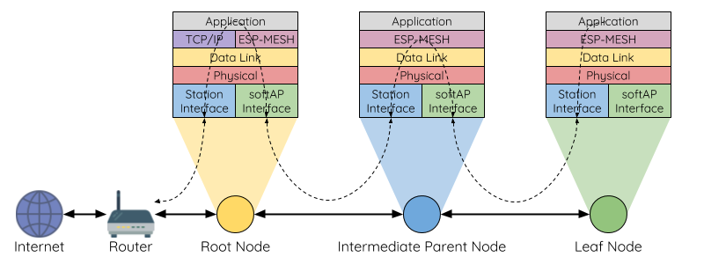

*ESP-WIFI-MESH Bidirectional Data Stream*[ℑ](https://docs.espressif.com/projects/esp-idf/en/stable/esp32/api-guides/esp-wifi-mesh.html#id16)

Due to the use of [Routing Tables](https://docs.espressif.com/projects/esp-idf/en/stable/esp32/api-guides/esp-wifi-mesh.html#routing-tables), **ESP-WIFI-MESH is able to handle pack forwarding entirely on the mesh layer**. A TCP/IP layer is only required on the root node when it transmits/receives a packet to/from an external IP network.

**Channel Switching**[**ℑ**](https://docs.espressif.com/projects/esp-idf/en/stable/esp32/api-guides/esp-wifi-mesh.html#channel-switching)

**Background**[**ℑ**](https://docs.espressif.com/projects/esp-idf/en/stable/esp32/api-guides/esp-wifi-mesh.html#background)

In traditional Wi-Fi networks, **channels** are predetermined frequency ranges. In an infrastructure basic service set (BSS), the serving AP and its connected stations must be on the same operating channels (1 to 14) in which beacons are transmitted. Physically adjacent BSS (Basic Service Sets) operating on the same channel can lead to interference and degraded performance.

In order to allow a BSS adapt to changing physical layer conditions and maintain performance, Wi-Fi contains mechanisms for **network channel switching**. A network channel switch is an attempt to move a BSS to a new operating channel whilst minimizing disruption to the BSS during this process. However it should be recognized that a channel switch may be unsuccessful in moving all stations to the new operating channel.

In an infrastructure Wi-Fi network, network channel switches are triggered by the AP with the aim of having the AP and all connected stations synchronously switch to a new channel. Network channel switching is implemented by embedding a **Channel Switch Announcement (CSA)** element within the AP's periodically transmitted beacon frames. The CSA element is used to advertise to all connected stations regarding an upcoming network channel switch and will be included in multiple beacon frames up until the switch occurs.

A CSA element contains information regarding the **New Channel Number** and a **Channel Switch Count** which indicates the number of beacon frame intervals (TBTTs) remaining until the network channel switch occurs. Therefore, the Channel Switch Count is decremented every beacon frame and allows connected stations to synchronize their channel switch with the AP.

**ESP-WIFI-MESH Network Channel Switching**[**ℑ**](https://docs.espressif.com/projects/esp-idf/en/stable/esp32/api-guides/esp-wifi-mesh.html#esp-wifi-mesh-network-channel-switching)

ESP-WIFI-MESH Network Channel Switching also utilize beacon frames that contain a CSA element. However, being a multi-hop network makes the switching process in ESP-WIFI-MESH is more complex due to the fact that a beacon frame might not be able to reach all nodes within the network (i.e., in a single hop). Therefore, an ESP-WIFI-MESH network relies on nodes to forward the CSA element so that it is propagated throughout the network.

When an intermediate parent node with one or more child nodes receives a beacon frame containing a CSA, the node will forward the CSA element by including the element in its next transmitted beacon frame (i.e., with the same **New Channel Number** and **Channel Switch Count**). Given that all nodes within an ESP-WIFI-MESH network receive the same CSA, the nodes can synchronize their channel switches using the Channel Switch Count, albeit with a short delay due to CSA element forwarding.

An ESP-WIFI-MESH network channel switch can be triggered by either the router or the root node.

**Root Node Triggered**[**ℑ**](https://docs.espressif.com/projects/esp-idf/en/stable/esp32/api-guides/esp-wifi-mesh.html#root-node-triggered)

**A root node triggered channel switch can only occur when the ESP-WIFI-MESH network is not connected to a router**. By calling [**esp_mesh_switch_channel()**](https://docs.espressif.com/projects/esp-idf/en/stable/esp32/api-reference/network/esp-wifi-mesh.html#_CPPv423esp_mesh_switch_channelPK7uint8_tii), the root node will set an initial Channel Switch Count value and begin including a CSA element in its beacon frames. Each CSA element is then received by second layer nodes, and forwarded downstream in their own beacon frames.

**Router Triggered**[**ℑ**](https://docs.espressif.com/projects/esp-idf/en/stable/esp32/api-guides/esp-wifi-mesh.html#router-triggered)

When an ESP-WIFI-MESH network is connected to a router, the entire network must use the same channel as the router. Therefore, **the root node will not be permitted to trigger a channel switch when it is connected to a router**.

When the root node receives beacon frame containing a CSA element from the router, **the root node will set Channel Switch Count value in the CSA element to a custom value before forwarding it downstream via beacon frames**. It will also decrement the Channel Switch Count of subsequent CSA elements relative to the custom value. This custom value can be based on factors such as the number of network layers, the current number of nodes etc.

The setting the Channel Switch Count value to a custom value is due to the fact that the ESP-WIFI-MESH network and its router may have a different and varying beacon intervals. Therefore, the Channel Switch Count value provided by the router is irrelevant to an ESP-WIFI-MESH network. By using a custom value, nodes within the ESP-WIFI-MESH network are able to switch channels synchronously relative to the ESP-WIFI-MESH network's beacon interval. However, this will also result in the ESP-WIFI-MESH network's channel switch being unsynchronized with the channel switch of the router and its connected stations.

**Impact of Network Channel Switching**[**ℑ**](https://docs.espressif.com/projects/esp-idf/en/stable/esp32/api-guides/esp-wifi-mesh.html#impact-of-network-channel-switching)

* **Due to the ESP-WIFI-MESH network channel switch being unsynchronized with the router's channel switch, there will be a temporary channel discrepancy between the ESP-WIFI-MESH network and the router.**
  + The ESP-WIFI-MESH network's channel switch time is dependent on the ESP-WIFI-MESH network's beacon interval and the root node's custom Channel Switch Count value.
  + The channel discrepancy prevents any data exchange between the root node and the router during that ESP-WIFI-MESH network's switch.
  + In the ESP-WIFI-MESH network, the root node and intermediate parent nodes will request their connected child nodes to stop transmissions until the channel switch takes place by setting the **Channel Switch Mode** field in the CSA element to 1.
  + Frequent router triggered network channel switches can degrade the ESP-WIFI-MESH network's performance. Note that this can be caused by the ESP-WIFI-MESH network itself (e.g., due to wireless medium contention with ESP-WIFI-MESH network). If this is the case, users should disable the automatic channel switching on the router and use a specified channel instead.
* **When there is a temporary channel discrepancy, the root node remains technically connected to the router.**
  + Disconnection occurs after the root node fails to receive any beacon frames or probe responses from the router over a fixed number of router beacon intervals.
  + Upon disconnection, the root node will automatically re-scan all channels for the presence of a router.
* **If the root node is unable to receive any of the router's CSA beacon frames (e.g., due to short switch time given by the router), the router will switch channels without the ESP-WIFI-MESH network's knowledge.**
  + After the router switches channels, the root node will no longer be able to receive the router's beacon frames and probe responses and result in a disconnection after a fixed number of beacon intervals.
  + The root node will re-scan all channels for the router after disconnection.
  + The root node will maintain downstream connections throughout this process.

**Note**

Although ESP-WIFI-MESH network channel switching aims to move all nodes within the network to a new operating channel, it should be recognized that a channel switch might not successfully move all nodes (e.g., due to reasons such as node failures).

**Channel and Router Switching Configuration**[**ℑ**](https://docs.espressif.com/projects/esp-idf/en/stable/esp32/api-guides/esp-wifi-mesh.html#channel-and-router-switching-configuration)

ESP-WIFI-MESH allows for autonomous channel switching to be enabled/disabled via configuration. Likewise, autonomous router switching (i.e., when a root node autonomously connects to another router) can also be enabled/disabled by configuration. Autonomous channel switching and router switching is dependent on the following configuration parameters and run-time conditions.

**Allow Channel Switch:** This parameter is set via the allow_channel_switch field of the [**mesh_cfg_t**](https://docs.espressif.com/projects/esp-idf/en/stable/esp32/api-reference/network/esp-wifi-mesh.html#_CPPv410mesh_cfg_t) structure and permits an ESP-WIFI-MESH network to dynamically switch channels when set.

**Preset Channel:** An ESP-WIFI-MESH network can have a preset channel by setting the channel field of the [**mesh_cfg_t**](https://docs.espressif.com/projects/esp-idf/en/stable/esp32/api-reference/network/esp-wifi-mesh.html#_CPPv410mesh_cfg_t) structure to the desired channel number. If this field is unset, the allow_channel_switch parameter is overridden such that channel switches are always permitted.

**Allow Router Switch:** This parameter is set via the allow_router_switch field of the [**mesh_router_t**](https://docs.espressif.com/projects/esp-idf/en/stable/esp32/api-reference/network/esp-wifi-mesh.html#_CPPv413mesh_router_t) and permits an ESP-WIFI-MESH to dynamically switch to a different router when set.

**Preset Router BSSID:** An ESP-WIFI-MESH network can have a preset router by setting the bssid field of the [**mesh_router_t**](https://docs.espressif.com/projects/esp-idf/en/stable/esp32/api-reference/network/esp-wifi-mesh.html#_CPPv413mesh_router_t) structure to the BSSID of the desired router. If this field is unset, the allow_router_switch parameter is overridden such that router switches are always permitted.

**Root Node Present:** The presence of a root node will can also affect whether or a channel or router switch is permitted.

The following table illustrates how the different combinations of parameters/conditions affect whether channel switching and/or router switching is permitted. Note that *X* represents a "do not care" for the parameter.

| **Preset Channel** | **Allow Channel Switch** | **Preset Router BSSID** | **Allow Router Switch** | **Root Node Present** | **Permitted Switches？** |
| --- | --- | --- | --- | --- | --- |
| N | X | N | X | X | Channel and Router |
| N | X | Y | N | X | Channel Only |
| N | X | Y | Y | X | Channel and Router |
| Y | Y | N | X | X | Channel and Router |
| Y | N | N | X | N | Router Only |
| Y | N | N | X | Y | Channel and Router |
| Y | Y | Y | N | X | Channel Only |
| Y | N | Y | N | N | N |
| Y | N | Y | N | Y | Channel Only |
| Y | Y | Y | Y | X | Channel and Router |
| Y | N | Y | Y | N | Router Only |
| Y | N | Y | Y | Y | Channel and Router |

**Performance**[**ℑ**](https://docs.espressif.com/projects/esp-idf/en/stable/esp32/api-guides/esp-wifi-mesh.html#performance)

The performance of an ESP-WIFI-MESH network can be evaluated based on multiple metrics such as the following:

**Network Building Time:** The amount of time taken to build an ESP-WIFI-MESH network from scratch.

**Healing Time:** The amount of time taken for the network to detect a node break down and carry out appropriate actions to heal the network (such as generating a new root node or forming new connections).

**Per-hop latency:** The latency of data transmission over one wireless hop. In other words, the time taken to transmit a data packet from a parent node to a child node or vice versa.

**Network Node Capacity:** The total number of nodes the ESP-WIFI-MESH network can simultaneously support. This number is determined by the maximum number of downstream connections a node can accept and the maximum number of layers permissible in the network.

The following table lists the common performance figures of an ESP-WIFI-MESH network:

* Network Building Time: < 60 seconds
* **Healing time:**
  + Root node break down: < 10 seconds
  + Child node break down: < 5 seconds
* Per-hop latency: 10 to 30 milliseconds

**Note**

The following test conditions were used to generate the performance figures above.

* Number of test devices: **100**
* Maximum Downstream Connections to Accept: **6**
* Maximum Permissible Layers: **6**

**Note**

Throughput depends on packet error rate and hop count.

**Note**

The throughput of root node's access to the external IP network is directly affected by the number of nodes in the ESP-WIFI-MESH network and the bandwidth of the router.

**Note**

The performance figures can vary greatly between installations based on network configuration and operating environment.

**Further Notes**[**ℑ**](https://docs.espressif.com/projects/esp-idf/en/stable/esp32/api-guides/esp-wifi-mesh.html#further-notes)

* Data transmission uses Wi-Fi WPA2-PSK encryption
* Mesh networking IE uses AES encryption

**ESP-MESH with ESP32 and ESP8266: Getting Started (painlessMesh library)**

Learn how to use ESP-MESH networking protocol to build a mesh network with the ESP32 and ESP8266 NodeMCU boards. ESP-MESH allows multiple devices (nodes) to communicate with each other under a single wireless local area network. It is supported on the ESP32 and ESP8266 boards. In this guide, we’ll show you how to get started with ESP-MESH using the Arduino core.

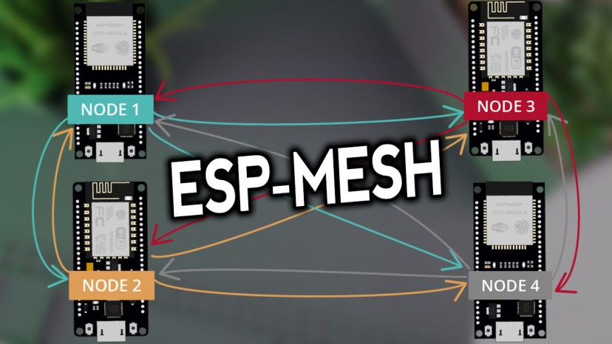

This article covers the following topics:

* [Introducing ESP-MESH](https://randomnerdtutorials.com/esp-mesh-esp32-esp8266-painlessmesh/#1)
* [ESP-MESH Basic Example (Broadcast messages)](https://randomnerdtutorials.com/esp-mesh-esp32-esp8266-painlessmesh/#2)
* [Exchange Sensor Readings using ESP-MESH (broadcast)](https://randomnerdtutorials.com/esp-mesh-esp32-esp8266-painlessmesh/#3)

**Arduino IDE**

If you want to program the [ESP32](https://makeradvisor.com/tools/esp32-dev-board-wi-fi-bluetooth/) and [ESP8266](https://makeradvisor.com/tools/esp8266-esp-12e-nodemcu-wi-fi-development-board/)boards using Arduino IDE, you should have the ESP32 or ESP8266 add-ons installed. Follow the next guides:

* [Installing ESP32 Board in Arduino IDE (Windows, Mac OS X, and Linux)](https://randomnerdtutorials.com/installing-the-esp32-board-in-arduino-ide-windows-instructions/)
* [Installing ESP8266 Board in Arduino IDE (Windows, Mac OS X, Linux)](https://randomnerdtutorials.com/how-to-install-esp8266-board-arduino-ide/)

If you want to program the ESP32/ESP8266 using VS Code + PlatformIO, follow the next tutorial:

* [Getting Started with VS Code and PlatformIO IDE for ESP32 and ESP8266 (Windows, Mac OS X, Linux Ubuntu)](https://randomnerdtutorials.com/vs-code-platformio-ide-esp32-esp8266-arduino/)

**Introducing ESP-MESH**

Accordingly to the Espressif documentation:

“ESP-MESH is a networking protocol built atop the Wi-Fi protocol. ESP-MESH allows numerous devices (referred to as nodes) spread over a large physical area (both indoors and outdoors) to be interconnected under a single WLAN (Wireless Local-Area Network).

ESP-MESH is self-organizing and self-healing meaning the network can be built and maintained autonomously.” For more information, visit the [ESP-MESH official documentation](https://docs.espressif.com/projects/esp-idf/en/latest/esp32/api-guides/mesh.html).

**Traditional Wi-Fi Network Architecture**

In a traditional Wi-Fi network architecture, a single node (access point – usually the router) is connected to all other nodes (stations). Each node can communicate with each other using the access point. However, this is limited to the access point wi-fi coverage. Every station must be in the range to connect directly to the access point. This doesn’t happen with ESP-MESH.

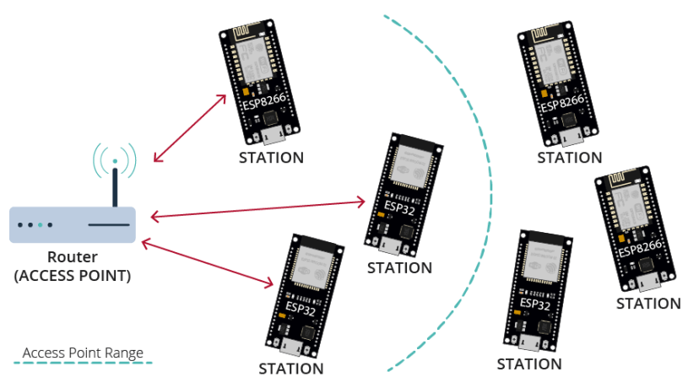

**ESP-MESH Network Architecture**

With ESP-MESH, the nodes don’t need to connect to a central node. Nodes are responsible for relaying each others transmissions. This allows multiple devices to spread over a large physical area. The Nodes can self-organize and dynamically talk to each other to ensure that the packet reaches its final node destination. If any node is removed from the network, it is able to self-organize to make sure that the packets reach their destination.

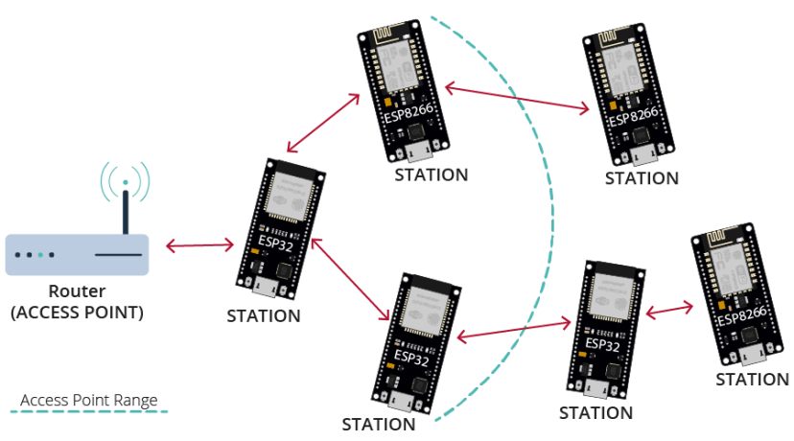

**painlessMesh Library**

The [painlessMesh library](https://gitlab.com/painlessMesh/painlessMesh) allows us to create a mesh network with the ESP8266 or/and ESP32 boards in an easy way.

“painlessMesh is a true ad-hoc network, meaning that no-planning, central controller, or router is required. Any system of 1 or more nodes will self-organize into fully functional mesh. The maximum size of the mesh is limited (we think) by the amount of memory in the heap that can be allocated to the sub-connections buffer and so should be really quite high.” [More information about the painlessMesh library](https://gitlab.com/painlessMesh/painlessMesh).

**Installing painlessMesh Library**

You can install painlessMesh through the Arduino Library manager. Go to **Tools** > **Manage Libraries**. The Library Manager should open.

Search for “**painlessmesh**” and install the library. We’re using Version 1.4.5

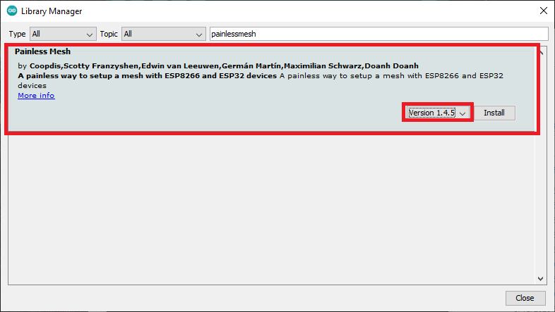

This library needs some other library dependencies. A new window should pop up asking you to install any missing dependencies. Select “Install all”.

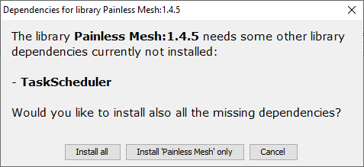

If this window doesn’t show up, you’ll need to install the following library dependencies:

* [ArduinoJson](https://github.com/bblanchon/ArduinoJson) (by bblanchon)
* [TaskScheduler](https://github.com/arkhipenko/TaskScheduler)
* [ESPAsyncTCP](https://github.com/me-no-dev/ESPAsyncTCP) (ESP8266)
* [AsyncTCP](https://github.com/me-no-dev/AsyncTCP) (ESP32)

If you’re using [PlatformIO](https://randomnerdtutorials.com/vs-code-platformio-ide-esp32-esp8266-arduino/), add the following lines to the platformio.ini file to add the libraries and change the monitor speed.

For the ESP32:

monitor_speed = 115200

lib_deps = painlessmesh/painlessMesh @ ^1.4.5

ArduinoJson

arduinoUnity

TaskScheduler

AsyncTCP

For the ESP8266:

monitor_speed = 115200

lib_deps = painlessmesh/painlessMesh @ ^1.4.5

ArduinoJson

TaskScheduler

ESPAsyncTCP

**ESP-MESH Basic Example (Broadcast messages)**

To get started with ESP-MESH, we’ll first experiment with the library’s basic example. This example creates a mesh network in which all boards broadcast messages to all the other boards.

We’ve experimented this example with four boards (two [ESP32](https://makeradvisor.com/tools/esp32-dev-board-wi-fi-bluetooth/) and two [ESP8266](https://makeradvisor.com/tools/esp8266-esp-12e-nodemcu-wi-fi-development-board/)). You can add or remove boards. The code is compatible with both the ESP32 and ESP8266 boards.

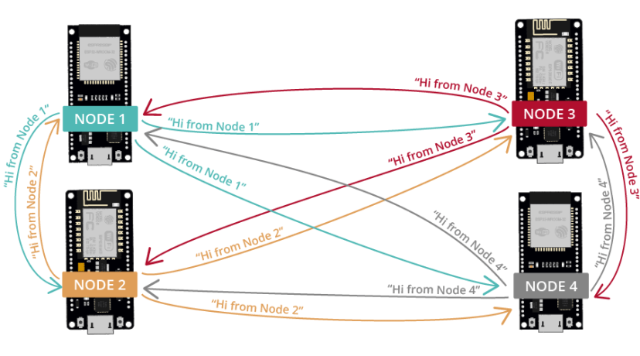

**Code – painlessMesh Library Basic Example**

Copy the following code to your Arduino IDE (code from the library examples). The code is compatible with both the ESP32 and ESP8266 boards.

/*

Rui Santos

Complete project details at https://RandomNerdTutorials.com/esp-mesh-esp32-esp8266-painlessmesh/

This is a simple example that uses the painlessMesh library: https://github.com/gmag11/painlessMesh/blob/master/examples/basic/basic.ino

*/

#include "painlessMesh.h"

#define MESH_PREFIX "whateverYouLike"

#define MESH_PASSWORD "somethingSneaky"

#define MESH_PORT 5555

Scheduler userScheduler; // to control your personal task

painlessMesh mesh;

// User stub

void sendMessage() ; // Prototype so PlatformIO doesn't complain

Task taskSendMessage( TASK_SECOND * 1 , TASK_FOREVER, &sendMessage );

void sendMessage() {

String msg = "Hi from node1";

msg += mesh.getNodeId();

mesh.sendBroadcast( msg );

taskSendMessage.setInterval( random( TASK_SECOND * 1, TASK_SECOND * 5 ));

}

// Needed for painless library

void receivedCallback( uint32_t from, String &msg ) {

Serial.printf("startHere: Received from %u msg=%s\n", from, msg.c_str());

}

void newConnectionCallback(uint32_t nodeId) {

Serial.printf("--> startHere: New Connection, nodeId = %u\n", nodeId);

}

void changedConnectionCallback() {

Serial.printf("Changed connections\n");

}

void nodeTimeAdjustedCallback(int32_t offset) {

Serial.printf("Adjusted time %u. Offset = %d\n", mesh.getNodeTime(),offset);

}

void setup() {

Serial.begin(115200);

//mesh.setDebugMsgTypes( ERROR | MESH_STATUS | CONNECTION | SYNC | COMMUNICATION | GENERAL | MSG_TYPES | REMOTE ); // all types on

mesh.setDebugMsgTypes( ERROR | STARTUP ); // set before init() so that you can see startup messages

mesh.init( MESH_PREFIX, MESH_PASSWORD, &userScheduler, MESH_PORT );

mesh.onReceive(&receivedCallback);

mesh.onNewConnection(&newConnectionCallback);

mesh.onChangedConnections(&changedConnectionCallback);

mesh.onNodeTimeAdjusted(&nodeTimeAdjustedCallback);

userScheduler.addTask( taskSendMessage );

taskSendMessage.enable();

}

void loop() {

// it will run the user scheduler as well

mesh.update();

}

[View raw code](https://github.com/RuiSantosdotme/Random-Nerd-Tutorials/raw/master/Projects/ESP/ESP_Mesh/ESP_Mesh_Basic.ino)

Before uploading the code, you can set up the MESH_PREFIX (it’s like the name of the MESH network) and the MESH_PASSWORD variables (you can set it to whatever you like).

Then, we recommend that you change the following line for each board to easily identify the node that sent the message. For example, for node 1, change the message as follows:

String msg = "Hi from node 1 ";

**How the Code Works**

Start by including the painlessMesh library.

#include "painlessMesh.h"

**MESH Details**

Then, add the mesh details. The MESH_PREFIX refers to the name of the mesh. You can change it to whatever you like.

#define MESH_PREFIX "whateverYouLike"

The MESH_PASSWORD, as the name suggests is the mesh password. You can change it to whatever you like.

#define MESH_PASSWORD "somethingSneaky"

All nodes in the mesh should use the same MESH_PREFIX and MESH_PASSWORD.

The MESH_PORT refers to the the TCP port that you want the mesh server to run on. The default is 5555.

#define MESH_PORT 5555

**Scheduler**

It is recommended to avoid using delay() in the mesh network code. To maintain the mesh, some tasks need to be performed in the background. Using delay() will stop these tasks from happening and can cause the mesh to lose stability/fall apart.

Instead, it is recommended to use TaskScheduler to run your tasks which is used in painlessMesh itself.

The following line creates a new Scheduler called userScheduler.

Scheduler userScheduler; // to control your personal task

**painlessMesh**

Create a painlessMesh object called mesh to handle the mesh network.

**Create tasks**

Create a task called taskSendMessage responsible for calling the sendMessage() function every second as long as the program is running.

Task taskSendMessage(TASK_SECOND * 1 , TASK_FOREVER, &sendMessage);

**Send a Message to the Mesh**

The sendMessage() function sends a message to all nodes in the message network (broadcast).

void sendMessage() {

String msg = "Hi from node 1";

msg += mesh.getNodeId();

mesh.sendBroadcast( msg );

taskSendMessage.setInterval(random(TASK_SECOND * 1, TASK_SECOND * 5));

}

The message contains the “Hi from node 1” text followed by the board chip ID.

String msg = "Hi from node 1";

msg += mesh.getNodeId();

To broadcast a message, simply use the sendBroadcast() method on the mesh object and pass as argument the message (msg) you want to send.

mesh.sendBroadcast(msg);

Every time a new message is sent, the code changes the interval between messages (one to five seconds).

taskSendMessage.setInterval(random(TASK_SECOND * 1, TASK_SECOND * 5));

**Mesh Callback Functions**

Next, several callback functions are created that will be called when specific events happen on the mesh.

The receivedCallback() function prints the message sender (from) and the content of the message (msg.c_str()).

void receivedCallback( uint32_t from, String &msg ) {

Serial.printf("startHere: Received from %u msg=%s\n", from, msg.c_str());

}

The newConnectionCallback() function runs whenever a new node joins the network. This function simply prints the chip ID of the new node. You can modify the function to do any other task.

void newConnectionCallback(uint32_t nodeId) {

Serial.printf("--> startHere: New Connection, nodeId = %u\n", nodeId);

}

The changedConnectionCallback() function runs whenever a connection changes on the network (when a node joins or leaves the network).

void changedConnectionCallback() {

Serial.printf("Changed connections\n");

}

The nodeTimeAdjustedCallback() function runs when the network adjusts the time, so that all nodes are synchronized. It prints the offset.

void nodeTimeAdjustedCallback(int32_t offset) {

Serial.printf("Adjusted time %u. Offset = %d\n", mesh.getNodeTime(),offset);

}

**setup()**

In the setup(), initialize the serial monitor.

void setup() {

Serial.begin(115200);

Choose the desired debug message types:

//mesh.setDebugMsgTypes( ERROR | MESH_STATUS | CONNECTION | SYNC | COMMUNICATION | GENERAL | MSG_TYPES | REMOTE ); // all types on

mesh.setDebugMsgTypes( ERROR | STARTUP ); // set before init() so that you can see startup messages

Initialize the mesh with the details defined earlier.

mesh.init(MESH_PREFIX, MESH_PASSWORD, &userScheduler, MESH_PORT);

Assign all the callback functions to their corresponding events.

mesh.onReceive(&receivedCallback);

mesh.onNewConnection(&newConnectionCallback);

mesh.onChangedConnections(&changedConnectionCallback);

mesh.onNodeTimeAdjusted(&nodeTimeAdjustedCallback);

Finally, add the taskSendMessage function to the userScheduler. The scheduler is responsible for handling and running the tasks at the right time.

userScheduler.addTask(taskSendMessage);

Finally, enable the taskSendMessage, so that the program starts sending the messages to the mesh.

taskSendMessage.enable();

To keep the mesh running, add mesh.update() to the loop().

void loop() {

// it will run the user scheduler as well

mesh.update();

}

**Demonstration**

Upload the code provided to all your boards. Don’t forget to modify the message to easily identify the sender node

With the boards connected to your computer, open a serial connection with each board. You can use the Serial Monitor, or you can use a software like [PuTTY](https://www.putty.org/) and open multiple windows for all the boards.

You should see that all boards receive each others messages. For example, these are the messages received by Node 1. It receives the messages from Node 2, 3 and 4.

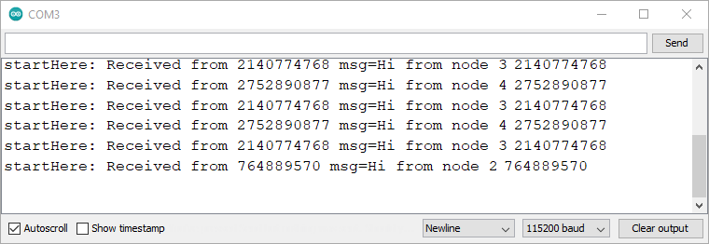

You should also see other messages when there are changes on the mesh: when a board leaves or joins the network.

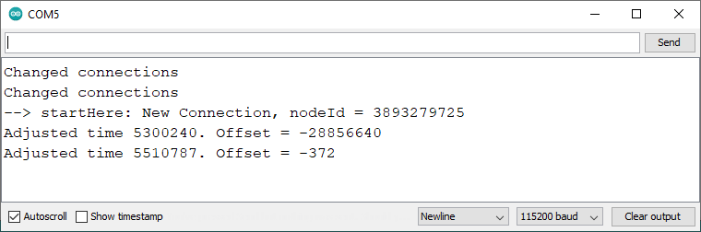

**Exchange Sensor Readings using ESP-MESH**

In this next example, we’ll exchange sensor readings between 4 boards (you can use a different number of boards). Every board receives the other boards’ readings.

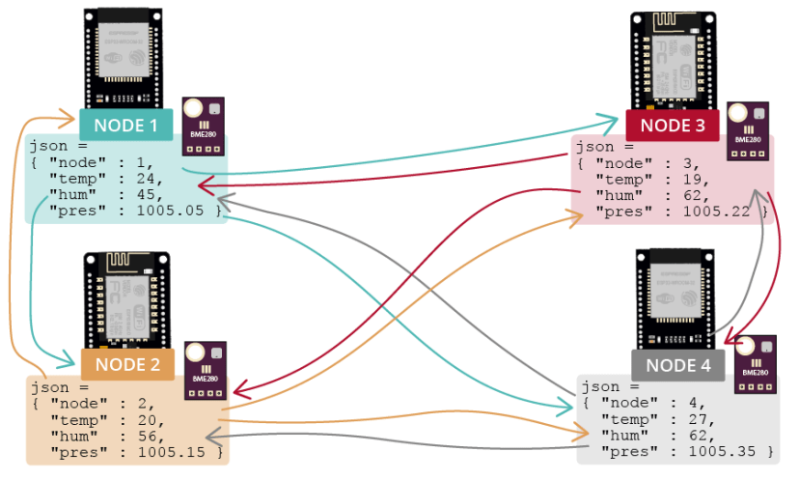

As an example, we’ll exchange sensor readings from a [BME280 sensor](https://makeradvisor.com/tools/bme280-sensor-module/), but you can use any other sensor.

**Parts Required**

Here’s the parts required for this example:

* 4x ESP boards ([ESP32](https://makeradvisor.com/esp32-development-boards-review-comparison/) or [ESP8266](https://makeradvisor.com/best-esp8266-wi-fi-development-board/))
* 4x [BME280](https://makeradvisor.com/tools/bme280-sensor-module/)
* [Breadboard](https://makeradvisor.com/tools/mb-102-solderless-breadboard-830-points/)
* [Jumper wires](https://makeradvisor.com/tools/jumper-wires-kit-120-pieces/)

**Arduino_JSON library**

In this example, we’ll exchange the sensor readings in JSON format. To make it easier to handle JSON variables, we’ll use the [Arduino_JSON library](https://github.com/arduino-libraries/Arduino_JSON).

You can install this library in the Arduino IDE Library Manager. Just go to **Sketch**> **Include Library** > **Manage Libraries** and search for the library name as follows:

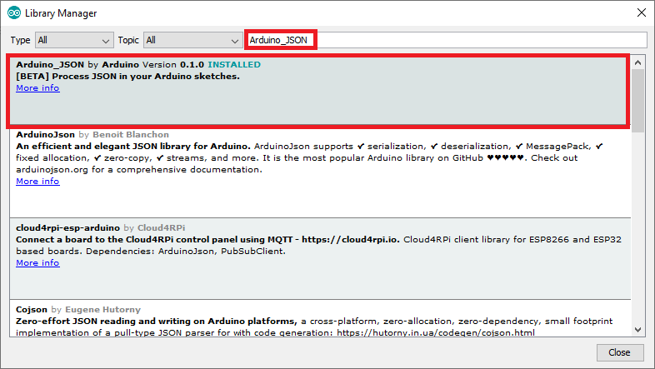

If you’re using VS Code with PlatformIO, include the libraries in the platformio.ini file as follows:

**ESP32**

monitor_speed = 115200

lib_deps = painlessmesh/painlessMesh @ ^1.4.5

ArduinoJson

arduinoUnity

AsyncTCP

TaskScheduler

adafruit/Adafruit Unified Sensor @ ^1.1.4

adafruit/Adafruit BME280 Library @ ^2.1.2

arduino-libraries/Arduino_JSON @ ^0.1.0

**ESP8266**

monitor_speed = 115200

lib_deps = painlessmesh/painlessMesh @ ^1.4.5

ArduinoJson

TaskScheduler

ESPAsyncTCP

adafruit/Adafruit Unified Sensor @ ^1.1.4

adafruit/Adafruit BME280 Library @ ^2.1.2

arduino-libraries/Arduino_JSON @ ^0.1.0

**Circuit Diagram**

Wire the BME280 sensor to the ESP32 or ESP8266 default I2C pins as shown in the following schematic diagrams.

**ESP32**

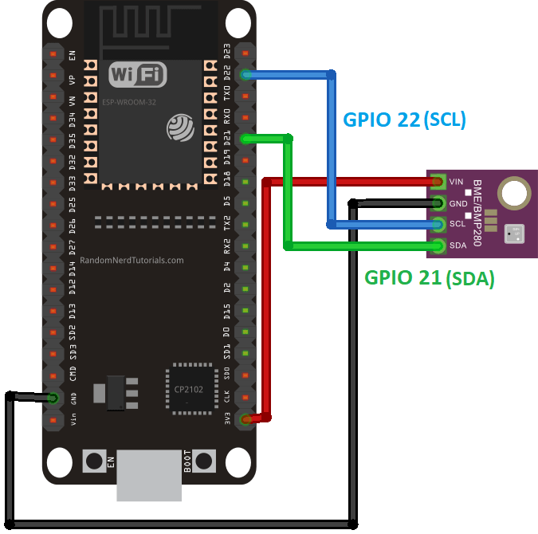

Recommended reading: [ESP32 with BME280 Sensor using Arduino IDE (Pressure, Temperature, Humidity)](https://randomnerdtutorials.com/esp32-bme280-arduino-ide-pressure-temperature-humidity/)

**ESP8266 NodeMCU**

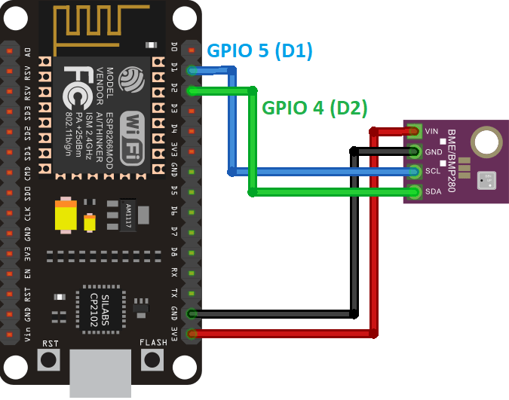

Recommended reading: [ESP8266 with BME280 using Arduino IDE (Pressure, Temperature, Humidity)](https://randomnerdtutorials.com/esp8266-bme280-arduino-ide/)

**Code – ESP-MESH Broadcast Sensor Readings**

Upload the following code to each of your boards. This code reads and broadcasts the current temperature, humidity and pressure readings to all boards on the mesh network. The readings are sent as a JSON string that also contains the node number to identify the sender board.

/*

Rui Santos

Complete project details at https://RandomNerdTutorials.com/esp-mesh-esp32-esp8266-painlessmesh/

Permission is hereby granted, free of charge, to any person obtaining a copy

of this software and associated documentation files.

The above copyright notice and this permission notice shall be included in all

copies or substantial portions of the Software.

*/

#include <Adafruit_Sensor.h>

#include <Adafruit_BME280.h>

#include "painlessMesh.h"

#include <Arduino_JSON.h>

// MESH Details

#define MESH_PREFIX "RNTMESH" //name for your MESH

#define MESH_PASSWORD "MESHpassword" //password for your MESH

#define MESH_PORT 5555 //default port

//BME object on the default I2C pins

Adafruit_BME280 bme;

//Number for this node

int nodeNumber = 2;

//String to send to other nodes with sensor readings

String readings;

Scheduler userScheduler; // to control your personal task

painlessMesh mesh;

// User stub

void sendMessage() ; // Prototype so PlatformIO doesn't complain

String getReadings(); // Prototype for sending sensor readings

//Create tasks: to send messages and get readings;

Task taskSendMessage(TASK_SECOND * 5 , TASK_FOREVER, &sendMessage);

String getReadings () {

JSONVar jsonReadings;

jsonReadings["node"] = nodeNumber;

jsonReadings["temp"] = bme.readTemperature();

jsonReadings["hum"] = bme.readHumidity();

jsonReadings["pres"] = bme.readPressure()/100.0F;

readings = JSON.stringify(jsonReadings);

return readings;

}

void sendMessage () {

String msg = getReadings();

mesh.sendBroadcast(msg);

}

//Init BME280

void initBME(){

if (!bme.begin(0x76)) {

Serial.println("Could not find a valid BME280 sensor, check wiring!");

while (1);

}

}

// Needed for painless library

void receivedCallback( uint32_t from, String &msg ) {

Serial.printf("Received from %u msg=%s\n", from, msg.c_str());

JSONVar myObject = JSON.parse(msg.c_str());

int node = myObject["node"];

double temp = myObject["temp"];

double hum = myObject["hum"];

double pres = myObject["pres"];

Serial.print("Node: ");

Serial.println(node);

Serial.print("Temperature: ");

Serial.print(temp);

Serial.println(" C");

Serial.print("Humidity: ");

Serial.print(hum);

Serial.println(" %");

Serial.print("Pressure: ");

Serial.print(pres);

Serial.println(" hpa");

}

void newConnectionCallback(uint32_t nodeId) {

Serial.printf("New Connection, nodeId = %u\n", nodeId);

}

void changedConnectionCallback() {

Serial.printf("Changed connections\n");

}

void nodeTimeAdjustedCallback(int32_t offset) {

Serial.printf("Adjusted time %u. Offset = %d\n", mesh.getNodeTime(),offset);

}

void setup() {

Serial.begin(115200);

initBME();

//mesh.setDebugMsgTypes( ERROR | MESH_STATUS | CONNECTION | SYNC | COMMUNICATION | GENERAL | MSG_TYPES | REMOTE ); // all types on

mesh.setDebugMsgTypes( ERROR | STARTUP ); // set before init() so that you can see startup messages

mesh.init( MESH_PREFIX, MESH_PASSWORD, &userScheduler, MESH_PORT );

mesh.onReceive(&receivedCallback);

mesh.onNewConnection(&newConnectionCallback);

mesh.onChangedConnections(&changedConnectionCallback);

mesh.onNodeTimeAdjusted(&nodeTimeAdjustedCallback);

userScheduler.addTask(taskSendMessage);

taskSendMessage.enable();

}

void loop() {

// it will run the user scheduler as well

mesh.update();

}

[View raw code](https://github.com/RuiSantosdotme/Random-Nerd-Tutorials/raw/master/Projects/ESP/ESP_Mesh/ESP_Mesh_Broadcast_Sensor_Readings.ino)

The code is compatible with both the ESP32 and ESP8266 boards.

**How the Code Works**

Continue reading this section to learn how the code works.

**Libraries**

Start by including the required libraries: the Adafruit_Sensor and Adafruit_BME280 to interface with the BME280 sensor; the painlessMesh library to handle the mesh network and the Arduino_JSON to create and handle JSON strings easily.

#include <Adafruit_Sensor.h>

#include <Adafruit_BME280.h>

#include "painlessMesh.h"

#include <Arduino_JSON.h>

**Mesh details**

Insert the mesh details in the following lines.

#define MESH_PREFIX "RNTMESH" //name for your MESH

#define MESH_PASSWORD "MESHpassword" //password for your MESH

#define MESH_PORT 5555 //default port

The MESH_PREFIX refers to the name of the mesh. You can change it to whatever you like. The MESH_PASSWORD, as the name suggests is the mesh password. You can change it to whatever you like. All nodes in the mesh should use the same MESH_PREFIX and MESH_PASSWORD.

The MESH_PORT refers to the the TCP port that you want the mesh server to run on. The default is 5555.

**BME280**

Create an Adafruit_BME280 object called bme on the default ESP32 or ESP8266 pins.

Adafruit_BME280 bme;

In the nodeNumber variable insert the node number for your board. It must be a different number for each board.

int nodeNumber = 2;

The readings variable will be used to save the readings to be sent to the other boards.

String readings;

**Scheduler**

The following line creates a new Scheduler called userScheduler.

Scheduler userScheduler; // to control your personal task

**painlessMesh**

Create a painlessMesh object called mesh to handle the mesh network.

**Create tasks**

Create a task called taskSendMessage responsible for calling the sendMessage() function every five seconds as long as the program is running.

Task taskSendMessage(TASK_SECOND * 5 , TASK_FOREVER, &sendMessage);

**getReadings()**

The getReadings() function gets temperature, humidity and pressure readings from the BME280 sensor and concatenates all the information, including the node number on a JSON variable called jsonReadings.

JSONVar jsonReadings;

jsonReadings["node"] = nodeNumber;

jsonReadings["temp"] = bme.readTemperature();

jsonReadings["hum"] = bme.readHumidity();

jsonReadings["pres"] = bme.readPressure()/100.0F;

The following line shows the structure of the jsonReadings variable with arbitrary values.

{

"node":2,

"temperature":24.51,

"humidity":52.01,

"pressure":1005.21

}

The jsonReadings variable is then converted into a JSON string using the stringify() method and saved on the readings variable.

readings = JSON.stringify(jsonReadings);

This variable is then returned by the function.

return readings;

**Send a Message to the Mesh**

The sendMessage() function sends the JSON string with the readings and node number (getReadings()) to all nodes in the network (broadcast).

void sendMessage () {

String msg = getReadings();

mesh.sendBroadcast(msg);

}

**Init BME280 sensor**

The initBME() function initializes the BME280 sensor.

void initBME(){

if (!bme.begin(0x76)) {

Serial.println("Could not find a valid BME280 sensor, check wiring!");

while (1);

}

}

**Mesh Callback Functions**

Next, several callback functions are created that will be called when some event on the mesh happens.

The receivedCallback() function prints the message sender (from) and the content of the message (msg.c_str()).

void receivedCallback( uint32_t from, String &msg ) {

Serial.printf("startHere: Received from %u msg=%s\n", from, msg.c_str());

The message comes in JSON format, so, we can access the variables as follows:

JSONVar myObject = JSON.parse(msg.c_str());

int node = myObject["node"];

double temp = myObject["temp"];

double hum = myObject["hum"];

double pres = myObject["pres"];

Finally, print all the information on the Serial Monitor.

Serial.print("Node: ");

Serial.println(node);

Serial.print("Temperature: ");

Serial.print(temp);

Serial.println(" C");

Serial.print("Humidity: ");

Serial.print(hum);

Serial.println(" %");

Serial.print("Pressure: ");

Serial.print(pres);

Serial.println(" hpa");

The newConnectionCallback() function runs whenever a new node joins the network. This function simply prints the chip ID of the new node. You can modify the function to do any other task.

void newConnectionCallback(uint32_t nodeId) {

Serial.printf("--> startHere: New Connection, nodeId = %u\n", nodeId);

}

The changedConnectionCallback() function runs whenever a connection changes on the network (when a node joins or leaves the network).

void changedConnectionCallback() {

Serial.printf("Changed connections\n");

}

The nodeTimeAdjustedCallback() function runs when the network adjusts the time, so that all nodes are synchronized. It prints the offset.

void nodeTimeAdjustedCallback(int32_t offset) {

Serial.printf("Adjusted time %u. Offset = %d\n", mesh.getNodeTime(),offset);

}

**setup()**

In the setup(), initialize the serial monitor.

void setup() {

Serial.begin(115200);

Call the initBME() function to initialize the BME280 sensor.

initBME();

Choose the desired debug message types:

//mesh.setDebugMsgTypes( ERROR | MESH_STATUS | CONNECTION | SYNC | COMMUNICATION | GENERAL | MSG_TYPES | REMOTE ); // all types on

mesh.setDebugMsgTypes( ERROR | STARTUP ); // set before init() so that you can see startup messages

Initialize the mesh with the details defined earlier.

mesh.init(MESH_PREFIX, MESH_PASSWORD, &userScheduler, MESH_PORT);

Assign all the callback functions to their corresponding events.

mesh.onReceive(&receivedCallback);

mesh.onNewConnection(&newConnectionCallback);

mesh.onChangedConnections(&changedConnectionCallback);

mesh.onNodeTimeAdjusted(&nodeTimeAdjustedCallback);

Finally, add the taskSendMessage function to the userScheduler. The scheduler is responsible for handling and running the tasks at the right time.

userScheduler.addTask(taskSendMessage);

Finally, enable the taskSendMessage, so that the program starts sending the messages to the mesh.

taskSendMessage.enable();

To keep the mesh running, add mesh.update() to the loop().

void loop() {

// it will run the user scheduler as well

mesh.update();

}

**Demonstration**

After uploading the code to all your boards (each board with a different node number), you should see that each board is receiving the other boards’ messages.

The following screenshot shows the messages received by node 1. It receives the sensor readings from node 2, 3 and 4.

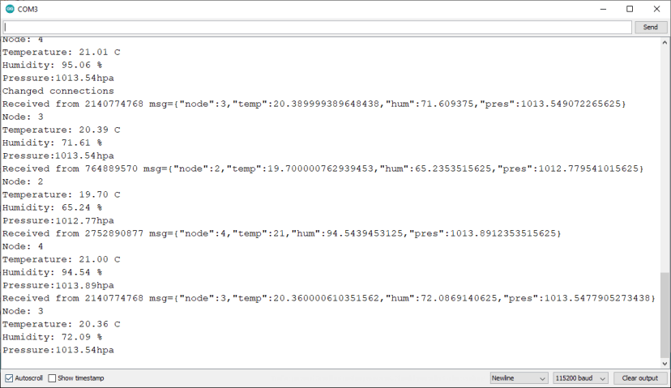

**Wrapping Up**

We hope you liked this quick introduction to the ESP-MESH networking protocol. You can take a look at the [painlessMesh library](https://gitlab.com/painlessMesh/painlessMesh) for more examples.

We intend to create more tutorials about this subject on a near future. So, write your suggestions on the comments’ section.

You may also like the following articles:

* [Getting Started with ESP-NOW (ESP32 with Arduino IDE)](https://randomnerdtutorials.com/esp-now-esp32-arduino-ide/)
* [Getting Started with ESP-NOW (ESP8266 NodeMCU with Arduino IDE)](https://randomnerdtutorials.com/esp-now-esp8266-nodemcu-arduino-ide/)
* [ESP32: ESP-NOW Web Server Sensor Dashboard (ESP-NOW + Wi-Fi)](https://randomnerdtutorials.com/esp32-esp-now-wi-fi-web-server/)

Learn more about the ESP32 and ESP8266 with our resources:

* [Learn ESP32 with Arduino IDE](https://randomnerdtutorials.com/learn-esp32-with-arduino-ide/)
* [Home Automation using ESP8266](https://randomnerdtutorials.com/home-automation-using-esp8266/)
* [More ESP32 Projects and Tutorials](https://randomnerdtutorials.com/projects-esp32/)
* [More ESP8266 Projects and Tutorials](https://randomnerdtutorials.com/projects-esp8266/)

Thanks for reading.

**Introduction**

ESP-MESH is a networking protocol built on the top of the Wi-Fi protocol. ESP-MESH allows numerous devices (generally referred as nodes) spread over a large physical area to be interconnected under a single WLAN. ESP-MESH allows multiple nodes to communicate with each other under a single wireless local area network. It is supported on the ESP32 and ESP8266 boards. In this project, controlling appliances using NodeMCU (ESP8266) with ESP-MESH is explained.

**What is Mesh Networking?**  
Mesh networking is a local network topology in which nodes are directly, dynamically and non-hierarchically connected to each other and cooperates with one another to efficiently route the data from/to clients. Mesh network supports auto-networking meaning when the user setup a mesh network, any node can scan access point and can connect easily. 87 nodes can be connected with a single router.

**ESP - MESH Network Architecture**  
In this, the nodes don’t need to connect to a central node. Nodes are responsible for relaying each others transmissions. This allows multiple devices to spread over a large physical area. The nodes can self-organize and dynamically talk to each other to ensure that the packet reaches its final node destination. If any node is removed from the network, it is able to self-organize to make sure that the packets reach their destination. ESP-MESH network has much greater coverage area as nodes can achieve inter-connectivity without needing to be in range of the central node. Here, stations are NodeMCU's.

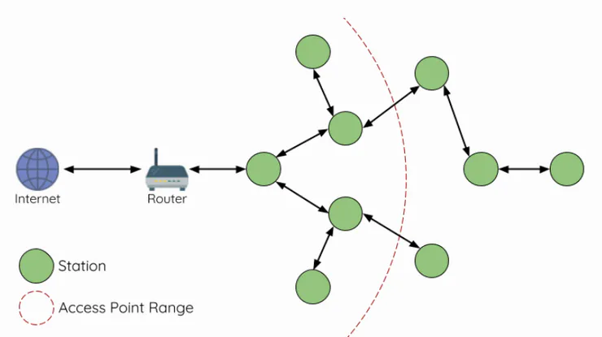

**Step 1: Arduino IDE**

Firstly, install all the required libraries for Mesh n/w. In this, 5 libraies are required namely DHT, painlessMesh, ArduinoJson, TaskScheduler and ESPAsyncTCP.

To install the libraries. Open Arduino IDE > go to Tools > Manage Libraries

1. Install DHT sensor library

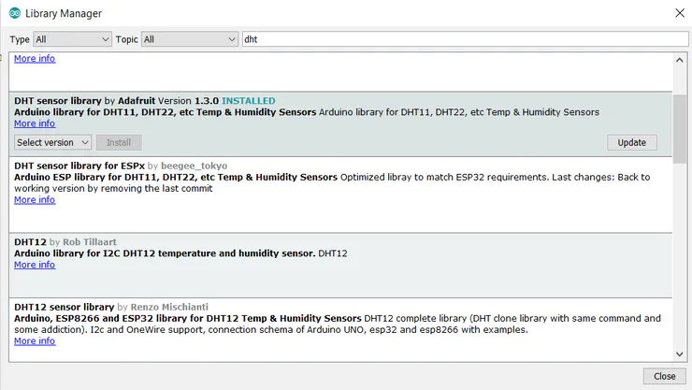

2. Install painlessmesh library

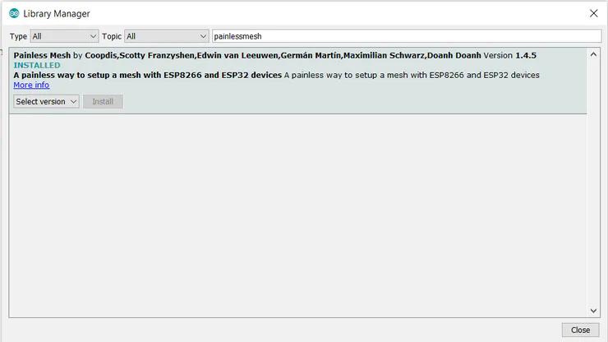

3. Install ArduinoJson library

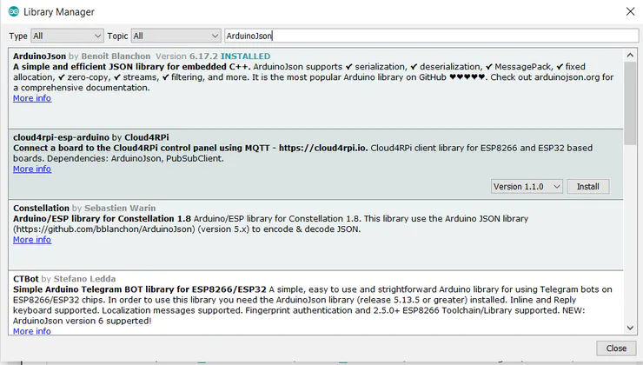

4. Install TaskScheduler library

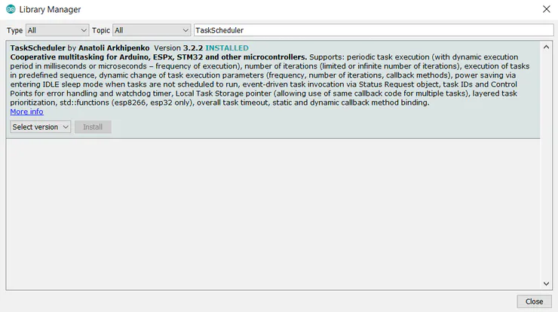

5. Install ESPAsyncTCP library

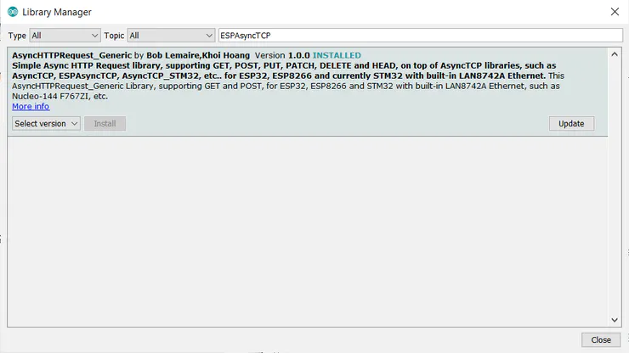

After installing all the libraries next step is to setup ESP-8266 for Arduino IDE

**Step 2: ESP8266 Setup**

1. Open the Arduino IDE and go to File > Preferences

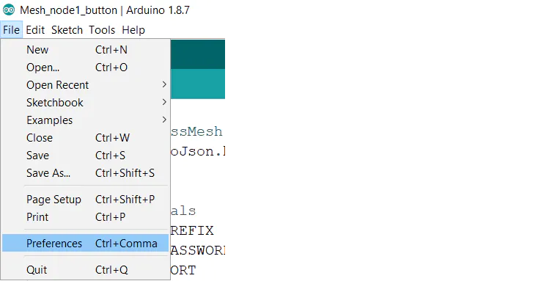

2. For adding ESP8266 Board manager use the URL as shown below :  
http://arduino.esp8266.com/stable/package_esp8266com_index.json

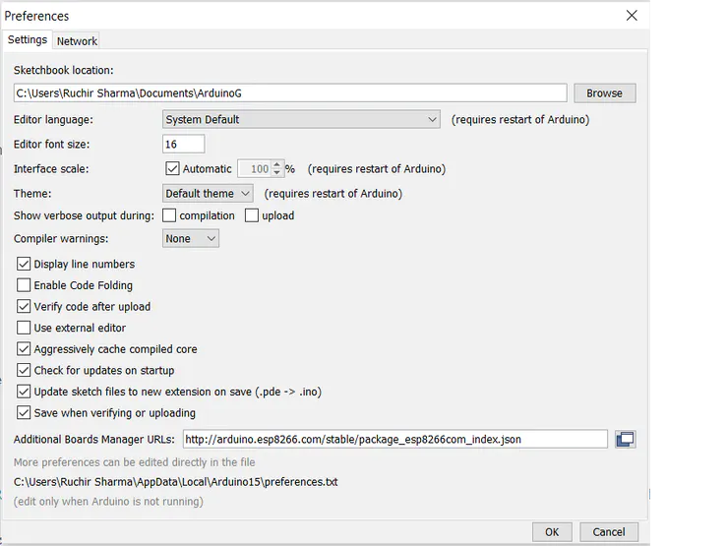

3. For selecting the board go to Tools > Board > Board Manager and search for esp8266.

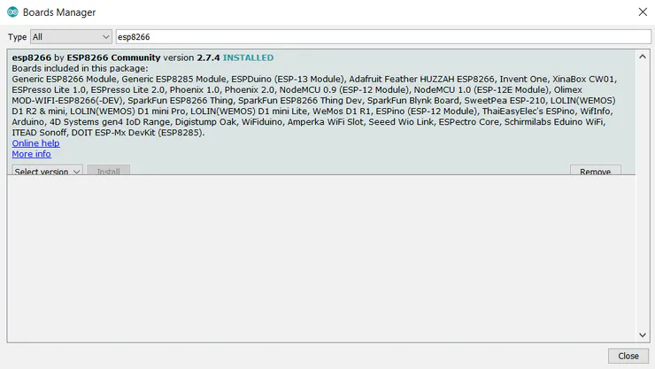

4. Once installed you will able to see the NodeMCU board in Tools > Board

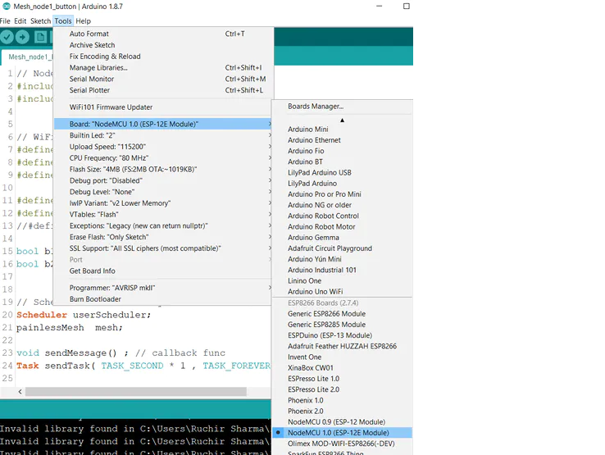

**Step 3: Different Nodes Using NodeMCU8266**

**Node 1**  
It has a DHT11 sensor and 1 LED. It will send temperature and humidity data to Node2 and Node3.

Connections

DHT11 ==> NodeMCU

* Gnd ==> Gnd
* Vcc ==> 3V3
* Data ==> D4

YellowLED ==> NodeMCU

* +VE ==> D5
* -VE ==> GND

**Node 2**  
It has 1 push button to control LED on the 1st Node and 1 LED to know data is sent.

Connections

Pushbutton ==> NodeMCU

* +VE ==> D4
* -VE ==> Gnd

GreenLED ==> NodeMCU

* +VE ==> D5
* -VE ==> Gnd

**Node 3**  
It has one LED and it receive button state, temperature and humidity data from other nodes. The LED will glow if temperature or Humidity is more than certain threshold.

Connections

RedLED ==> NodeMCU

* +VE ==> D5
* -VE ==> Gnd

**Step 4: Program**

#define MESH_PREFIX "Meshname"  
#define MESH_PASSWORD "meshpassword"

#define MESH_PORT 5555 // default port

* The MESH_PREFIX is the name of the mesh. You can change it to whatever you like.
* The MESH_PASSWORD is the mesh password. You can change it to whatever you like.
* The MESH_PORT is the TCP port that you want the mesh server to run on. The default is 5555.

Note:- All nodes in the mesh should use the same MESH_PREFIX and MESH_PASSWORD.

Scheduler userScheduler;

This line creates a new Scheduler called userScheduler

painlessMesh mesh;

Create a painlessMesh object called mesh to handle the mesh network

Task taskSendMessage( TASK_SECOND * 1 , TASK_FOREVER, &sendMessage );

Create a task called taskSendMessage responsible for calling the sendMessage() function every second as long as the program is running.

The sendMessage() function sends the JSON string with the readings to all nodes in the network (broadcast).

DynamicJsonDocument doc(1024);

For sending values to the network using JSON. DynamicJsonDocument is used. We define an instance to use this with the size of the document.

doc["TEMP"] = t;<br>doc["HUM"] = h;

Then, store the values in two different doc variables as shown above.

String msg ;<br>serializeJson(doc, msg);

This doc data is then converted into a string using serializeJson() function.

mesh.sendBroadcast( msg );<br>taskSendMessage.setInterval((TASK_SECOND * 1, TASK_SECOND * 10));

After that, mesh.sendBroadcast() is used to send this message in the mesh network after a fixed interval.

void receivedCallback( uint32_t from, String &msg ) {<br>String json;

DynamicJsonDocument doc(1024);

json = msg.c_str();

DeserializationError error = deserializeJson(doc, json);

Whenever there will be a message in the network, receivedCallback() comes in the action. The receivedCallback() function prints the message sender (from) and the content of the message using msg.c_str(). As data is serialized in sending function, it must be de-serialized while receiving.

void newConnectionCallback(uint32_t nodeId) {<br>Serial.printf("--> startHere: New Connection, nodeId = %u\n", nodeId);

}

The newConnectionCallback() runs whenever a new node joins the network. This function prints the chip ID of the new node.

void changedConnectionCallback() {<br>Serial.printf("Changed connections\n");

}

The changedConnectionCallback() runs whenever a connection changes on the network that is when a node joins or leaves the network.

void nodeTimeAdjustedCallback(int32_t offset) {<br>Serial.printf("Adjusted time %u. Offset = %d\n", mesh.getNodeTime(), offset);

}

The nodeTimeAdjustedCallback() runs when the network adjusts the time, so that all nodes are synchronized.

mesh.setDebugMsgTypes( ERROR | STARTUP );<br>mesh.init( MESH_PREFIX, MESH_PASSWORD, &userScheduler, MESH_PORT );

* Here, debug function is used to get any error occurred while making a connection with the nodes.
* Initialize the mesh bypassing the SSID, password, port number and scheduler address

mesh.onReceive(&receivedCallback);

When a new node make connection this callback is called.

mesh.onNewConnection(&newConnectionCallback);

When there is a change in mesh topology this callback is called.

mesh.onChangedConnections(&changedConnectionCallback);

Local time is adjusted to synchronize it with mesh time.

mesh.onNodeTimeAdjusted(&nodeTimeAdjustedCallback);

In this, scheduler executes the task and send the appropriate message to nodes.

userScheduler.addTask( taskSendMessage );

The scheduler is responsible for handling and running the tasks at the right time.

taskSendMessage.enable();

Enable the taskSendMessage to start sending the messages to the mesh.

In Arduino IDE,

* first select the boardGo to Tools > Board > NodeMCU
* To upload the code to NodeMCU's select the port  
  Go to Tools > Port > select the port

**Attachments**

* [**led_node3.ino**](https://content.instructables.com/F0C/N562/KM4VS3ZP/F0CN562KM4VS3ZP.ino)

[Download](https://content.instructables.com/F0C/N562/KM4VS3ZP/F0CN562KM4VS3ZP.ino)

* [**pushbuttonandled_node2.ino**](https://content.instructables.com/F0E/4T6S/KM4VS3ZQ/F0E4T6SKM4VS3ZQ.ino)

[Download](https://content.instructables.com/F0E/4T6S/KM4VS3ZQ/F0E4T6SKM4VS3ZQ.ino)

* [**tempandled_node1.ino**](https://content.instructables.com/FCN/3THQ/KM4VS3ZR/FCN3THQKM4VS3ZR.ino)

[Download](https://content.instructables.com/FCN/3THQ/KM4VS3ZR/FCN3THQKM4VS3ZR.ino)

**Step 5: Circuit Diagram**

[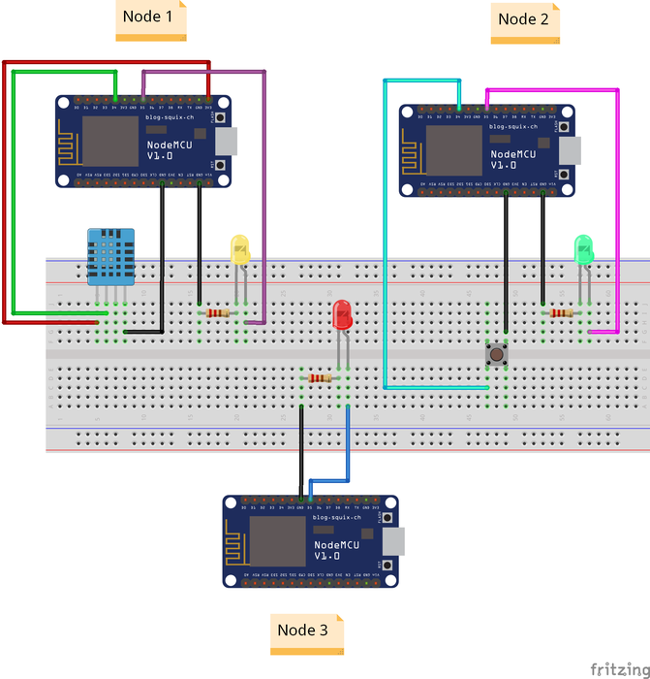](https://content.instructables.com/FK5/PEJZ/KM4VS3ZF/FK5PEJZKM4VS3ZF.png?auto=webp&frame=1&width=1024&height=1024&fit=bounds&md=ab0c3f8080681e5ec6fa572e2056c839)

**Step 6: Result**

Note:- Putty is used to see the serial output as in Arduino IDE we can only open one port at a time.

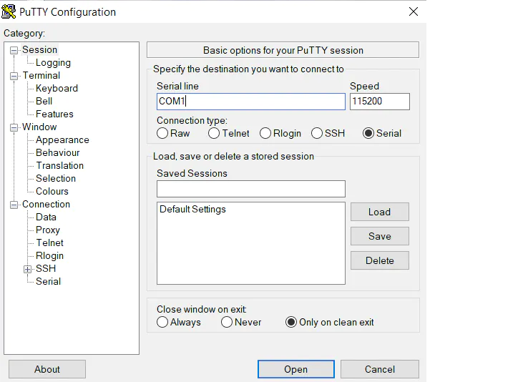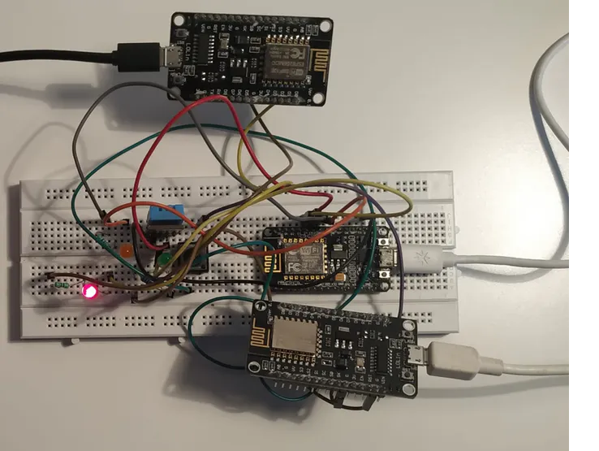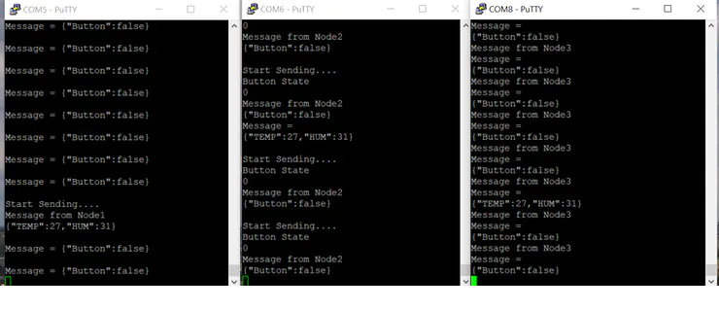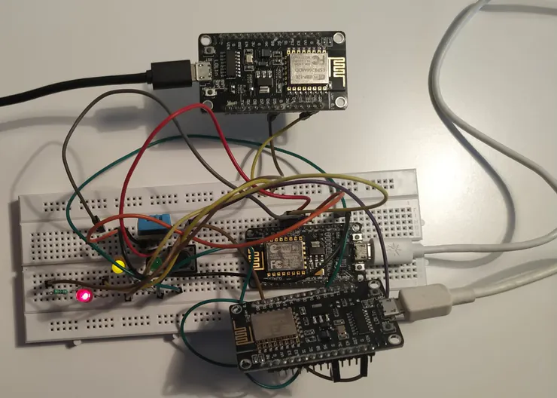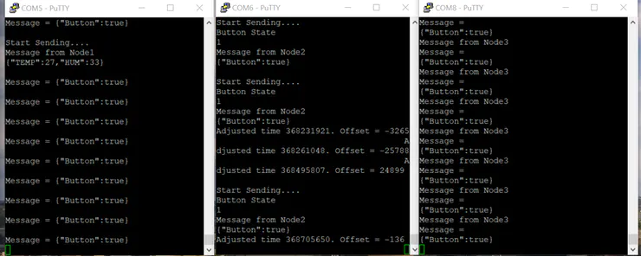

**How to Configure an ESP Mesh Network using Arduino IDE – Communicate among and between ESP32, ESP8266, and NodeMCU**

**Published**  January 18, 2021  8

[](https://circuitdigest.com/microcontroller-projects/how-to-configure-an-esp-mesh-network-using-arduino-ide-to-communicate-between-esp32-esp8266-and-nodemcu)[Debashis Das](https://circuitdigest.com/users/debashis-das)  
Author

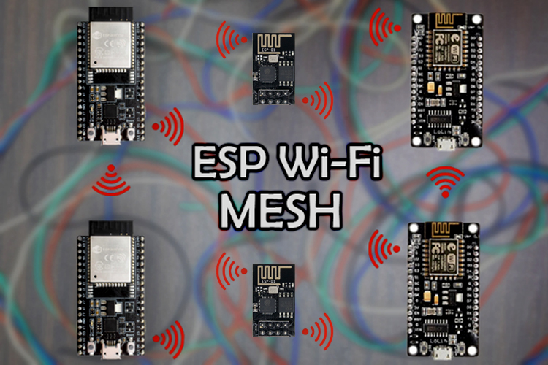

ESP Wi-Fi MESH Network

Internet of Things (IoT) has seen exponential growth over the past couple of years. A new study from International Data Corporation (IDC) estimates that there will be almost 42 billion connected devices within the year 2025, generating over 80 zettabytes (ZB) of data. As the number of IoT devices grows; the amount of data grows, along with that, grows the need for superior network instruments; which can support this load.

However, if we consider a common host (like a generic router), it can connect to a limited number of nodes, less than 32 to be exact. And with an increasing number of IoT devices that could be in our home or industry, this is not sufficient. Currently, there are two solutions to this problem: The first one is to use a **Mesh Router**that can handle a lot more connections compared to a generic one, or we can use a network protocol known as **Mesh Network**.

So in this article, we are going to make a simple **ESP Mesh network** setup that consists of four ESP devices that will communicate with each other with the help of a **Wi-Fi Mesh Network**. And finally, we are going to connect a single ESP to our laptop in order to get data from all the four sensors on the network. Note that we will be using both the ESP32 and ESP8266 boards in this tutorial so that you can create an **ESP8266 Mesh network** or **ESP32 Mesh network** using the same method.

**What is ESP-MESH and How it Work?**

According to the official documentation of ESP-MESH, it is a self-organizing and self-healing network meaning the network can be built and maintained autonomously. For more information, visit the [ESP-MESH official documentation](https://docs.espressif.com/projects/esp-idf/en/latest/esp32/api-guides/mesh.html).

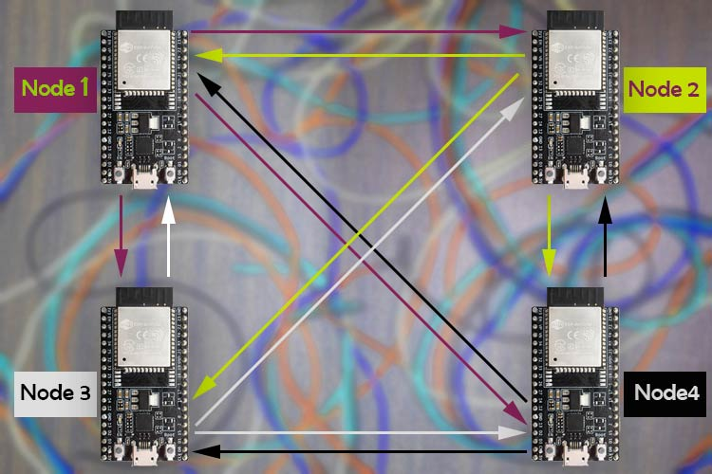

A mesh network is a group of connected devices on a network that is acting as a single network. **ESP-Mesh** is quite different from a traditional mesh setup. In an ESP-Mesh, the node or a single device can connect to its neighbor simultaneously. One single node can connect to multiple nodes and they can relay data from one node to another. This process is not only efficient but it’s also redundant. If one of any nodes fails; the data from other nodes can reach its destination without a problem. This also opens possibilities of achieving interconnection without needing a central node, which significantly extends the coverage area of the mesh-network. With these features, this network is less prone to conjunction because the total number of nodes in the network is not limited by a single central node.

For the sake of simplicity, we have decided to use four ESP modules; but if you are building this network, you can use as many ESPdevices as you can. To build the mesh network, we are going to use the **painlessMesh library** for Arduino which has support for both the [ESP8266](https://circuitdigest.com/tags/esp8266) and the [ESP32](https://circuitdigest.com/tags/esp32) modules.

**Components Required to build the Mesh Network with ESP**

The list of components required for this project is given below.  To build this project, I have used components that are pretty generic and you can find them in your local hobby store.

* NodeMCU(ESP8266) - 2
* ESP32 Dev Board - 2
* BMP280 Sensor - 2
* DHT22 Sensor - 1
* DS18B20 Sensor - 1
* Breadboard
* USB Cable (for power and data)

**ESP Wi-Fi Mesh - Circuit Diagram**

The schematic shown below is used to construct the hardware section for**ESP8266 and ESP32 based Wi-Fi Mesh Network**.

[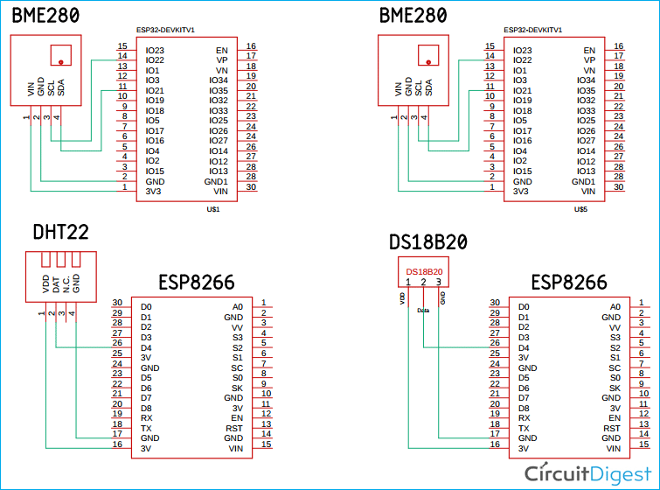](https://circuitdigest.com/fullimage?i=circuitdiagram_mic/ESP-Wi-Fi-Mesh-Circuit-Diagram.png)

For this circuit, we have connected two [BME280 sensors](https://circuitdigest.com/microcontroller-projects/how-to-interface-bmp280-pressure-sensor-with-arduino) with the [ESP32 board](https://circuitdigest.com/esp32-projects), we have connected a DHT22 sensor to one of the [ESP8266 board](https://circuitdigest.com/esp8266-projects), and we have connected the DS18B20 sensor with another ESP8266 board. We have previously used all these sensors in different projects individually. Here, we will be using them on different NodeMCU/ESP32 boards and then connect them all through an **ESP Mesh network.**An image for the hardware setup is shown below.

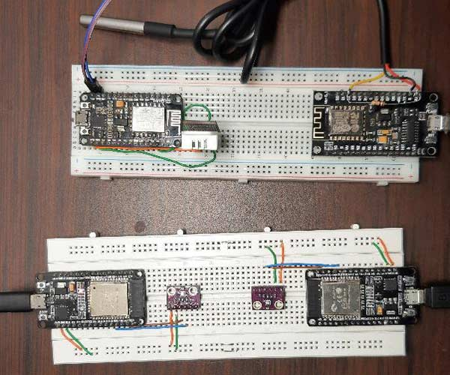

**Programming the ESP8266 and ESP32 for Mesh Networking**

For this article, we are going to use Arduino IDE to program the ESP32 and the ESP8266 boards. Here, we will use the **Painless Mesh library** to construct our mesh network. To install the library, go to**Sketch->Include Library->Manage Libraries** and search for the **painlessMesh. O**nce done, just click install and the library will be installed in the Arduino IDE. As you can see in the image below, once you click Install, this library asks you to install additional dependencies. You need to install those for the library to work.

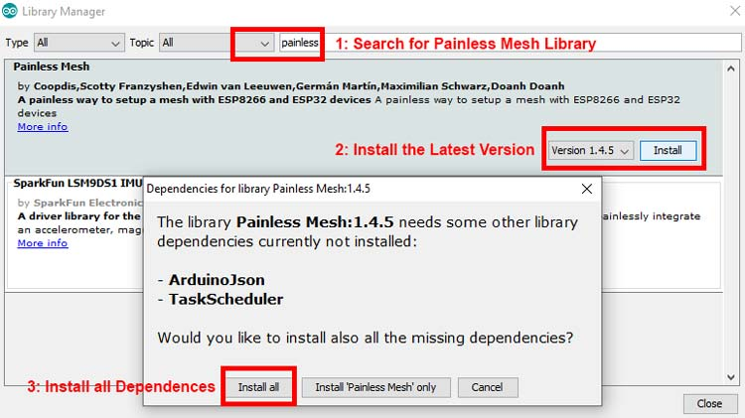

As you already know from the hardware section, we are going to use a DS18B20 Sensor, A DHT22 sensor, and two BME 280 sensors. We need to install all of those, and it can be simply done with the board manager method.

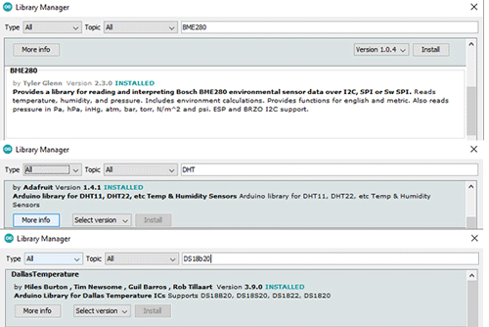

You can also download these libraries from the link given below. Once we have downloaded and installed all the required libraries, we can move on to creating our code.

* [Download Painless Mesh Library](https://github.com/gmag11/painlessMesh)
* [Download DHT Sensor Library](https://github.com/adafruit/DHT-sensor-library)
* [Download BME280 Library](https://github.com/finitespace/BME280)
* [Download DallasTemperature Library](https://github.com/milesburton/Arduino-Temperature-Control-Library)

**Note:**The code explanation you see next is the code used in all four boards. We designed the code so that we can tweak it a little and we can upload it to any of our ESP boards despite the fact that it’s an ESP32 or an ESP8266 board.

**Upload the Code to ESP32 Board in which a BME280 Sensor is Connected:**

As you can see in the hardware schematic, we have connected a BME280 sensor. For that, you need to uncomment the **macro for the BME_280** sensor and give it a unique Node Name. In our case, we have used **Node_1** and **Node_2** for our two ESP32 boards to which we have attached the BME280 sensor

#define BME_280

//#define DHT22

//#define DS18B20

//#define ENABLE_LOG

String nodeName = "NODE_1";

**Upload the Code to ESP8266 Board in Which A DHT Sensor is Connected:**

In one of our ESP8266 boards, we have a DHT22 sensor and in another one, we have a DS18B20 sensor. To upload the code to the DHT22 board, we have to follow the same process.  First, we uncomment the macro for DHT22 and then comment out the macro for BME280 and upload the code to the board to which we have connected the DHT 22 sensor.

//#define BME_280

#define DHT22

//#define DS18B20

//#define ENABLE_LOG

String nodeName = "NODE_3";

**Upload the Code to ESP8266 Board in Which A DS18B20 Sensor is Connected:**

The process stays exactly the same for this board also. We uncomment the macro for the DS18B20 sensor and we comment on other macros.

//#define BME_280

//#define DHT22

#define DS18B20

//#define ENABLE_LOG

String nodeName = "NODE_3";

Finally, to enable or disable other log statements, you can uncomment the ENABLE_LOG macro. Now that we have an understanding of how the code works, we can move further and explain the code.

We will start our code by including the **painlessMesh**library and the **Arduino_JSON**library.

#include <painlessMesh.h>

#include <Arduino_JSON.h>

Next, we define some macros which we will use to enable or disable the parts of our code. This is needed because not all the nodes use the same sensor type and. So for including or excluding parts of our code, we can fit four different codes into a single file.

//#define BME_280

#define DHT22

//#define DS18B20

//#define ENABLE_LOG

Next, we define a String type variable nodeName. This will be used to uniquely identify the nodes in the network. Along with that we also define the float type variable to store the temperature, humidity, and barometric pressure data.

String nodeName = "NODE_4"; // Name needs to be unique

float temp(NAN), hum(NAN), pres(NAN);

From this step onwards, we will be using **#ifdef** and **#endif**macros to include or exclude parts of our code. The first section of the code is for the BME280 sensor. As said earlier, we will start by **#ifdef BME_280** statement. Next, we define all the required libraries for the BME280 sensor. The BME sensor also uses the wire library, so we define that as well. Next, we make a **BME280I2C**object **bme.**Next, using the **scope resolution operator,**we access the variable of the class and we finish that off with the endif statement.

#ifdef BME_280

#include <BME280I2C.h>

#include <Wire.h>

BME280I2C bme;

BME280::TempUnit tempUnit(BME280::TempUnit_Celsius);

BME280::PresUnit presUnit(BME280::PresUnit_Pa);

#endif

We do the same for the DHT library too. We start with the **#ifdef DHT22**statement followed by including the **DHT.h**library. Next, we define the PIN for DHT, and add a prototype for DHT22. Thereafter, we create an object by passing the above-defined statements. And we finish off with the **#endif**statement.

#ifdef DHT22

#include "DHT.h"

#define DHTPIN 4

#define DHTTYPE DHT22

DHT dht(DHTPIN, DHTTYPE);

#endif

We also do the same for the DS18B20 sensor.  We start with the **#ifdef DS18B20**statement.

As the DS18B20 sensor requires **OneWire**library,  we include that along with the **DallasTemperature**library. Next, we define the pin for the sensor and create an OneWire object by passing the pin variable. Next, we pass the address of the OneWire object to the  DallasTemperature object by making a new DallasTemperature object.

#ifdef DS18B20

#include <OneWire.h>

#include <DallasTemperature.h>

const int oneWireBus = 4;

OneWire oneWire(oneWireBus);

DallasTemperature ds18b20(&oneWire);

#endif

Next, we define the Wi-Fi credentials along with the port number. This credential and port number should stay the same for all nodes within the network.

#define MESH_PREFIX "whateverYouLike"

#define MESH_PASSWORD "somethingSneaky"

#define MESH_PORT 5555

Next, we make three instances. One is for the **Scheduler,**another is for the **painlessMesh**and the final one is for the JSON library **JSONVar**

Scheduler userScheduler; // to control your task

painlessMesh mesh;

JSONVar myVar;

Next, we have created a task that is like a thread that always runs and calls a function after some time. The defined task below will be used to send a broadcast message to all the nodes. The task instantly takes three parameters. First one defines how often the task will call the function, Next, it asks for the life of the task, and finally, it takes a pointer to the calling function.

Task taskSendMessage( TASK_SECOND * 1 , TASK_FOREVER, &sendMessage );

Next, we have our calling function **sendMessage().**This function calls another function that returns a string of JSON. As the name implies, the sendMessage task is used to send the message to all the nodes.

void sendMessage() {

String msg = construnct_json();

mesh.sendBroadcast( msg );

taskSendMessage.setInterval( random( TASK_SECOND * 1, TASK_SECOND * 5 ));

}

Next, we have our **receivedCallback()** function. Whenever a new message arrives, this function gets a call. If you want to do something with the received message, you need to tweak this function to get your job done. This function takes two arguments - the node id and message as a  pointer.

void receivedCallback( uint32_t from, String &msg ) {

Serial.printf("startHere: Received from %u msg=%s\n", from, msg.c_str());

}

Next, we have our **newConnectionCallback(**) function. This function gets a call whenever there is a new device is added to the network, and it sends a print statement to the serial monitor.

void newConnectionCallback(uint32_t nodeId) {

Serial.printf("--> startHere: New Connection, nodeId = %u\n", nodeId);

}

Next, we have our **nodeTimeAdjustedCallback()**. This callback function takes care of all the timing necessities required by the painless mesh.

void nodeTimeAdjustedCallback(int32_t offset) {

Serial.printf("Adjusted time %u. Offset = %d\n", mesh.getNodeTime(), offset);

}

Next, we have our*setup()* function. In the setup, we initialize the serial and print the node name. This is helpful because once all the nodes are programed, we can identify the nodes easily with the serial monitor. We also have the **setDebugMsgTypes( )** class of the mesh object that logs any ERROR | STARTUP messages. Next, we initialize the mesh by-passing the SSID, Password, and Port Number to the *init()* function. Please keep in mind that these functions also need the pointer to the Scheduler in order to work properly.

Serial.begin(115200);

Serial.println(nodeName);

mesh.setDebugMsgTypes( ERROR | STARTUP ); // set before init() so that you can see startup messages

mesh.init( MESH_PREFIX, MESH_PASSWORD, &userScheduler, MESH_PORT );

Now, we will initialize all the callback functions which we have discussed above. These callback functions will be called whenever a certain task is needed to be performed.

mesh.onReceive(&receivedCallback);

mesh.onNewConnection(&newConnectionCallback);

mesh.onChangedConnections(&changedConnectionCallback);

mesh.onNodeTimeAdjusted(&nodeTimeAdjustedCallback);

Now we add the task to the task scheduler, and enabled it with the help of the taskSendMessage.enable() method. when it's executed, different tasks start to run simultaneously in the background.

userScheduler.addTask( taskSendMessage );

taskSendMessage.enable();

Next, in the setup section, we have all the necessary**ifdef** and **endif** macros which are used to initialize different sensors depending upon the requirement. First, we will config the BME280 sensor. The code below initializes the BME280 sensor and checks for the version of the sensor as the BME280 sensor comes with many different versions.

#ifdef BME_280

Wire.begin();

while (!bme.begin())

{

Serial.println("Could not find BME280 sensor!");

delay(1000);

}

// bme.chipID(); // Deprecated. See chipModel().

switch (bme.chipModel())

{

case BME280::ChipModel_BME280:

Serial.println("Found BME280 sensor! Success.");

break;

case BME280::ChipModel_BMP280:

Serial.println("Found BMP280 sensor! No Humidity available.");

break;

default:

Serial.println("Found UNKNOWN sensor! Error!");

}

#endif

Finally, we have configured the DHT22 and the DS18B20 sensor with the help of the **ifdef** and **#endif** method. And this marks the end of the *setup()* function.

#ifdef DHT22

Serial.println(F("DHTxx Begin!"));

dht.begin();

#endif

#ifdef DS18B20

ds18b20.begin();

Serial.println(F("DS18B20 Begin!"));

#endif

Next, we have our loop. In this code, the loop dose does not do much, it just updates the mesh with the help of **mesh.update()** method. It takes care of all the tasks. These tasks will not work if this update method is not present.

void loop()

{

mesh.update();

// construnct_json();

}

Next, we have our final function. This function constructs the JSON string and returns it to the calling function. In this function, we start by calling the **bme.read()** method and we pass all the predefined variables that get updated with new values. Next, we divide the pressure value by 100 because we want to convert it into millibar. Next, we define our JSON array and put the Sensor name, the node name, the temperature, pressure value, and return the values using the **JSON.stringify()** function. Finally, we define another ifdef and endif macros to enable or disable log parameters.

String construnct_json()

{

#ifdef BME_280

bme.read(pres, temp, hum, tempUnit, presUnit);

pres = pres / 100;

myVar["Sensor Type"] = "BME280";

myVar["Node Name"] = nodeName;

myVar["Temperature"] = serialized(String(temp, 2));

myVar["pres"] = serialized(String(pres, 2));

#ifdef ENABLE_LOG

Serial.println(JSON.stringify(myVar));

#endif

return JSON.stringify(myVar);

#endif

Finally, we do the same for the DHT22 and the DS18B20 sensor code.

#ifdef DHT22

temp = dht.readTemperature();

hum = dht.readHumidity();

myVar["Sensor Type"] = "DHT22";

myVar["Node Name"] = nodeName;

myVar["Temperature"] = serialized(String(temp));

myVar["Humidity"] = serialized(String(hum));

#ifdef ENABLE_LOG

Serial.println(JSON.stringify(myVar));

#endif

return JSON.stringify(myVar);

#endif

#ifdef DS18B20

ds18b20.requestTemperatures();

temp = ds18b20.getTempCByIndex(0);

myVar["Sensor Type"] = "DS18B20";

myVar["Node Name"] = nodeName;

myVar["Temperature"] = serialized(String(temp));

#ifdef ENABLE_LOG

Serial.println(JSON.stringify(myVar));

#endif

return JSON.stringify(myVar);

#endif

}

Now, as the coding process is finished; we comment or uncomment the defined macros on top; according to our board which we are going to upload. Next, we give each node a unique name and we simply upload the code. If everything is all right, the code will compile and upload properly without any error.

**ESP8266 and ESP32 based Mesh Network - Testing**

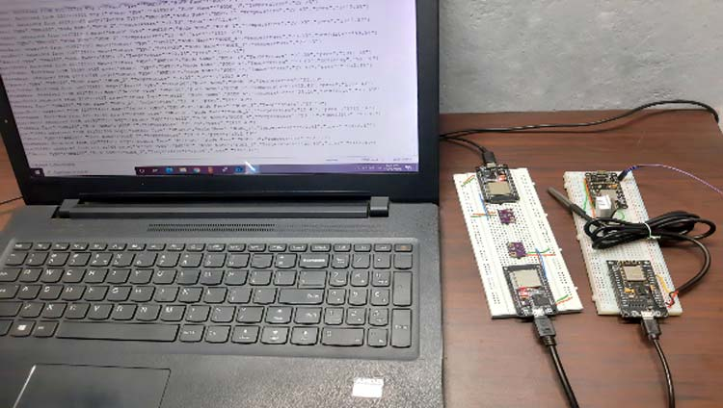

The test setup for the ESp8266 and esp32 based mesh network is shown below. As you can see in the above image, I have connected power to all the esp modules and you can also see the output data on the screen of the laptop. A screenshot of the serial monitor windows is shown below.

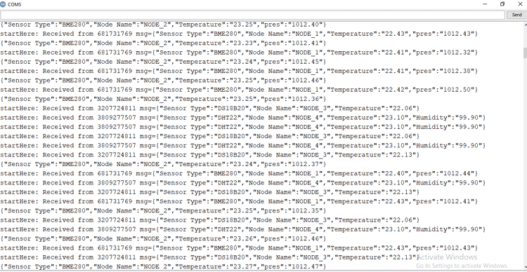

In the above window, you can see that we are easily receiving the data from all four sensors.

The complete working of the project can also be found in the video linked below. Hope you enjoyed the project and found it interesting to build your own. If you have any questions, please leave them in the comment section below. You can also write all your technical questions on [forums](https://circuitdigest.com/forums) to get them answered or to start a discussion.

**Code**

#include <painlessMesh.h>

#include <Arduino_JSON.h>

//#define BME_280

#define DHT22

//#define DS18B20

//#define ENABLE_LOG

String nodeName = "NODE_4"; // Name needs to be unique

float temp(NAN), hum(NAN), pres(NAN);

//########################## Init_BME280 ##########################

#ifdef BME_280

#include <BME280I2C.h>

#include <Wire.h>

BME280I2C bme;

BME280::TempUnit tempUnit(BME280::TempUnit_Celsius);

BME280::PresUnit presUnit(BME280::PresUnit_Pa);

#endif

//__________________________ End of _BME280 __________________________

//########################## Init_DHT22 ##########################

#ifdef DHT22

#include "DHT.h"

#define DHTPIN 4

#define DHTTYPE DHT22

DHT dht(DHTPIN, DHTTYPE);

#endif

//__________________________ End of DHT22 __________________________

//########################## Init_Ds18B20 ##########################

#ifdef DS18B20

#include <OneWire.h>

#include <DallasTemperature.h>

const int oneWireBus = 4;

OneWire oneWire(oneWireBus);

DallasTemperature ds18b20(&oneWire);

#endif

//__________________________ End of DHT22 __________________________

#define MESH_PREFIX "whateverYouLike"

#define MESH_PASSWORD "somethingSneaky"

#define MESH_PORT 5555

Scheduler userScheduler; // to control your personal task

painlessMesh mesh;

JSONVar myVar;

void sendMessage() {

String msg = construnct_json();

mesh.sendBroadcast( msg );

taskSendMessage.setInterval( random( TASK_SECOND * 1, TASK_SECOND * 5 ));

}

Task taskSendMessage( TASK_SECOND * 1 , TASK_FOREVER, &sendMessage );

// Needed for painless library

void receivedCallback( uint32_t from, String &msg ) {

Serial.printf("startHere: Received from %u msg=%s\n", from, msg.c_str());

}

void newConnectionCallback(uint32_t nodeId) {

Serial.printf("--> startHere: New Connection, nodeId = %u\n", nodeId);

}

void changedConnectionCallback() {

Serial.printf("Changed connections\n");

}

void nodeTimeAdjustedCallback(int32_t offset) {

Serial.printf("Adjusted time %u. Offset = %d\n", mesh.getNodeTime(), offset);

}

void setup()

{

Serial.begin(115200);

Serial.println(nodeName);

// mesh.setDebugMsgTypes( ERROR | STARTUP | MESH_STATUS | CONNECTION | SYNC | COMMUNICATION | GENERAL | MSG_TYPES | REMOTE ); // all types on

mesh.setDebugMsgTypes( ERROR | STARTUP ); // set before init() so that you can see startup messages

mesh.init( MESH_PREFIX, MESH_PASSWORD, &userScheduler, MESH_PORT );

mesh.onReceive(&receivedCallback);

mesh.onNewConnection(&newConnectionCallback);

mesh.onChangedConnections(&changedConnectionCallback);

mesh.onNodeTimeAdjusted(&nodeTimeAdjustedCallback);

userScheduler.addTask( taskSendMessage );

taskSendMessage.enable();

#ifdef BME_280

Wire.begin();

while (!bme.begin())

{

Serial.println("Could not find BME280 sensor!");

delay(1000);

}

// bme.chipID(); // Deprecated. See chipModel().

switch (bme.chipModel())

{

case BME280::ChipModel_BME280:

Serial.println("Found BME280 sensor! Success.");

break;

case BME280::ChipModel_BMP280:

Serial.println("Found BMP280 sensor! No Humidity available.");

break;

default:

Serial.println("Found UNKNOWN sensor! Error!");

}

#endif

#ifdef DHT22

Serial.println(F("DHTxx test!"));

dht.begin();

#endif

#ifdef DS18B20

ds18b20.begin();

#endif

}

void loop()

{

mesh.update();

// construnct_json();

}

String construnct_json()

{

#ifdef BME_280

bme.read(pres, temp, hum, tempUnit, presUnit); // update with new values

pres = pres / 100;

myVar["Sensor Type"] = "BME280";

myVar["Node Name"] = nodeName;

myVar["Temperature"] = serialized(String(temp, 2)); // serialized need to conver flot values

myVar["pres"] = serialized(String(pres, 2));// serialized need to conver flot values

#ifdef ENABLE_LOG

Serial.println(JSON.stringify(myVar)); //stringify converts the arry to a string

#endif

return JSON.stringify(myVar);

#endif

#ifdef DHT22

temp = dht.readTemperature();

hum = dht.readHumidity();

myVar["Sensor Type"] = "DHT22";

myVar["Node Name"] = nodeName;

myVar["Temperature"] = serialized(String(temp));

myVar["Humidity"] = serialized(String(hum));

#ifdef ENABLE_LOG

Serial.println(JSON.stringify(myVar));

#endif

return JSON.stringify(myVar);

#endif

#ifdef DS18B20

ds18b20.requestTemperatures();

temp = ds18b20.getTempCByIndex(0);

myVar["Sensor Type"] = "DS18B20";

myVar["Node Name"] = nodeName;

myVar["Temperature"] = serialized(String(temp));

#ifdef ENABLE_LOG

Serial.println(JSON.stringify(myVar));

#endif

return JSON.stringify(myVar);

#endif

}

**Video**

**ESP-MESH Getting Started using painlessMesh Library and ESP32/ESP8266**

In this tutorial, we will learn to use ESP-MESH network using the painlessMesh library and ESP32/ESP8266 NodeMCU. This getting started user guide focuses on ESP-MESH networking protocol by Espressif. This protocol lets numerous ESP boards communicate with each other over a large distance under a sole WLAN. These ESP boards are commonly referred to as nodes. We learn how to create a mesh network using these nodes( ESP32 and ESP8366) and communicate wirelessly using the ESP-MESH networking protocol. We will be using Arduino IDE to program our ESP boards.

By the end of this guide we will show you:

* Introduction to ESP-MESH protocol
* Exchanging simple messages between ESP32/ESP8266 via ESP-MESH
* Exchanging sensor readings between ESP32/ESP8266 via ESP-MESH

**ESP-MESH protocol Introduction**

ESP-MESH networking protocol allows ESP devices commonly known as nodes spread over a vast area to connect with each and transmit/receive data in an easy and efficient manner. Here the mesh network consists of all the various nodes interconnected with each other and forming a single network. The nodes consist of both the ESP32 and ESP8266 NodeMCU boards.

[](https://www.pcbway.com/HighQualityOrderOnline.aspx?from=microcontrollerlab.com2022D)

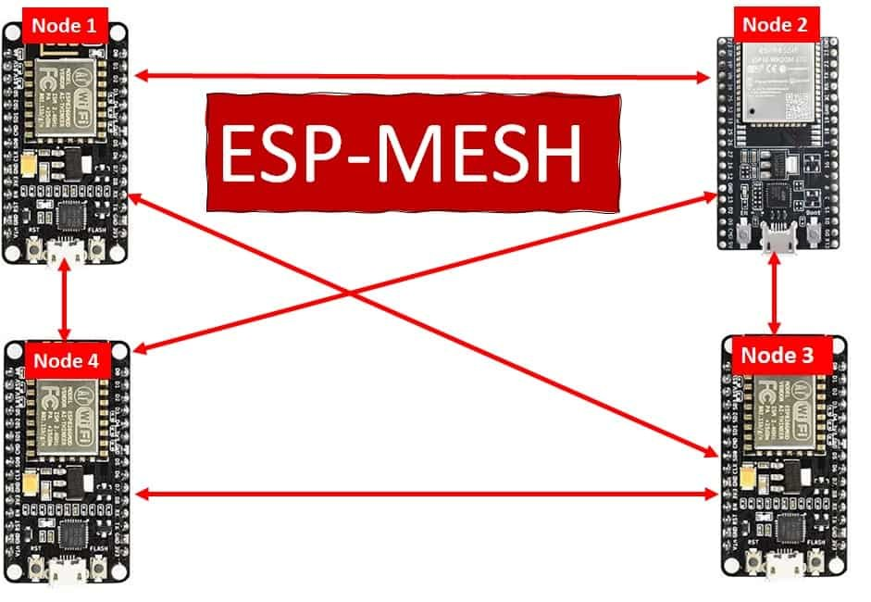

The nodes connect to each other immediately once the ESP-MESH protocol is initiated. As an example a single node can connect with multiple other nodes and transmit messages accordingly. This forms a very orderly process where the message is effectively transmitted to other nodes even if any one of them fails or is removed. This interconnection of nodes does not require a central node thus increasing the number of nodes in the network as well as the coverage area.

**Learn more**

**ESP-MESH Network Architecture**

The following diagram shows the ESP-MESH network architecture that the protocol follows.

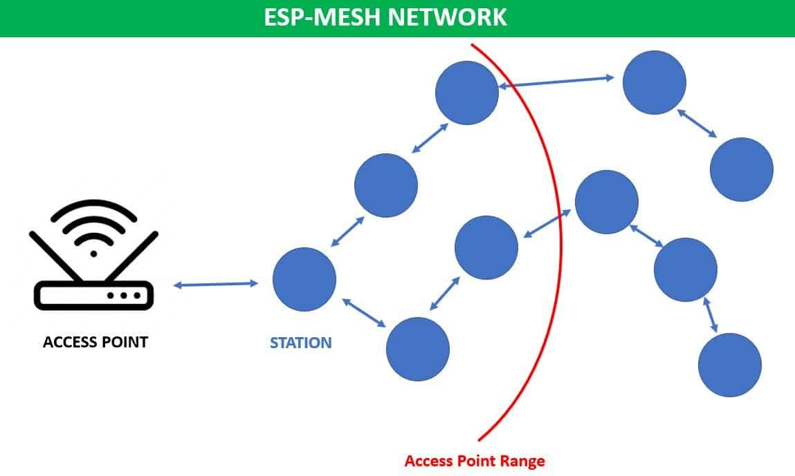

As you can see there is a central node (access point) that connects with a single node. In the ESP-MESH network, the other nodes are not required to connect to the central node to relay messages.

This is different as compared to the traditional Wi-Fi network architecture where the central node (access point) is connected with all the stations. This causes a limited coverage area due to the fact that every station has to be connected with the central node. However, in ESP-MESH network this is not the case. Stations outside the range of the access point will also be able to connect with other nodes as there is no need to connect with the central node. Thus, a large number of ESP devices will be able to connect with each other to exchange messages effectively. In case of a failure of a node, the others re-align in such a manner that the interconnectivity stays and the message gets delivered promptly.

**ESP-MESH Key Features**

Some key features of ESP-MESH networking protocol are given below:

**Learn more**

* Low cost network
* Nodes automatically connect with neighbouring nodes to form a mesh network
* Has a data transfer rate of 10Mbps
* The mesh network consumes very less power making it a power efficient choice
* Due to the fact that nodes do not need to connect with the central node, the coverage area exceeds considerably covering almost 1000 nodes per network with a maximum distance of 200m between the neighbouring nodes.
* Has a considerably easy configuration of Bluetooth connection between the smartphones and the mesh network

**Setting up Arduino IDE for ESP-MESH**

We will use Arduino IDE to program our ESP32/ESP8266 development boards. Thus, you should have the latest version of Arduino IDE. Additionally, you also need to install the ESP32 and the ESP8266 plugin. If your IDE does not have the plugins installed you can visit the links below:

[Installing ESP32 library in Arduino IDE and upload code](https://microcontrollerslab.com/install-esp32-arduino-ide/)

[Installing ESP8266 library in Arduino IDE](https://microcontrollerslab.com/how-to-install-esp8266-board-arduino-ide/)

**Installing painlessMesh Library**

We will use the painlessMesh library to construct our Mesh network with ESP32 and ESP8266 boards in a fairly easier way. We will use the Arduino Library Manager to install this library.

Open your Arduino IDE and go to **Sketch > Library > Manage Libraries**. Type ‘painlessMesh’ in the search bar and press enter. Install the library that is highlighted below.

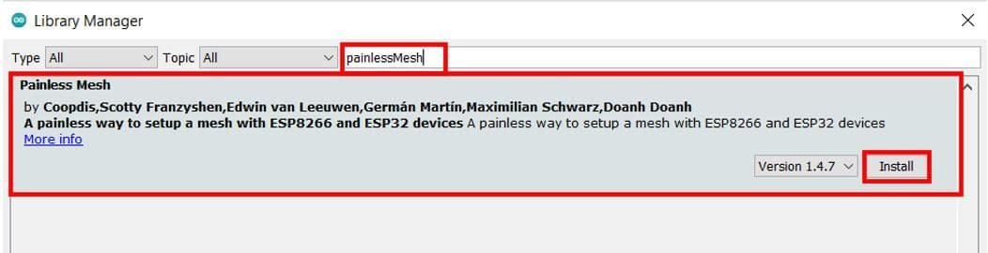

Additionally, you will be asked to install all the library dependencies as well. These include:

1. ArduinoJson by bblanchon
2. TaskScheduler
3. ESPAsyncTCP (for ESP8266)
4. AsyncTCP (for ESP32)

As we already installed the other libraries except for TaskScheduler previously, hence only it showed as a missing dependency. Click ‘Install all’ to install all the missing dependencies.

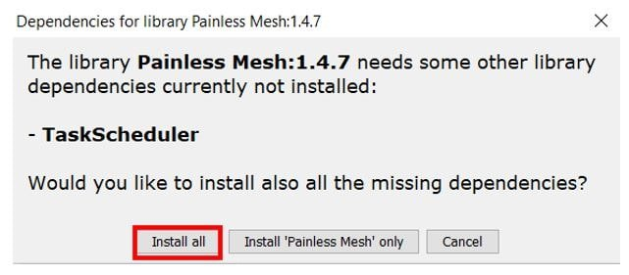

**ESP32/ESP8266 Exchanging Simple Message using ESP-MESH protocol**

Now, let us learn how to exchange simple messages between multiple ESP32/ESP8266 boards. As an example we will use four ESP boards including one ESP8266 NodeMCU and three ESP32 development boards. The ESP8266 board will be assigned as Node 1 and the ESP32 boards will assigned Node 2, Node 3 and Node 4 respectively.

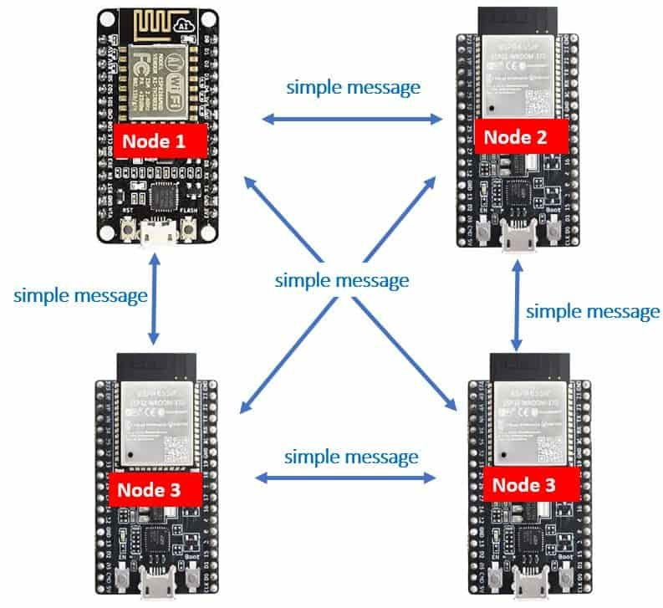

Our aim will be to show you how to exchange a simple message between ESP boards using the ESP-MESH network protocol using the painlessMesh library that we installed previously. The message exchanged will be: ‘This is a testing message from Node X’ where X will specify the number assigned to each board in the program sketch. Node 1 will receive messages from Node 2, Node 3 and Node 4. Likewise, each Node will receive messages from the other node and send its own message to the rest of the nodes.

**Arduino Sketch: ESP32/ESP8266 Exchanging Simple Message using ESP-MESH protocol**

Open your Arduino IDE and go to File > New to open a new file. Copy the code given below in that file and save it. This sketch works for both ESP32 and ESP8266 development boards.

#include "painlessMesh.h"

#define MESH_PREFIX "Mesh_username"

#define MESH_PASSWORD "mesh_password"

#define MESH_PORT 5555

Scheduler userScheduler;

painlessMesh mesh;

void sendmsg() ;

Task taskSendmsg( TASK_SECOND * 1 , TASK_FOREVER, &sendmsg );

void sendmsg() {

String msg = "This is a testing message from Node1";

msg += mesh.getNodeId();

mesh.sendBroadcast( msg );

taskSendmsg.setInterval( random( TASK_SECOND * 1, TASK_SECOND * 5 ));

}

void receivedCallback( uint32_t from, String &msg ) {

Serial.printf("Received from %u msg=%s\n", from, msg.c_str());

}

void newConnectionCallback(uint32_t nodeId) {

Serial.printf("New Connection, nodeId = %u\n", nodeId);

}

void changedConnectionCallback() {

Serial.printf("Changed connections\n");

}

void nodeTimeAdjustedCallback(int32_t offset) {

Serial.printf("Adjusted time %u. Offset = %d\n", mesh.getNodeTime(),offset);

}

void setup() {

Serial.begin(115200);

mesh.setDebugMsgTypes( ERROR | STARTUP );

mesh.init( MESH_PREFIX, MESH_PASSWORD, &userScheduler, MESH_PORT );

mesh.onReceive(&receivedCallback);

mesh.onNewConnection(&newConnectionCallback);

mesh.onChangedConnections(&changedConnectionCallback);

mesh.onNodeTimeAdjusted(&nodeTimeAdjustedCallback);

userScheduler.addTask( taskSendmsg );

taskSendmsg.enable();

}

void loop() {

mesh.update();

}

**How the Code Works?**

Firstly, we will include the painlessMesh library that we previously installed. This library will make it easier for us to exchange messages between the ESP boards via the ESP-MESH networking protocol. Our Mesh network will get constructed in a fairly simpler manner through this.

#include "painlessMesh.h"

Next, we will define some details for our mesh. These include the mesh name, password and port. You can set the mesh name and password according to your liking. The mesh port will remain 5555 as it is the default port.

#define MESH_PREFIX "Mesh_username"

#define MESH_PASSWORD "mesh_password"

#define MESH_PORT 5555

Then, we will create two instances one for the Scheduler and the other for the painlessMesh library. These are named ‘userScheduler’ and ‘mesh’ respectively. The userScheduler will make sure the mesh network stays intact throughout and the mesh object will be used to handle the mesh network accordingly.

Scheduler userScheduler;

painlessMesh mesh;

Now, we will create a task called taskSendmsg() that takes in three parameters. The first parameter is the time in seconds after which the task will call the function. The second parameter is the duration of the task. The third parameter is the pointer to the calling function. This task will call the sendMessage() function indefinitely after every 1 second.

Task taskSendmsg( TASK_SECOND * 1 , TASK_FOREVER, &sendmsg );

**Sending Message**

The void sendmsg() function will be the one that is responsible for sending the message to all the nodes.

void sendmsg() {

String msg = "This is a testing message from Node1";

msg += mesh.getNodeId();

mesh.sendBroadcast( msg );

taskSendmsg.setInterval( random( TASK_SECOND * 1, TASK_SECOND * 5 ));

}

The message is saved in the string variable ‘msg.’ For our example, this sketch is for Node 1 so it holds the message “This is a testing message from Node1.” Additionally, the chip ID of the board will also be sent along. This will be obtained by using the getNodeId() on the mesh object.

String msg = "This is a testing message from Node1";

msg += mesh.getNodeId();

By using mesh.sendBroadcast() with ‘msg’ as the parameter inside it, the message saved in the ‘msg’ variable will be broadcasted. Moreover, we will also set the interval in seconds between the messages.

mesh.sendBroadcast( msg );

taskSendmsg.setInterval( random( TASK_SECOND * 1, TASK_SECOND * 5 ))

**Callback functions**

The following four functions are the mesh callback functions.

The first function is the receivedCallback() that takes in two parameters. The first parameters is the node ID of the sender and the second parameter is the message pointer (&msg). This function is called whenever a message is received by a node. It prints the message and the sender’s ID in the serial monitor of the receiver board.

The second function is the newConnectcallback() that takes in the node Id of a new node joining the mesh network. Whenever a new node joins the mesh network, this function is called. It prints new connection with its ID in the serial monitor.

The third function is changedConnectionCallback() that takes in no parameters. It is called whenever a node joins or leaves the mesh network.

Lastly, the nodeTimeAdjustedCallback() makes sure that the time is adjusted to keep all the nodes in the mesh network synchronized. The time offset will be printed in the serial monitor.

void receivedCallback( uint32_t from, String &msg ) {

Serial.printf("Received from %u msg=%s\n", from, msg.c_str());

}

void newConnectionCallback(uint32_t nodeId) {

Serial.printf("New Connection, nodeId = %u\n", nodeId);

}

void changedConnectionCallback() {

Serial.printf("Changed connections\n");

}

void nodeTimeAdjustedCallback(int32_t offset) {

Serial.printf("Adjusted time %u. Offset = %d\n", mesh.getNodeTime(),offset);

}

**setup()**

Inside the setup() function we will open the serial communication at a baud rate 115200.

Serial.begin(115200);

Next, we will set up the debug function for ERROR | STARTUP messages by using setDebugMsgTypes() on the mesh object and passing the debug message type as a parameter inside it. Moreover, we will also initialize the mesh by using init() on the mesh object. This takes in the parameters which we defined earlier including the mesh name, mesh password, userScheduler pointer, and the mesh port.

mesh.setDebugMsgTypes( ERROR | STARTUP );

mesh.init( MESH_PREFIX, MESH_PASSWORD, &userScheduler, MESH_PORT );

The next important step is to initialize all the callback functions that we previously defined according to their events. These will be called according to the event occurrence.

mesh.onReceive(&receivedCallback);

mesh.onNewConnection(&newConnectionCallback);

mesh.onChangedConnections(&changedConnectionCallback);

mesh.onNodeTimeAdjusted(&nodeTimeAdjustedCallback);

Then we will use addTask() on the userScheduler object and pass the taskSendmsg as a parameter inside it. This will add the task to the scheduler which will then be enabled by using taskSendmsg.enable(). This will make sure that all the tasks are handled in a proper and timely manner.

userScheduler.addTask( taskSendmsg );

taskSendmsg.enable();

**loop()**

Inside the loop() function, we will update the mesh indefinitely so that the mesh network keeps on running.

void loop() {

mesh.update();

}

**Demonstration**

Now upload this code onto the respective ESP32/ESP8266 boards. Make sure to change the message contents according to the sender node so that the receiver is able to identify which node sent the particular message. In our case ESP8266 is Node 1 and ESP32 are Node 2, Node 3 and Node 4. Also make sure all the four boards are powered on throughout the demonstration.

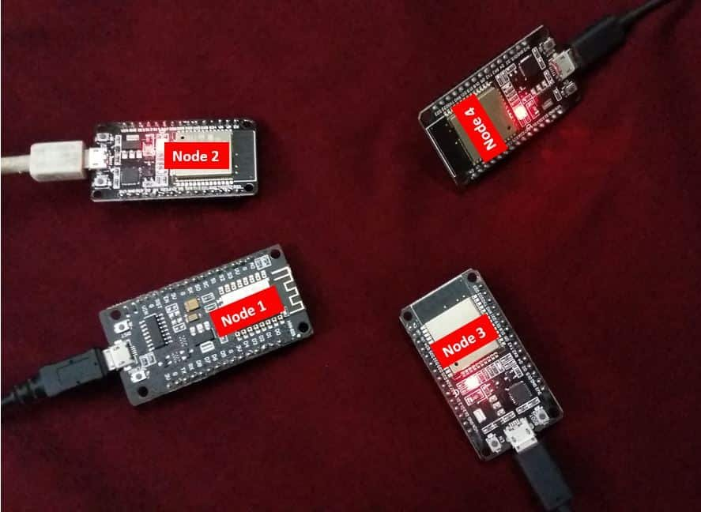

Choose the correct board and COM port before uploading your code to the board. Therefore go to **Tools > Board** and **select ESP32 Dev Module or NodeMCU 1.0.**

If you are using ESP32, select the ESP32 Dev module as follows:

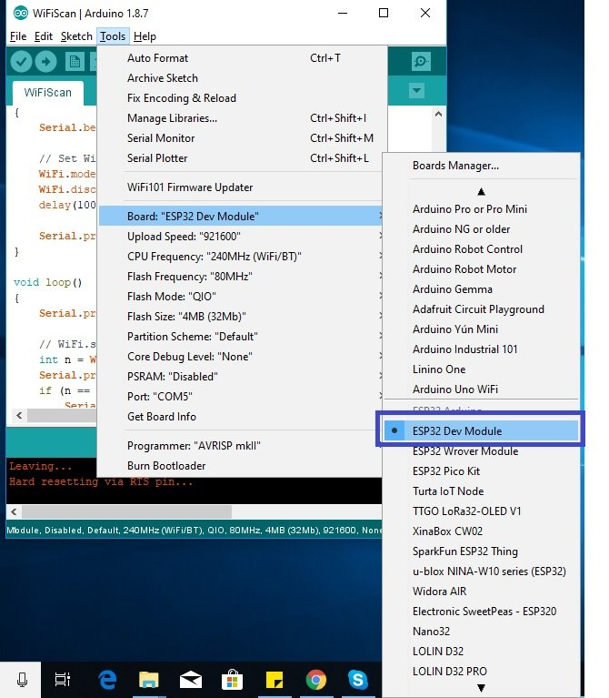

If you are using ESP8266 NodeMCU, select the NodMCU module as follows:

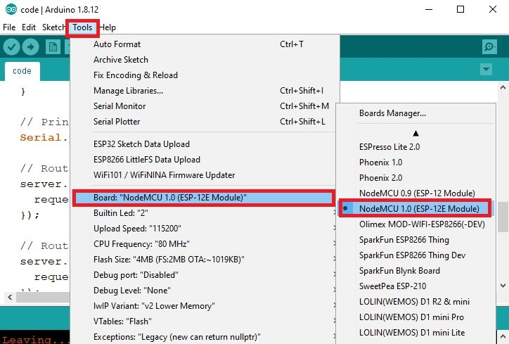

Then, go to Tools > Port and select the appropriate port through which your board is connected.

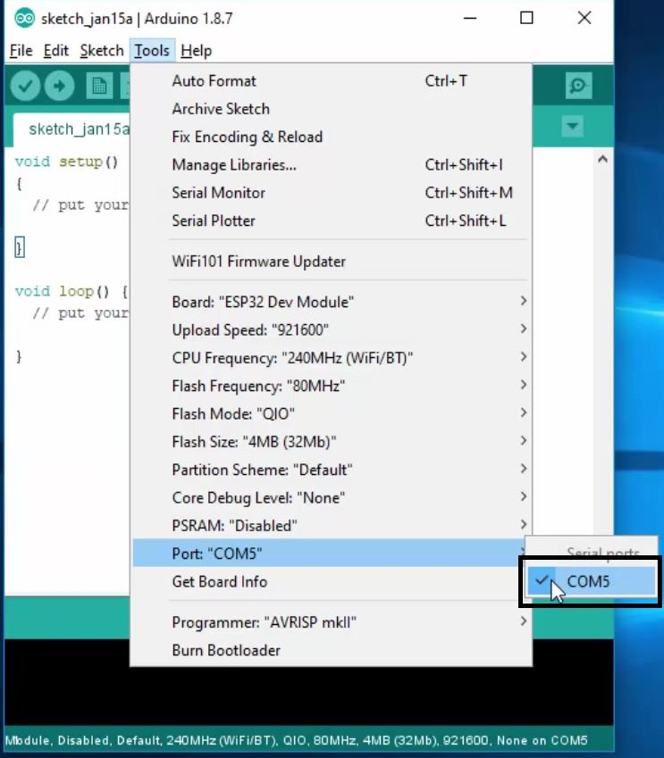

Click on the upload button to upload the code to ESP32 or ESP8266 development board.

After you have uploaded your code to the ESP32 or ESP8266 development board, press its ENABLE button.

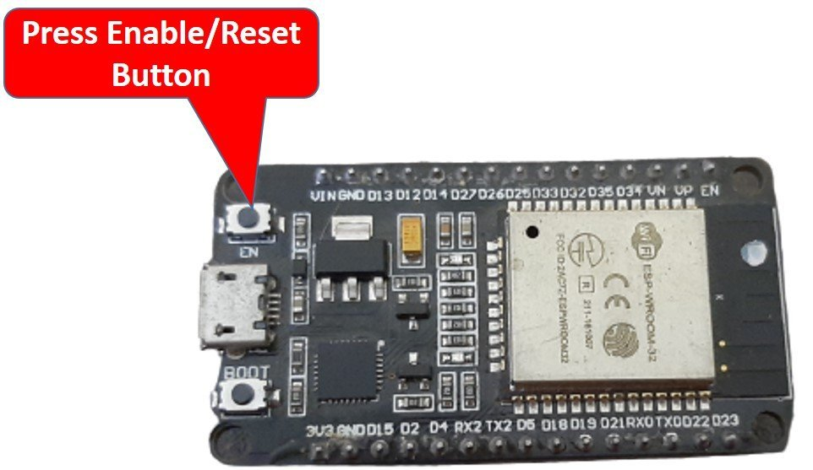

ESP8266 NodeMCU reset button:

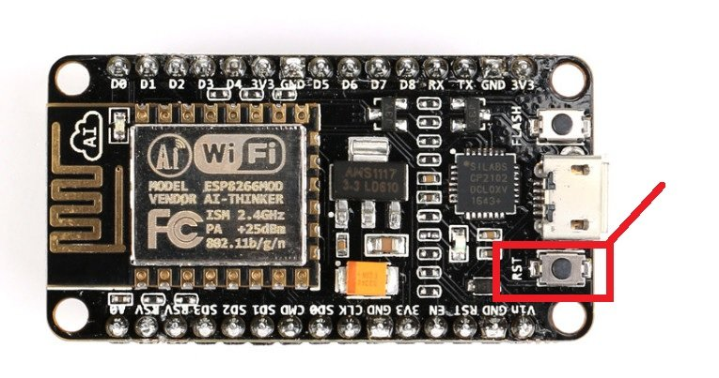

In your Arduino IDE, open up the serial monitor and you will see that the messages received by your board. In our case, we have opened the serial monitor for Node 4 thus it shows messages being received from Node 1, Node 2 and Node 3 along with their chip IDs.

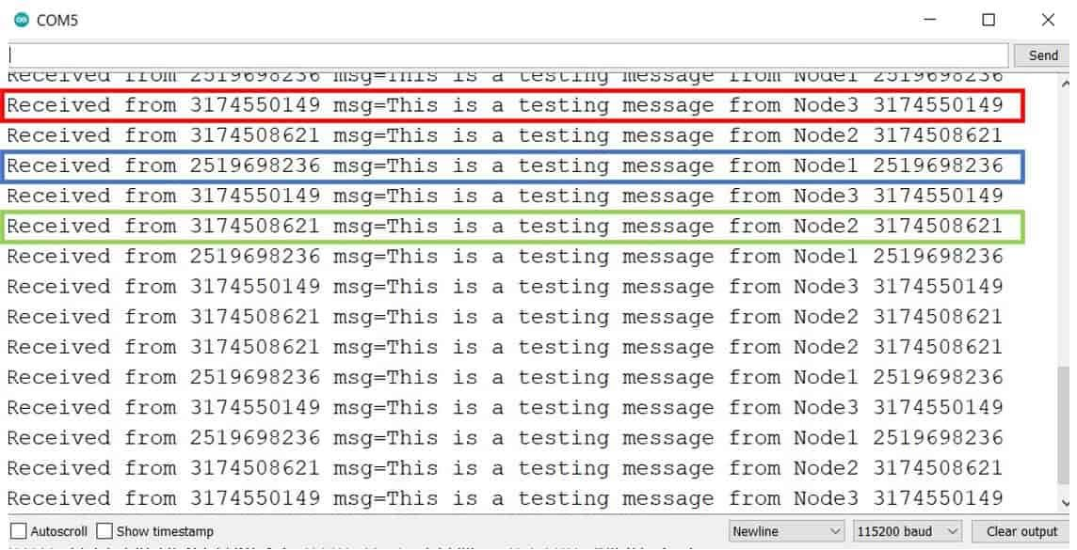Serial Monitor of Node 4

**ESP32/ESP8266 Exchanging Sensor Readings using ESP-MESH protocol**

After seeing how to exchange simple messages between ESP boards using ESP-MESH network let us move ahead. This time we will exchange sensor readings between multiple ESP32/ESP8266 boards. As an example we will use four ESP boards including one ESP8266 NodeMCU and three ESP32 development boards each connected with a ds18b20 temperature sensor. The ESP8266 board will be assigned as Node 1 and the ESP32 boards will assigned Node 2, Node 3 and Node 4 respectively. Each node will receive temperature readings of the other nodes.

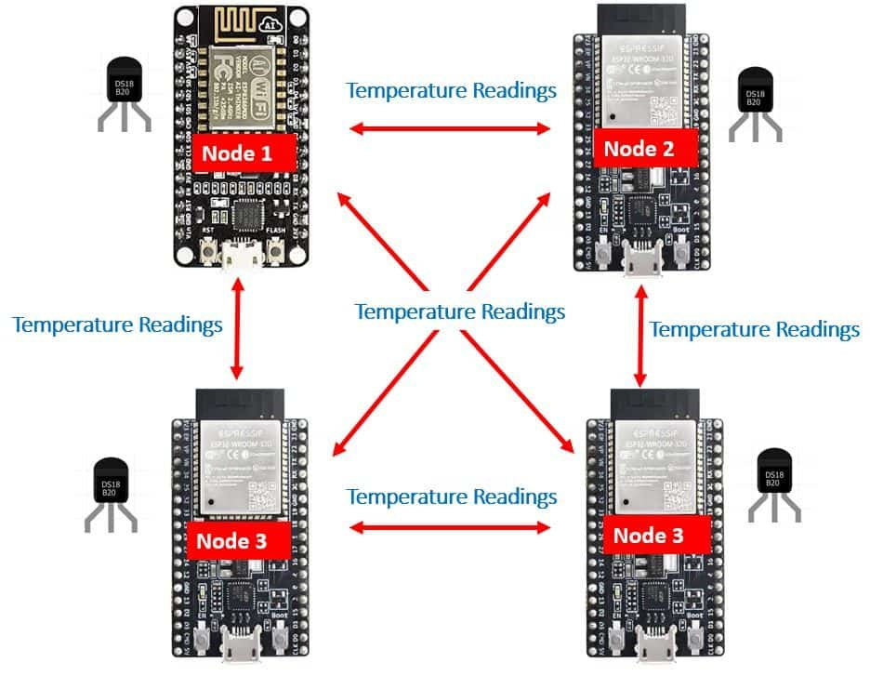

Any preferred sensor, such as [BME280](https://microcontrollerslab.com/esp32-esp8266-publish-sensor-readings-google-sheets-via-ifttt/), [BME680](https://microcontrollerslab.com/lm35-temperature-sensor-with-esp32-web-server/), [LM35](https://microcontrollerslab.com/lm35-temperature-sensor-with-esp32-web-server/), and [MPU6050](http://mpu6050/), can be used but for this article, we will use a ds18b20 sensor which will be used to measure the ambient temperature. One of the advantages of using this sensor is that we only require a single pin of our ESP boards to transfer data. Thus, it is extremely convenient to use with the micro-controller as we can measure multiple temperatures by using the least number of pins on our development board. The sensor readings will be accessed from the ds18b20 sensor connected with the ESP32/ESP8266 board.

Our aim will be to show you how to exchange these temperature readings between ESP boards using the ESP-MESH network protocol using the painlessMesh library that we installed previously. The message exchanged will be the temperature reading along with the node number and the chip ID of the board. Node 1 will receive temperature readings from Node 2, Node 3 and Node 4. Likewise, each Node will receive temperature readings from the other node and send its own reading to the rest of the nodes.

For this example we will require the following components:

**Required Components**

* 4x ESP32/ESP8266 boards
* Connecting wires
* 4x ds18b20 sensors
* 4x 4.7k ohm resistors
* Breadboard

**ESP32 NodeMCU with DS18B20 Schematic Diagram**

If using ESP32, connect the development board and the sensor as shown in the schematic diagram below.

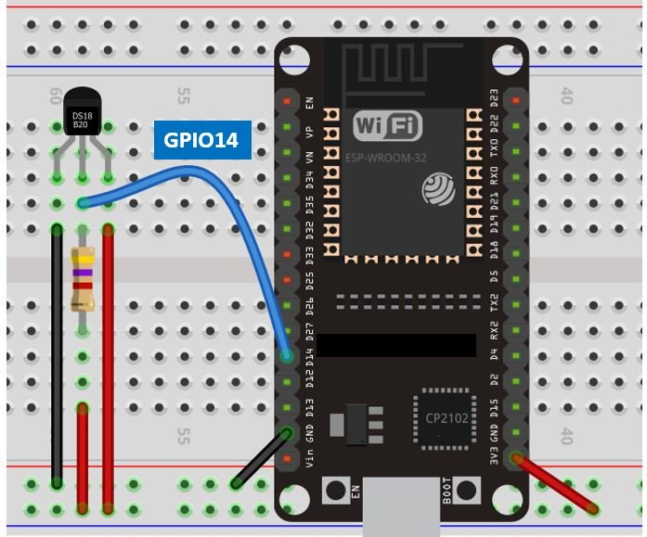ESP32 with ds18b20 sensor

We have powered the sensor using the normal mode. The DS18B20 sensor has three terminals. The first terminal is grounded with the ESP32 board. The data line of the sensor, which is the middle terminal, is connected through GPIO14 through a pull-up resistor of 4.7k-ohm. You can choose any other GPIO pin as well. The third terminal is powered by 3.3V from the ESP32 board.

**ESP8266 NodeMCU with DS18B20 Schematic Diagram**

If using ESP8266 NodeMCU, connect the development board and the sensor as shown in the schematic diagram below.

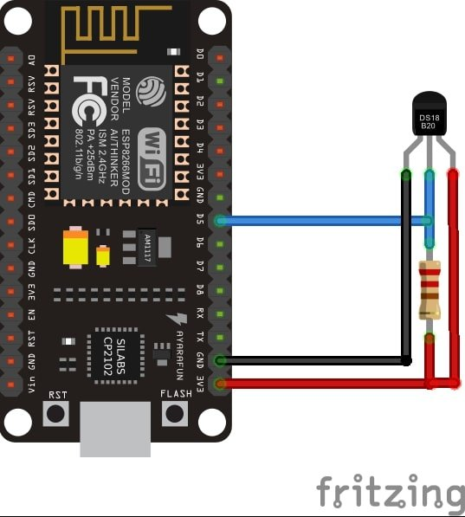ESP8266 with ds18b20 sensor

We have powered the sensor using the normal mode. The DS18B20 sensor has three terminals. The first terminal is grounded with the ESP8266 NodeMCU board. The data line of the sensor, which is the middle terminal, is connected through GPIO14 through a pull-up resistor of 4.7k-ohm. You can choose any other GPIO pin as well. The third terminal is powered by 3.3V from the ESP8266 board.

**Installing Required Arduino Libraries for exchanging sensor readings using ESP-MESH protocol**

To use the Dallas DS18B20 sensor we will have to install two libraries.

1. OneWire library
2. DallasTemperature library

Follow the steps below to successfully install them. We will use the Library Manager in our Arduino IDE to install the latest versions of the libraries. Open your Arduino IDE and go to **Sketch > Include Libraries > Manage Libraries.** Type each library name in the search bar and install them both.

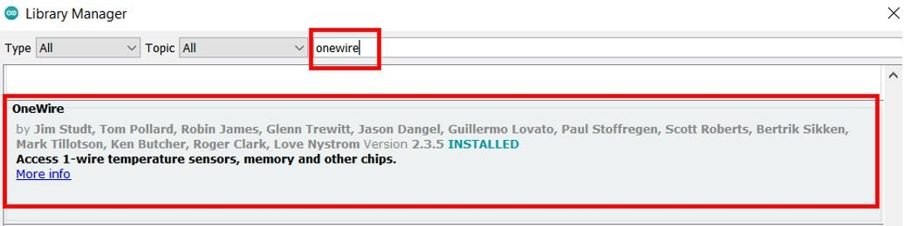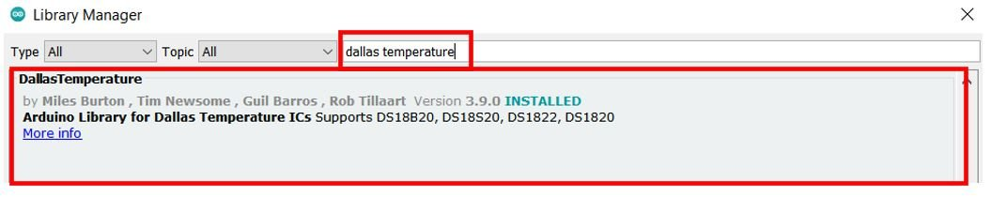

Additionally, we will also require Arduino_JSON library as we will be sending the temperature readings, along with the node ID and chip ID in a JSON string. Follow the same procedure to install it as well. In the Arduino Library Manager type the name ‘Arduino_JSON’ and install it as well.

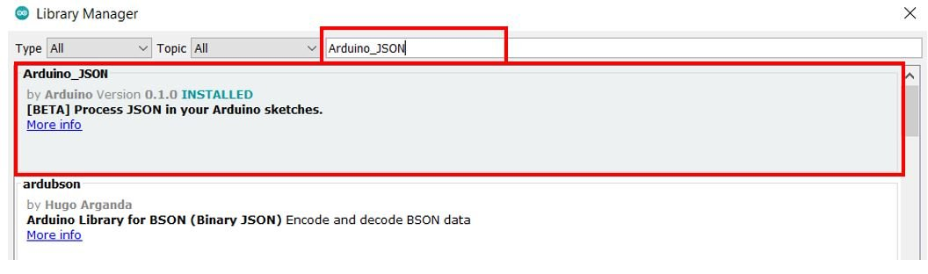

**Arduino Sketch: ESP32/ESP8266 Exchanging Sensor Readings using ESP-MESH protocol**

Open your Arduino IDE and go to File > New to open a new file. Copy the code given below in that file and save it. This sketch works for both ESP32 and ESP8266 development boards.

#include <OneWire.h>

#include <DallasTemperature.h>

#include "painlessMesh.h"

#include <Arduino_JSON.h>

#define MESH_PREFIX "Mesh_username"

#define MESH_PASSWORD "Mesh_password"

#define MESH_PORT 5555

const int SensorDataPin = 14;

OneWire oneWire(SensorDataPin);

DallasTemperature sensors(&oneWire);

int Node = 1;

String temp_readings;

Scheduler userScheduler;

painlessMesh mesh;

void sendMessage() ;

String obtain_readings();

Task taskSendMessage(TASK_SECOND * 5 , TASK_FOREVER, &sendMessage);

String obtain_readings () {

JSONVar jsonReadings;

sensors.requestTemperatures();

jsonReadings["Node"] = Node;

jsonReadings["Temperature"] = sensors.getTempCByIndex(0);

temp_readings = JSON.stringify(jsonReadings);

return temp_readings;

}

void sendMessage () {

String msg = obtain_readings();

mesh.sendBroadcast(msg);

}

void receivedCallback( uint32_t from, String &msg ) {

Serial.printf("Received from %u msg=%s\n", from, msg.c_str());

JSONVar json_object = JSON.parse(msg.c_str());

int node = json_object["Node"];

double temp = json_object["Temperature"];

Serial.print("Node: ");

Serial.println(node);

Serial.print("Temperature: ");

Serial.print(temp);

Serial.println(" C");

}

void newConnectionCallback(uint32_t nodeId) {

Serial.printf("New Connection, nodeId = %u\n", nodeId);

}

void changedConnectionCallback() {

Serial.printf("Changed connections\n");

}

void nodeTimeAdjustedCallback(int32_t offset) {

Serial.printf("Adjusted time %u. Offset = %d\n", mesh.getNodeTime(),offset);

}

void setup() {

Serial.begin(115200);

sensors.begin();

mesh.setDebugMsgTypes( ERROR | STARTUP );

mesh.init( MESH_PREFIX, MESH_PASSWORD, &userScheduler, MESH_PORT );

mesh.onReceive(&receivedCallback);

mesh.onNewConnection(&newConnectionCallback);

mesh.onChangedConnections(&changedConnectionCallback);

mesh.onNodeTimeAdjusted(&nodeTimeAdjustedCallback);

userScheduler.addTask(taskSendMessage);

taskSendMessage.enable();

}

void loop() {

mesh.update();

}

**How the Code Works?**

**Including Libraries**

Firstly, we will include the necessary libraries required for this example. The painlessMesh library will make it easier for us to exchange sensor readings between the ESP boards via the ESP-MESH networking protocol. Our Mesh network will get constructed in a fairly simpler manner through this. Additionally, we will include the libraries that we previously installed for ds18b20 sensor functionality and Arduino_JSON to handle the JSON strings.

#include <OneWire.h>

#include <DallasTemperature.h>

#include "painlessMesh.h"

#include <Arduino_JSON.h>

**Defining Mesh Details**

Secondly, we will define some details for our mesh. These include the mesh name, password and port. You can set the mesh name and password according to your liking. For the mesh port we are using the default port that is 5555.

#define MESH_PREFIX "Mesh_username"

#define MESH_PASSWORD "Mesh_password"

#define MESH_PORT 5555

**Setting Sensor Parameters**

Then, we will create a variable to store the GPIO pin through which the sensor’s data pin is connected. It is called ‘SensorDataPin.’ In our case it is GPIO14. You can use any appropriate GPIO pin.

const int SensorDataPin = 14;

We will require the following instances to access the temperature readings. First, we will create a oneWire instance and use the SensorDataPin as an argument inside it. Then we will call the DallasTemperature sensor and pass the oneWire reference which we created above as an argument inside it.

OneWire oneWire(SensorDataPin);

DallasTemperature sensors(&oneWire);

**Defining Variables**

Now, we will define an integer variable called ‘Node.’ This will hold the node ID (1, 2, 3 or 4). In our case, this sketch is for Node 1 hence the Node is set to 1.

int Node = 1;

We will also define a string variable called ‘temp_readings’ that will save the current temperature readings acquired from the ds18b20 sensor.

String temp_readings;

**Declaring Instances**

Then, we will create two instances one for the Scheduler and the other for the painlessMesh library. These are named ‘userScheduler’ and ‘mesh’ respectively. The userScheduler will make sure the mesh network stays intact throughout and the mesh object will be used to handle the mesh network accordingly.

Scheduler userScheduler;

painlessMesh mesh;

Now, we will create a task called taskSendmsg() that takes in three parameters. The first parameter is the time in seconds after which the task will call the function. The second parameter is the duration of the task. The third parameter is the pointer to the calling function. This task will call the sendMessage() function indefinitely after every 5 seconds.

Task taskSendMessage(TASK_SECOND * 5 , TASK_FOREVER, &sendMessage);

**obtain_readings()**

The obtain_readings() function is responsible to acquire the temperature reading from the ds18b20 sensor and store it in a JSON variable.

String obtain_readings () {

JSONVar jsonReadings;

sensors.requestTemperatures();

jsonReadings["Node"] = Node;

jsonReadings["Temperature"] = sensors.getTempCByIndex(0);

temp_readings = JSON.stringify(jsonReadings);

return temp_readings;

}

We will first create a JSON variable called ‘jsonReadings.’ To obtain the temperature reading we will first call the requestTemperatures() method. Then we will use the getTempCByIndex() function to retrieve the temperature in degree Celsius. Notice that we are passing 0 as a parameter inside the function. This is because we are using a single ds18b20 sensor connected with each board. This temperature reading along with the node ID (1,2,3 or 4) gets linked together in the JSON variable ‘jsonReadings.’

JSONVar jsonReadings;

sensors.requestTemperatures();

jsonReadings["Node"] = Node;

jsonReadings["Temperature"] = sensors.getTempCByIndex(0);

Additionally, the JSON variable is then changed into a string using JSON.stringify() and passing jsonReadings as a parameter inside it. This string is saved in the variable ‘temp_readings’ that we initially defined at the start of the sketch. The temp_readings string is thus, returned whenever the obtain_readings() function will be called.

temp_readings = JSON.stringify(jsonReadings);

return temp_readings;

**sendMessage()**

The void sendMessage() function will be the one that is responsible for sending the message to all the nodes. In our case the message is saved in the string variable ‘msg’ that calls the obtain_readings() function. This msg is then broadcasted to all the nodes in the mesh network.

void sendMessage () {

String msg = obtain_readings();

mesh.sendBroadcast(msg);

}

**Callback Functions**

Next up is the receivedCallback() function that takes in two parameters. The first parameter is the node ID (1,2,3 or 4) of the sender and the second parameter is the message pointer (&msg). This function is called whenever a message is received by a node. It prints the message and the sender’s ID in the serial monitor of the receiver board.

void receivedCallback( uint32_t from, String &msg ) {

Serial.printf("Received from %u msg=%s\n", from, msg.c_str());

JSONVar json_object = JSON.parse(msg.c_str());

int node = json_object["Node"];

double temp = json_object["Temperature"];

Serial.print("Node: ");

Serial.println(node);

Serial.print("Temperature: ");

Serial.print(temp);

Serial.println(" C");

}

You can also view the other callback functions below.

The second calback function is the newConnectcallback() that takes in the node Id of a new node joining the mesh network. Whenever a new node joins the mesh network, this function is called. It prints new connection with its ID in the serial monitor.

The third function is changedConnectionCallback() that takes in no parameters. It is called whenever a node joins or leaves the mesh network.

Lastly, the nodeTimeAdjustedCallback() makes sure that the time is adjusted to keep all the nodes in the mesh network synchronized. The time offset will be printed in the serial monitor.

void newConnectionCallback(uint32_t nodeId) {

Serial.printf("New Connection, nodeId = %u\n", nodeId);

}

void changedConnectionCallback() {

Serial.printf("Changed connections\n");

}

void nodeTimeAdjustedCallback(int32_t offset) {

Serial.printf("Adjusted time %u. Offset = %d\n", mesh.getNodeTime(),offset);

}

**setup()**

Inside the setup() function, we will open a serial connection at a baud rate of 115200. Moreover, we will call sensors.begin() to initialize the ds18b20 sensor as well.

Serial.begin(115200);

sensors.begin();

Next, we will set up the debug function for ERROR | STARTUP messages by using setDebugMsgTypes() on the mesh object and passing the debug message type as parameter inside it. Moreover, we will also initialize the mesh by using init() on the mesh object. This takes in the parameters which we defined earlier including the mesh name, mesh password, userScheduler pointer and the mesh port.

mesh.setDebugMsgTypes( ERROR | STARTUP );

mesh.init( MESH_PREFIX, MESH_PASSWORD, &userScheduler, MESH_PORT );

The next important step is to initialize all the callback functions that we previously defined according to their events. These will be called according to the event occurrence.

mesh.onReceive(&receivedCallback);

mesh.onNewConnection(&newConnectionCallback);

mesh.onChangedConnections(&changedConnectionCallback);

mesh.onNodeTimeAdjusted(&nodeTimeAdjustedCallback);

Then we will use addTask() on the userScheduler object and pass the taskSendmsg as a parameter inside it. This will add the task to the scheduler which will then be enabled by using taskSendmsg.enable(). This will make sure that all the tasks are handled in a proper and timely manner.

userScheduler.addTask(taskSendMessage);

taskSendMessage.enable();

**loop()**

Inside the loop() function, we will update the mesh indefinitely so that the mesh network keeps on running.

void loop() {

mesh.update();

}

**Demonstration**

Now upload this code onto the respective ESP32/ESP8266 boards. Make sure to change the integer variable ‘Node’ according to the sender node ID so that the receiver is able to identify which node sent the particular message. In our case ESP8266 is Node 1 and ESP32 are Node 2, Node 3 and Node 4. Also make sure all the four boards are powered on throughout the demonstration.

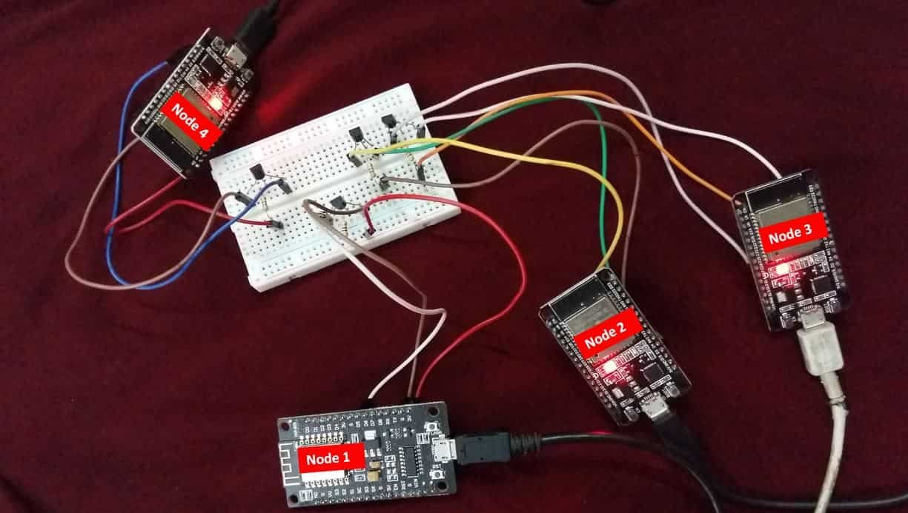

Choose the correct board and COM port before uploading your code to the board. Therefore go to **Tools > Board** and **select ESP32 Dev Module or NodeMCU 1.0.**

If you are using ESP32, select the ESP32 Dev module as follows:



If you are using ESP8266 NodeMCU, select the NodMCU module as follows:



Then, go to Tools > Port and select the appropriate port through which your board is connected.



Click on the upload button to upload the code to ESP32 or ESP8266 development board.

After you have uploaded your code to the ESP32 or ESP8266 development board, press its ENABLE button.



ESP8266 NodeMCU reset button:



In your Arduino IDE, open up the serial monitor and you will see that the messages received by your board. In our case, we have opened the serial monitor for Node 3 thus it shows the temperature readings being received from Node 1, Node 2 and Node 4 along with their chip IDs.

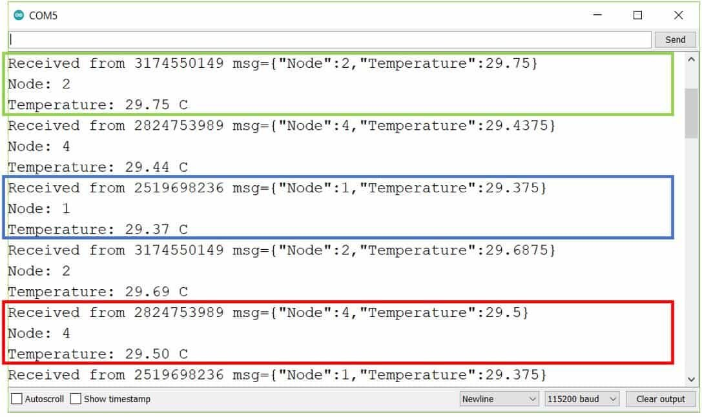Serial Monitor of Node 3

**Conclusion**

In conclusion, we have learned about the ESP-MESH networking protocol for ESP32 and ESP8266 NodeMCU development boards using Arduino IDE. To ensure an easier approach, we used the painlessMesh library to create and handle the mesh network properly. In this guide, we had a look at two Arduino sketches. For the first one, we exchanged a simple message between the ESP boards using the ESP-MESH protocol. In the second sketch, we connected ESP boards with the ds18b20 temperature sensor and exchanged temperature readings between the ESP boards.

You may also like to read:

* [ESP32 ESP-NOW Getting Started Tutorial with Arduino IDE](https://microcontrollerslab.com/esp32-esp-now-tutorial-arduino-ide/)
* [ESP32 ESP-NOW Two way Communication (Arduino IDE)](https://microcontrollerslab.com/esp32-esp-now-two-way-communication-arduino-ide/)
* [ESP32 ESP-NOW Send Data to Multiple boards (One to Many Communication)](https://microcontrollerslab.com/esp-now-one-to-many-esp32-esp8266/)
* [ESP32 ESP-NOW Receive Data from Multiple boards (Many to One Communication)](https://microcontrollerslab.com/esp32-esp-now-receive-data-from-multiple-boards-many-to-one/)
* [ESP32 ESP-NOW and Wi-Fi Web Server using Arduino IDE](https://microcontrollerslab.com/esp32-esp-now-wi-fi-web-server/)

**Getting started with ESP-MESH and ESP-8266**

ESP mesh n/w is created to control LED with push button and sending DHT data to other nodes. Turn on the LED when temp/hum is more.

[Beginner](https://www.hackster.io/projects?difficulty=beginner)Full instructions provided1 hour3,550

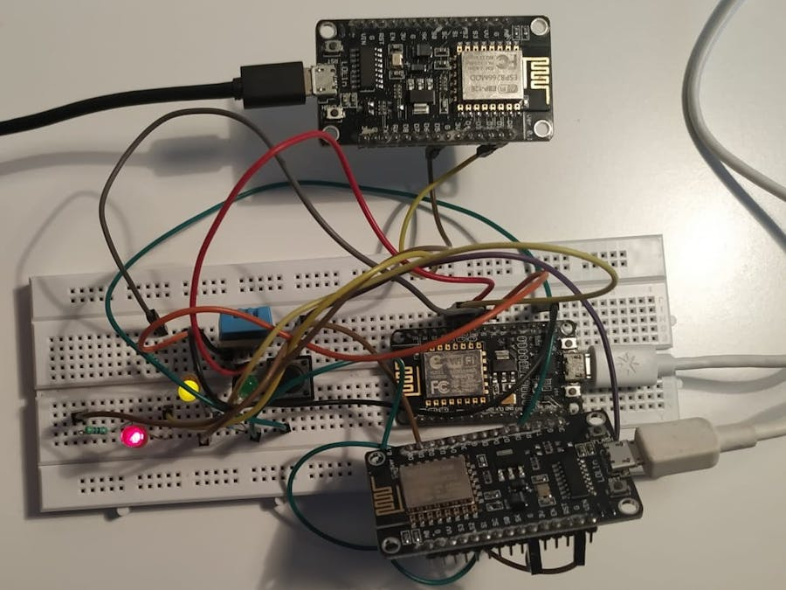

**Things used in this project**

|  |  |  |  |  |  |
| --- | --- | --- | --- | --- | --- |
| **Hardware components** | | | | | |
| NodeMCU ESP8266 Breakout Board | |  | | --- | | [NodeMCU ESP8266 Breakout Board](https://www.hackster.io/nodemcu/products/nodemcu-esp8266-breakout-board?ref=project-73e7e9) | |  | | × | 3 |  |  |
| DHT11 Temperature & Humidity Sensor (4 pins) | |  | | --- | | DHT11 Temperature & Humidity Sensor (4 pins) | |  | | × | 1 |  |  |
| Pushbutton switch 12mm | |  | | --- | | [SparkFun Pushbutton switch 12mm](https://www.hackster.io/sparkfun/products/pushbutton-switch-12mm?ref=project-73e7e9) | |  | | × | 1 |  |  |
| LED (generic) | |  | | --- | | LED (generic) | |  | | × | 3 |  |  |
| Jumper wires (generic) | |  | | --- | | Jumper wires (generic) | |  | | × | 1 |  |  |

**Story**

**Introduction**

ESP-MESH is a networking protocol built on the top of the Wi-Fi protocol. ESP-MESH allows numerous devices (generally referred as nodes) spread over a large physical area to be interconnected under a single WLAN.

ESP-MESH allows multiple nodes to communicate with each other under a single wireless local area network. It is supported on the ESP32 and ESP8266 boards. In this project, controlling appliances using NodeMCU (ESP8266) with ESP-MESH is explained.

**What is Mesh Networking?**

Mesh networking is a local network topology in which nodes are directly, dynamically and non-hierarchically connected to each other and cooperates with one another to efficiently route the data from/to clients. Mesh network supports auto-networking meaning when the user setup a mesh network, any node can scan access point and can connect easily. 87 nodes can be connected with a single router.

**ESP - MESH Network Architecture**

In this, the nodes don’t need to connect to a central node. Nodes are responsible for relaying each others transmissions. This allows multiple devices to spread over a large physical area. The nodes can self-organize and dynamically talk to each other to ensure that the packet reaches its final node destination. If any node is removed from the network, it is able to self-organize to make sure that the packets reach their destination. ESP-MESH network has much greater coverage area as nodes can achieve inter-connectivity without needing to be in range of the central node. Here, stations are NodeMCU's.

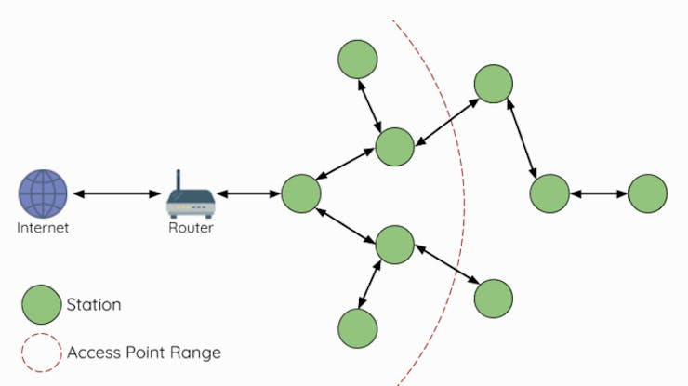

ESP-MESH Network Architecture

**Arduino IDE**

Firstly, install all the required libraries for Mesh n/w. In this, 5 libraies are required namely DHT, painlessMesh, ArduinoJson, TaskScheduler and ESPAsyncTCP.

To install the libraries. Open Arduino IDE > go to **Tools** > **Manage Libraries**

**1.** Install DHT sensor library

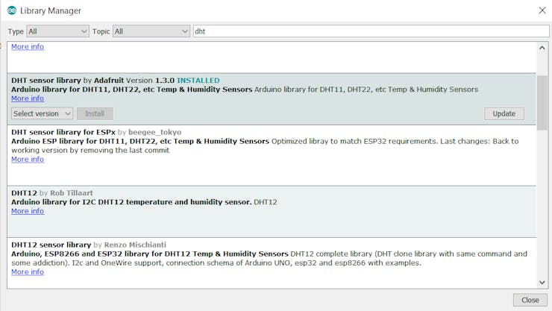

2. Install painlessmesh library

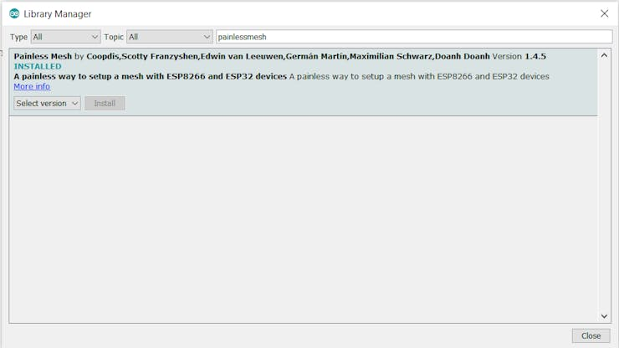

3. Install ArduinoJson library

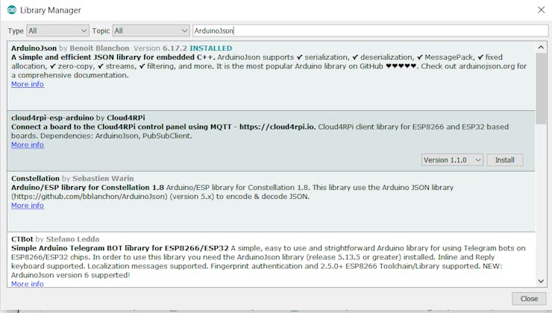

4. Install TaskScheduler library

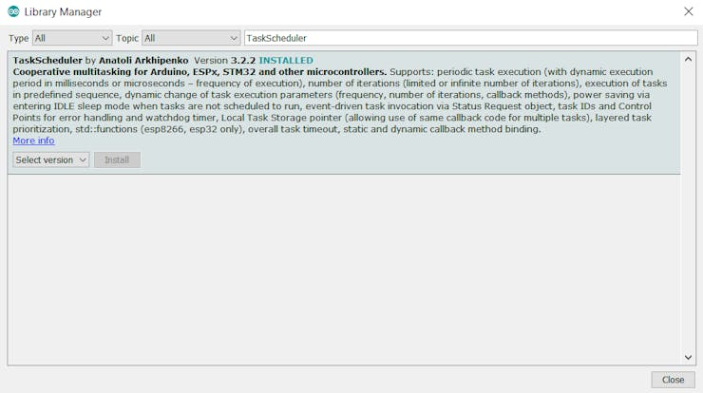

5. Install ESPAsyncTCP library

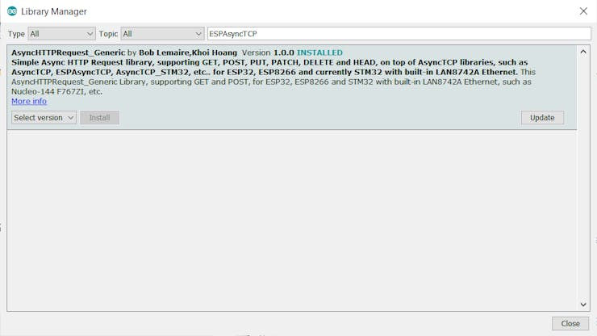

After installing all the libraries next step is to setup ESP-8266 for Arduino IDE

**ESP8266 Setup**

**1.** Open the Arduino IDE and go to **File** > **Preferences**

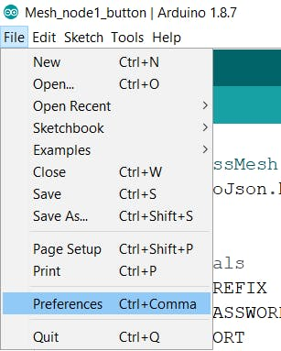

**2.** For adding ESP8266 Board manager use the URL as shown below :

<http://arduino.esp8266.com/stable/package_esp8266com_index.json>

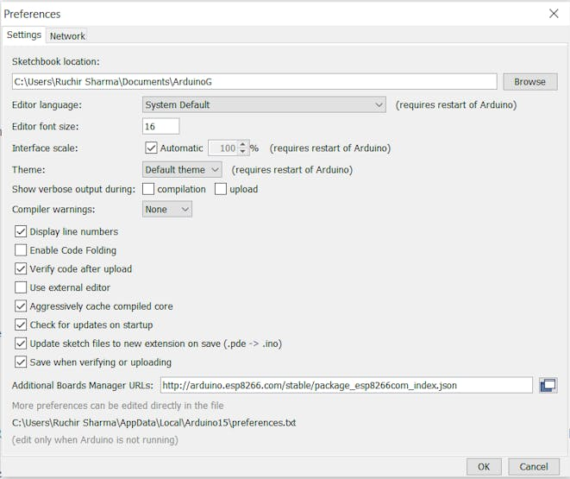

3. For selecting the board go to **Tools** >**Board** > **Board Manager** and search for esp8266.

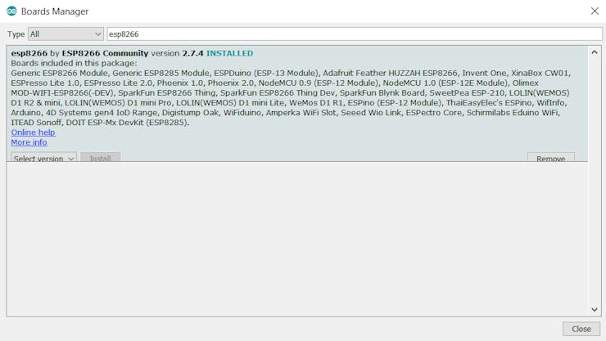

4. Once installed you will able to see the NodeMCU board in **Tools** > **Board**

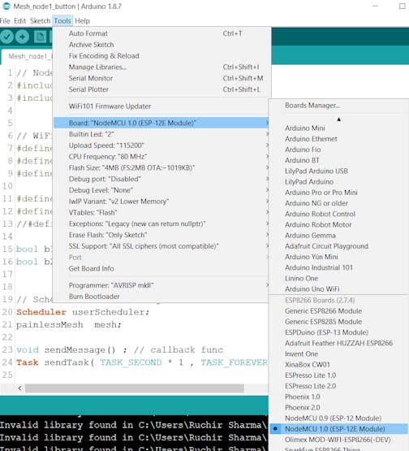

After installing the board, next step is to create a Mesh network, here we are using 3 NodeMCU's.

**NodeMCU 8266**

**Node 1**

It has a DHT11 sensor and 1 LED. It will send temperature and humidity data to Node2 and Node3.

**Connections**

**DHT11** ==> **NodeMCU**

* Gnd ==> Gnd
* Vcc ==> 3V3
* Data ==> D4

**YellowLED ==> NodeMCU**

* +VE ==> D5
* -VE ==> GND

**Circuit Diagram**

**Node 2**

It has 1 push button to control LED on the 1st Node and 1 LED to know data is sent.

**Connections**

**Pushbutton** ==> **NodeMCU**

* +VE ==> D4
* -VE ==> Gnd

**GreenLED ==> NodeMCU**

+VE ==> D5

-VE ==> Gnd

**Circuit Diagram**

**Node 3**

It has one LED and it receive button state, temperature and humidity data from other nodes. The LED will glow if temperature or Humidity is more than certain threshold.

**Connections**

**RedLED ==> NodeMCU**

+VE ==> D5

-VE ==> Gnd

**Circuit Diagram**

**Program**

#define MESH_PREFIX "Meshname"  
#define MESH_PASSWORD "meshpassword"  
#define MESH_PORT 5555 // default port

* The MESH_PREFIX is the name of the mesh. You can change it to whatever you like.
* The MESH_PASSWORD is the mesh password. You can change it to whatever you like.
* The MESH_PORT is the TCP port that you want the mesh server to run on. The default is 5555.

Note:- All nodes in the mesh should use the same MESH_PREFIX and MESH_PASSWORD.

Scheduler userScheduler;

This line creates a new Scheduler called userScheduler

painlessMesh mesh;

Create a painlessMesh object called mesh to handle the mesh network

Task taskSendMessage( TASK_SECOND * 1 , TASK_FOREVER, &sendMessage );

Create a task called taskSendMessage responsible for calling the sendMessage() function every second as long as the program is running.

The sendMessage() function sends the JSON string with the readings to all nodes in the network (broadcast).

DynamicJsonDocument doc(1024);

For sending values to the network using JSON. *DynamicJsonDocument* is used. We define an instance to use this with the size of the document.

doc["TEMP"] = t;  
doc["HUM"] = h;

Then, store the values in two different doc variables as shown above.

String msg ;  
serializeJson(doc, msg);

This doc data is then converted into a string using serializeJson() function.

mesh.sendBroadcast( msg );  
taskSendMessage.setInterval((TASK_SECOND * 1, TASK_SECOND * 10));

After that, mesh.sendBroadcast() is used to send this message in the mesh network after a fixed interval.

void receivedCallback( uint32_t from, String &msg ) {  
String json;  
DynamicJsonDocument doc(1024);  
json = msg.c_str();  
DeserializationError error = deserializeJson(doc, json);

Whenever there will be a message in the network, receivedCallback() comes in the action. The receivedCallback() function prints the message sender (from) and the content of the message using msg.c_str(). As data is serialized in sending function, it must be de-serialized while receiving.

void newConnectionCallback(uint32_t nodeId) {  
Serial.printf("--> startHere: New Connection, nodeId = %u\n", nodeId);  
}

The newConnectionCallback() runs whenever a new node joins the network. This function prints the chip ID of the new node.

void changedConnectionCallback() {  
Serial.printf("Changed connections\n");  
}

The changedConnectionCallback() runs whenever a connection changes on the network that is when a node joins or leaves the network.

void nodeTimeAdjustedCallback(int32_t offset) {  
Serial.printf("Adjusted time %u. Offset = %d\n", mesh.getNodeTime(), offset);  
}

The nodeTimeAdjustedCallback() runs when the network adjusts the time, so that all nodes are synchronized.

mesh.setDebugMsgTypes( ERROR | STARTUP );  
mesh.init( MESH_PREFIX, MESH_PASSWORD, &userScheduler, MESH_PORT );

* Here, debug function is used to get any error occurred while making a connection with the nodes.
* Initialize the mesh bypassing the SSID, password, port number and scheduler address.

mesh.onReceive(&receivedCallback);

When a new node make connection this callback is called.

mesh.onNewConnection(&newConnectionCallback);

When there is a change in mesh topology this callback is called.

mesh.onChangedConnections(&changedConnectionCallback);

Local time is adjusted to synchronize it with mesh time.

mesh.onNodeTimeAdjusted(&nodeTimeAdjustedCallback);

In this, scheduler executes the task and send the appropriate message to nodes.

userScheduler.addTask( taskSendMessage );

The scheduler is responsible for handling and running the tasks at the right time.

taskSendMessage.enable();

Enable the taskSendMessage to start sending the messages to the mesh.

**Uploading the sketch**

In Arduino IDE, first select the board

* Go to **Tools** > **Board** >**NodeMCU**as shown below:

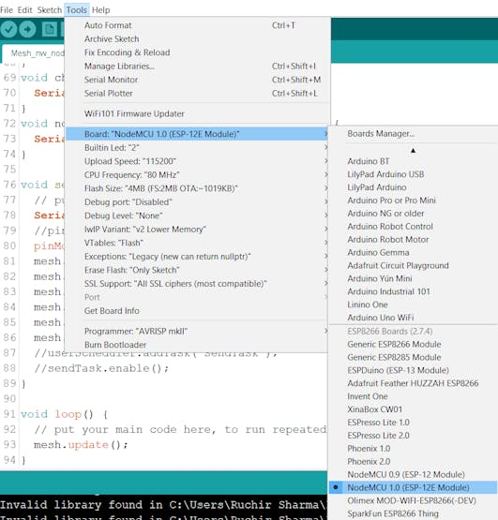

To upload the code to NodeMCU's select the port

* Go to**Tools** > **Port** > select the port

**Result**

Note:- Putty is used to see the serial output as in Arduino IDE we can only open one port at a time.

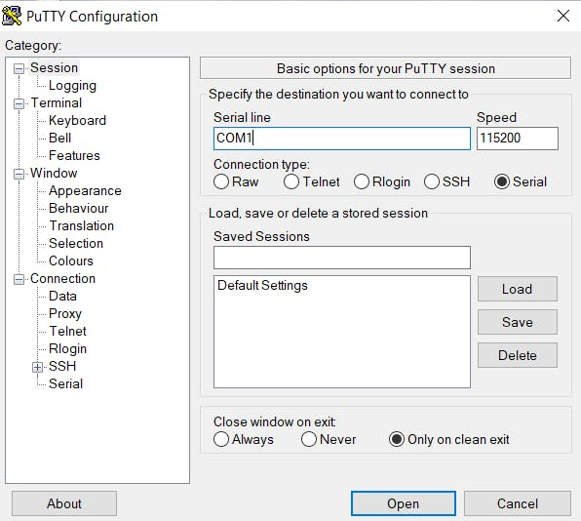

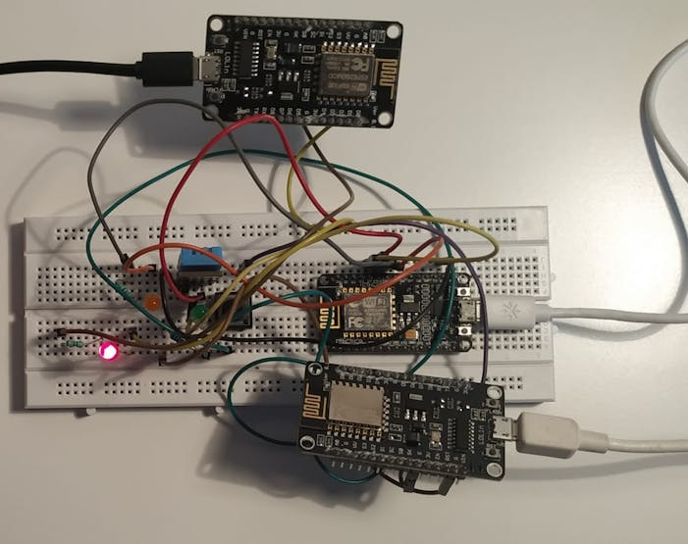

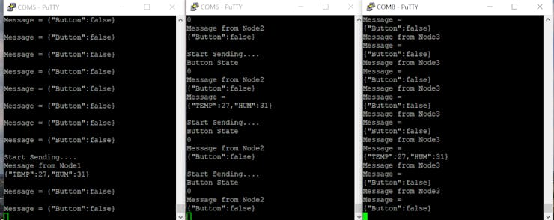

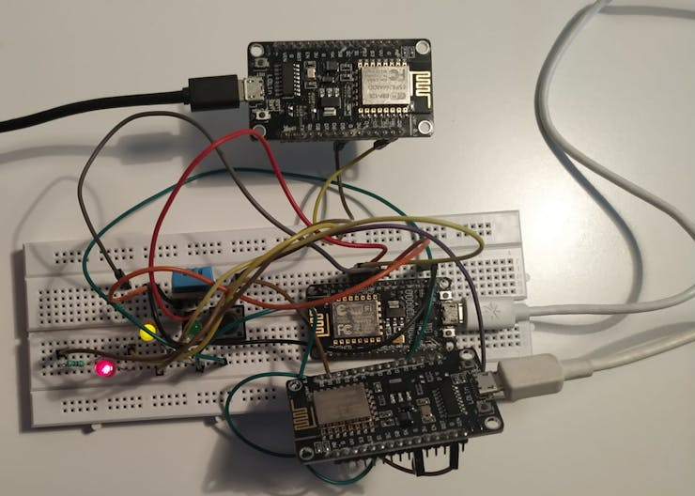

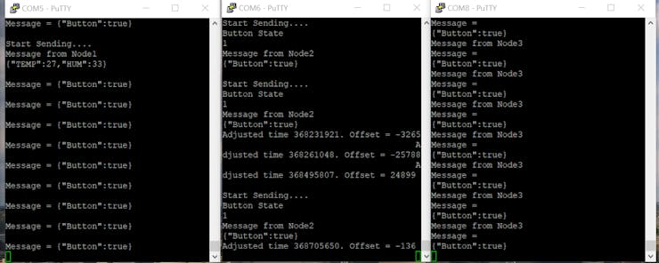

**Schematics**

**Mesh_nodes**

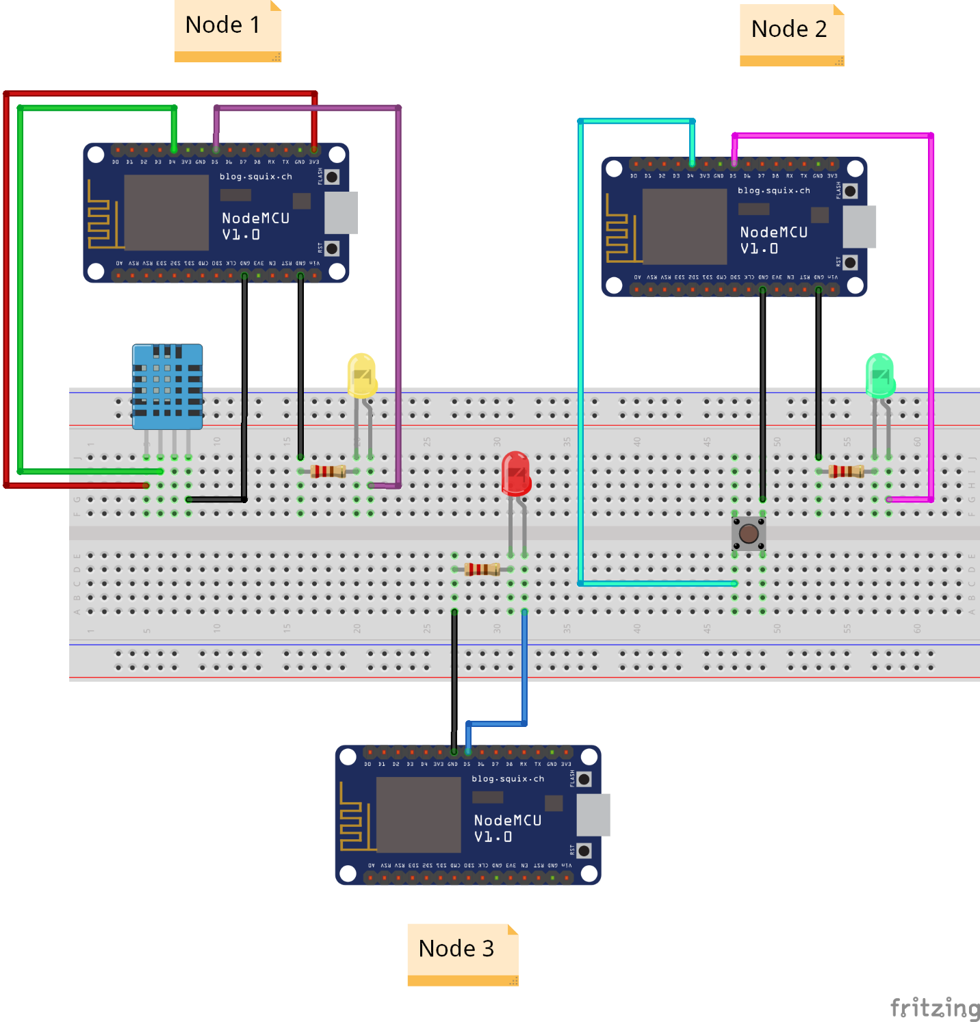

**Code**

* [**TempandLED_node1**](javascript:void(0))
* [PushbuttonandLED_node2](javascript:void(0))
* [LED_node3](javascript:void(0))

**TempandLED_node1**

Arduino

// Node 1

#include "painlessMesh.h"

#include <DHT.h>

// WiFi Credentials

#define MESH_PREFIX "AccordingToYou"

#define MESH_PASSWORD "somethingSecret"

#define MESH_PORT 5555

//Pin Declaration

#define LED D5 //Relay1

#define DHTPIN D4

#define DHTTYPE DHT11 // DHT 11

int LState;

DHT dht(DHTPIN, DHTTYPE);

Scheduler userScheduler;

painlessMesh mesh;

void sendMessage() ;

Task taskSendMessage( TASK_SECOND * 1 , TASK_FOREVER, &sendMessage );

void sendMessage()

{

Serial.println();

Serial.println("Start Sending....");

// Serializing in JSON Format

DynamicJsonDocument doc(1024);

float h = dht.readHumidity();

float t = dht.readTemperature();

doc["TEMP"] = t;

doc["HUM"] = h;

String msg ;

serializeJson(doc, msg);

mesh.sendBroadcast( msg );

Serial.println("Message from Node1");

Serial.println(msg);

taskSendMessage.setInterval((TASK_SECOND * 1, TASK_SECOND * 10));

}

// Needed for painless library

void receivedCallback( uint32_t from, String &msg ) {

Serial.println();

Serial.print("Message = ");Serial.println(msg);

String json;

DynamicJsonDocument doc(1024);

json = msg.c_str();

DeserializationError error = deserializeJson(doc, json);

if (error)

{

Serial.print("deserializeJson() failed: ");

Serial.println(error.c_str());

}

LState = doc["Button"];

digitalWrite(LED, LState);

}

void newConnectionCallback(uint32_t nodeId) {

Serial.printf("--> startHere: New Connection, nodeId = %u\n", nodeId);

}

void changedConnectionCallback() {

Serial.printf("Changed connections\n");

}

void nodeTimeAdjustedCallback(int32_t offset) {

Serial.printf("Adjusted time %u. Offset = %d\n", mesh.getNodeTime(), offset);

}

void setup() {

Serial.begin(115200);

pinMode(DHTPIN,INPUT);

pinMode(LED, OUTPUT);

mesh.setDebugMsgTypes( ERROR | STARTUP );

mesh.init( MESH_PREFIX, MESH_PASSWORD, &userScheduler, MESH_PORT );

mesh.onReceive(&receivedCallback);

mesh.onNewConnection(&newConnectionCallback);

mesh.onChangedConnections(&changedConnectionCallback);

mesh.onNodeTimeAdjusted(&nodeTimeAdjustedCallback);

userScheduler.addTask( taskSendMessage );

taskSendMessage.enable();

}

void loop() {

mesh.update();

}

**PushbuttonandLED_node2**

Arduino

// Node 2

#include "painlessMesh.h"

// WiFi Credentials

#define MESH_PREFIX "AccordingToYou"

#define MESH_PASSWORD "somethingSecret"

#define MESH_PORT 5555 // default number and should be an integer

#define button D4

#define LED D5

bool Bstate = 0;

// Scheduler is used to synchronize the connection bw other nodes

Scheduler userScheduler;

painlessMesh mesh;

void sendMessage() ; // callback func

Task sendTask( TASK_SECOND * 1 , TASK_FOREVER, &sendMessage );

// everthying should be done in callback func

void sendMessage()

{

digitalWrite(LED,HIGH); // when start sending

Serial.println();

Serial.println("Start Sending....");

if(digitalRead(button) == LOW)

Bstate = !Bstate;

Serial.println("Button State");Serial.println(Bstate);

// Serialize the message

DynamicJsonDocument doc(1024);

doc["Button"] = Bstate;

String msg ;

serializeJson(doc, msg); //

mesh.sendBroadcast( msg );

Serial.println("Message from Node2");

Serial.println(msg);

digitalWrite(LED,LOW);

}

// Deserialize the message

void receivedCallback( uint32_t from, String &msg ) {

Serial.println("Message ="); Serial.println(msg);

String json = msg.c_str();;

DynamicJsonDocument doc(1024);

DeserializationError error = deserializeJson(doc, json);

if (error)

{

Serial.print("deserializeJson() failed: ");

Serial.println(error.c_str());

}

}

void newConnectionCallback(uint32_t nodeId) {

Serial.printf("--> startHere: New Connection, nodeId = %u\n", nodeId);

}

void changedConnectionCallback() {

Serial.printf("Changed connections\n");

}

void nodeTimeAdjustedCallback(int32_t offset) {

Serial.printf("Adjusted time %u. Offset = %d\n", mesh.getNodeTime(), offset);

}

void setup() {

Serial.begin(115200);

pinMode(button, INPUT);

pinMode(LED, OUTPUT);

mesh.setDebugMsgTypes( ERROR | STARTUP );

mesh.init( MESH_PREFIX, MESH_PASSWORD, &userScheduler, MESH_PORT );

mesh.onReceive(&receivedCallback);

mesh.onNewConnection(&newConnectionCallback);

mesh.onChangedConnections(&changedConnectionCallback);

mesh.onNodeTimeAdjusted(&nodeTimeAdjustedCallback);

userScheduler.addTask( sendTask );

sendTask.enable();

}

void loop() {

mesh.update();

}

**Credits**

**LED_node3**

Arduino

// Node 3

#include "painlessMesh.h"

// WiFi Credentials

#define MESH_PREFIX "AccordingToYou"

#define MESH_PASSWORD "somethingSecret"

#define MESH_PORT 5555 // default number and should be an integer

#define LED D5

// As we want to read both the messages

int Bstate;

float h, t;

// Scheduler is used to synchronize the connection bw other nodes

Scheduler userScheduler;

painlessMesh mesh;

// Deserialize the message

void receivedCallback( uint32_t from, String &msg ) {

Serial.println("Message from Node3");

Serial.println("Message ="); Serial.println(msg);

String json = msg.c_str();;

DynamicJsonDocument doc(1024);

DeserializationError error = deserializeJson(doc, json);

if (error)

{

Serial.print("deserializeJson() failed: ");

Serial.println(error.c_str());

}

Bstate = doc["Button"];

t = doc["TEMP"];

h = doc["HUM"];

if (t > 27 || h > 50)

digitalWrite(LED,HIGH);

else(digitalWrite(LED,LOW));

}

void newConnectionCallback(uint32_t nodeId) {

Serial.printf("--> startHere: New Connection, nodeId = %u\n", nodeId);

}

void changedConnectionCallback() {

Serial.printf("Changed connections\n");

}

void nodeTimeAdjustedCallback(int32_t offset) {

Serial.printf("Adjusted time %u. Offset = %d\n", mesh.getNodeTime(), offset);

}

void setup() {

Serial.begin(115200);

pinMode(LED, OUTPUT);

mesh.setDebugMsgTypes( ERROR | STARTUP );

mesh.init( MESH_PREFIX, MESH_PASSWORD, &userScheduler, MESH_PORT );

mesh.onReceive(&receivedCallback);

mesh.onNewConnection(&newConnectionCallback);

mesh.onChangedConnections(&changedConnectionCallback);

mesh.onNodeTimeAdjusted(&nodeTimeAdjustedCallback);

}

void loop() {

mesh.update();

}

**ESP32 Wireless Mesh ( Made Easy with PainlessMesh ) - Part 1**

Lets build a complete wireless mesh network, fully functional, with all the features you need. A starting point for your next project

[Intermediate](https://www.hackster.io/projects?difficulty=intermediate)Protip1 hour31,851

**Story**

**Long story short**

There's nothing more simple than the concept of a wireless mesh network... but there's nothing more complex than building such a mesh. A steep learning curve is involved ( and, worst af all, the examples you may find never cover the whole story ) !

Here the steps to build your mesh ( we will cover each separately ):

1) build the mesh between nodes - easy

2) [add ota ( wireless ) update of the nodes](https://www.hackster.io/davidefa/esp32-wireless-mesh-made-easy-with-painlessmesh-part-2-1cfc1d) - intermediate

3) [add a bridge ( to the internet )](https://www.hackster.io/davidefa/esp32-wireless-mesh-made-easy-with-painlessmesh-part-3-982af1) - intermediate

4) an app ( to access the mesh from anywhere ) - intermediate

Let's start from the first step.

**Parts required**

* ESP32 development boards ( two or more ), I used a [ttgo t-display](https://www.banggood.com/LILYGO-TTGO-T-Display-ESP32-CP2104-WiFi-bluetooth-Module-1_14-Inch-LCD-Development-Board-p-1522925.html?rmmds=search&cur_warehouse=CN)
* [PlatformIO development software ( install from here)](https://platformio.org/platformio-ide)
* [PainlessMesh library](https://gitlab.com/painlessMesh/painlessMesh)

**Programming**

After programming the boards with the node software you should have something like this

NOTE: You should program one board with the WHITE define enabled ( line 22 ) and the other board with the RED define enabled ( line 23 )

The code simply:

* creates a wireless mesh ( see defines in line 15-17 )
* writes the software version, the id of the node and the number of nodes in the mesh on the first 3 lines ( yes I know is the number of the 'other nodes' in the mesh, but I was too lazy to add 1 to the value returned by nodes.size() )
* writes the message received on the fourth line
* broadcasts a message ( to all the other nodes ) every time the lower button is pressed

Now you can add other nodes and they will be automatically discovered and added to the mesh ( after a small delay )

**Mesh testing**

Now you know that the nodes ( a few inches apart ) on your desk are able to communicate.

So lets space a node until it is out of the mesh range ( until the mesh node count decreases ) now add a new node 'in between', a green node, ( let's call it 'the-node-in-the-middle' attack )... and after a small delay... the node is automagically reconnected.

Good job, your mesh is indeed self configuring, self healing, self recovering...

NOTE It is never a good idea to keep the nodes too close to each other ( as shown on the video ;-)

**What Next?**

This is the first ( and easy ) step of our job.

In the next step we'll continue adding ota support.

**MeshLamp ( fast and easy project )**

If you are not happy with the basic node software proposed let's see how easily we can control a lamp with a switch using our wireless mesh.

**Parts Required**

Same as above

**Programming**

After programming the boards with the MeshLamp software you should have something like this

NOTE: You should program both boards with the same software ( and yes both boards are switch and lamp at the same time )

The code simply:

* creates a wireless mesh ( see defines in line 15-17 )
* the lower button toggle the associated lamp ( or all lamps if no association performed )
* the higher button perform the association: short press on the lamp, long press on the switch and the association is completed

**Last Note on the board**

I do not recommend any hardware or software

The ttgo t-display I used is a small and inexpensive ESP32 board, with a small color display ( 240x135 ), onboard antenna ( sorry no external antenna connector ), tp4054 battery charger, cp2014 usb converter, no sd slot, small form factor. It becomes quite warm during usage. Can't say nothing about its reliability. [Here you can find a small documentation](https://github.com/Xinyuan-LilyGO/TTGO-T-Display).

**Code**

* [**Node.cpp**](javascript:void(0))
* [MeshLamp](javascript:void(0))
* [platformio.ini](javascript:void(0))

**Node.cpp**

C/C++

Mesh Node software copy to your main.cpp

//************************************************************

// this is a simple example that uses the painlessMesh library

//

// 1. sends a silly message to every node on the mesh at a random time between 1 and 5 seconds

// 2. prints anything it receives to Serial.print

//

//

//************************************************************

//#include <Arduino.h>

#include "painlessMesh.h"

#include "Button2.h"

#include <TFT_eSPI.h>

#define MESH_PREFIX "whateverYouLike"

#define MESH_PASSWORD "somethingSneaky"

#define MESH_PORT 5555

Scheduler userScheduler; // to control your personal task

painlessMesh mesh;

// uncomment only one of the following

#define WHITE

//#define RED

//#define GREEN

#ifdef WHITE

#define ROLE "white"

#define VERSION "WHITE v1.0.0"

#define MESSAGE "White "

#endif

#ifdef RED

#define ROLE "red"

#define VERSION "RED - 1.0.0"

#define MESSAGE "Red "

#endif

#ifdef GREEN

#define ROLE "green"

#define VERSION "GREEN - 1.0.0"

#define MESSAGE "Green "

#endif

// TFT start

#ifndef TFT_DISPOFF

#define TFT_DISPOFF 0x28

#endif

#ifndef TFT_SLPIN

#define TFT_SLPIN 0x10

#endif

#define TFT_MOSI 19

#define TFT_SCLK 18

#define TFT_CS 5

#define TFT_DC 16

#define TFT_RST 23

#define TFT_BL 4 // Display backlight control pin

#define ADC_EN 14 //ADC_EN is the ADC detection enable port

#define ADC_PIN 34

#define BUTTON_1 35

#define BUTTON_2 0

TFT_eSPI tft = TFT_eSPI(135, 240); // Invoke custom library

// TFT end

Button2 btn1(BUTTON_1);

Button2 btn2(BUTTON_2);

bool calc_delay = false;

SimpleList<uint32_t> nodes;

uint32_t nsent=0;

char buff[512];

// User stub

void sendMessage(String msg) ; // Prototype so PlatformIO doesn't complain

//Task taskSendMessage( TASK_SECOND * 1 , TASK_FOREVER, &sendMessage );

// Needed for painless library

void receivedCallback( uint32_t from, String &msg )

{

Serial.printf("Rx from %u <- %s\n", from, msg.c_str());

if (strcmp(msg.c_str(),"GETRT") == 0)

{

mesh.sendBroadcast( mesh.subConnectionJson(true).c_str() );

}

else

{

sprintf(buff,"Rx:%s",msg.c_str());

tft.drawString(buff, 0, 48);

}

}

void newConnectionCallback(uint32_t nodeId)

{

Serial.printf("--> Start: New Connection, nodeId = %u\n", nodeId);

Serial.printf("--> Start: New Connection, %s\n", mesh.subConnectionJson(true).c_str());

}

void changedConnectionCallback()

{

Serial.printf("Changed connections\n");

nodes = mesh.getNodeList();

Serial.printf("Num nodes: %d\n", nodes.size());

Serial.printf("Connection list:");

SimpleList<uint32_t>::iterator node = nodes.begin();

while (node != nodes.end())

{

Serial.printf(" %u", *node);

node++;

}

Serial.println();

calc_delay = true;

sprintf(buff,"Nodes:%d",nodes.size());

tft.drawString(buff, 0, 32);

}

void nodeTimeAdjustedCallback(int32_t offset)

{

Serial.printf("Adjusted time %u Offset = %d\n", mesh.getNodeTime(),offset);

}

void onNodeDelayReceived(uint32_t nodeId, int32_t delay)

{

Serial.printf("Delay from node:%u delay = %d\n", nodeId,delay);

}

void sendMessage(String msg) {

if (strcmp(msg.c_str(), "") == 0)

{

nsent++;

msg = MESSAGE;

//msg += mesh.getNodeId();

msg += nsent;

}

mesh.sendBroadcast( msg );

Serial.printf("Tx-> %s\n", msg.c_str());

sprintf(buff,"Tx:%s",msg.c_str());

tft.drawString(buff, 0, 64);

if (calc_delay)

{

SimpleList<uint32_t>::iterator node = nodes.begin();

while (node != nodes.end())

{

mesh.startDelayMeas(*node);

node++;

}

calc_delay = false;

}

//taskSendMessage.setInterval( random( TASK_SECOND * 2, TASK_SECOND * 10 ));

}

void button_setup()

{

// button dx

btn1.setPressedHandler([](Button2 & b)

{

sendMessage("GETRT"); // get routing table

});

// button sx

btn2.setPressedHandler([](Button2 & b)

{

sendMessage("");

});

}

void setup()

{

Serial.begin(115200);

// TFT

tft.init();

tft.setRotation(1);

tft.fillScreen(TFT_BLACK);

//tft.setTextSize(4);

tft.setTextColor(TFT_GREEN,TFT_BLACK);

tft.setCursor(0, 0);

tft.setTextDatum(MC_DATUM);

tft.setTextSize(2);

if (TFT_BL > 0)

{ // TFT_BL has been set in the TFT_eSPI library in the User Setup file TTGO_T_Display.h

pinMode(TFT_BL, OUTPUT); // Set backlight pin to output mode

digitalWrite(TFT_BL, TFT_BACKLIGHT_ON); // Turn backlight on. TFT_BACKLIGHT_ON has been set in the TFT_eSPI library in the User Setup file TTGO_T_Display.h

}

tft.fillScreen(TFT_BLACK);

tft.setTextDatum(TL_DATUM);

tft.drawString(VERSION, 0, 0);

//tft.setTextDatum(MC_DATUM);

//tft.drawString("LeftButton:", tft.width() / 2, tft.height() / 2 - 16);

//mesh.setDebugMsgTypes( ERROR | MESH_STATUS | CONNECTION | SYNC | COMMUNICATION | MSG_TYPES | REMOTE ); // all types on except GENERAL

//mesh.setDebugMsgTypes( ERROR | MESH_STATUS | CONNECTION | SYNC | COMMUNICATION | GENERAL | MSG_TYPES | REMOTE ); // all types on

mesh.setDebugMsgTypes( ERROR | STARTUP ); // set before init() so that you can see startup messages

mesh.init( MESH_PREFIX, MESH_PASSWORD, &userScheduler, MESH_PORT );

mesh.onReceive(&receivedCallback);

mesh.onNewConnection(&newConnectionCallback);

mesh.onChangedConnections(&changedConnectionCallback);

mesh.onNodeTimeAdjusted(&nodeTimeAdjustedCallback);

// if you want your node to accept OTA firmware, simply include this line

// with whatever role you want your hardware to be. For instance, a

// mesh network may have a thermometer, rain detector, and bridge. Each of

// those may require different firmware, so different roles are preferrable.

//

// MAKE SURE YOUR UPLOADED OTA FIRMWARE INCLUDES OTA SUPPORT OR YOU WILL LOSE

// THE ABILITY TO UPLOAD MORE FIRMWARE OVER OTA. YOU ALSO WANT TO MAKE SURE

// THE ROLES ARE CORRECT

mesh.initOTAReceive(ROLE);

//userScheduler.addTask( taskSendMessage );

//taskSendMessage.enable();

sprintf(buff,"Id:%d",mesh.getNodeId());

tft.drawString(buff, 0, 16);

button_setup();

}

void loop()

{

// it will run the user scheduler as well

mesh.update();

btn1.loop();

btn2.loop();

}

**MeshLamp**

C/C++

Used for switch and lamp ( copy tomain.cpp )

//************************************************************

// this is a simple example that uses the painlessMesh library

//

// 1. uses btn2 to turn on/off a lamp

// 2. uses btn1 to 'join' a lamp

// 3. simulates a lamp

//

//************************************************************

//#include <Arduino.h>

#include "painlessMesh.h"

#include "Button2.h"

#include <TFT_eSPI.h>

#define MESH_PREFIX "whateverYouLike"

#define MESH_PASSWORD "somethingSneaky"

#define MESH_PORT 5555

Scheduler userScheduler; // to control your personal task

painlessMesh mesh;

#define ROLE "switchlamp"

#define VERSION "SWITCHLAMP v1.0.0"

#define MESSAGE "switchlamp "

// TFT start

#ifndef TFT_DISPOFF

#define TFT_DISPOFF 0x28

#endif

#ifndef TFT_SLPIN

#define TFT_SLPIN 0x10

#endif

#define TFT_MOSI 19

#define TFT_SCLK 18

#define TFT_CS 5

#define TFT_DC 16

#define TFT_RST 23

#define TFT_BL 4 // Display backlight control pin

#define ADC_EN 14 //ADC_EN is the ADC detection enable port

#define ADC_PIN 34

#define BUTTON_1 35

#define BUTTON_2 0

TFT_eSPI tft = TFT_eSPI(135, 240); // Invoke custom library

// TFT end

Button2 btn1(BUTTON_1);

Button2 btn2(BUTTON_2);

bool calc_delay = false;

SimpleList<uint32_t> nodes;

uint32_t nsent=0;

char buff[512];

uint8_t iLampState1=0;

uint32_t iLastAddr=0;

uint32_t iAddr1=0;

// User stub

//void sendMessage(String msg) ; // Prototype so PlatformIO doesn't complain

//Task taskSendMessage( TASK_SECOND * 1 , TASK_FOREVER, &sendMessage );

// Needed for painless library

void receivedCallback( uint32_t from, String &msg )

{

Serial.printf("Rx from %u <- %s\n", from, msg.c_str());

sprintf(buff,"Rx:%s ",msg.c_str());

tft.drawString(buff, 0, 48);

if (strcmp(msg.c_str(),"GETRT") == 0)

{

mesh.sendBroadcast( mesh.subConnectionJson(true).c_str() );

}

else if (strcmp(msg.c_str(),"toggle1") == 0)

{

iLampState1=!iLampState1;

tft.fillRect(0,80,240,135-80,iLampState1?TFT_WHITE:TFT_BLACK);

}

else if (strcmp(msg.c_str(),"on1") == 0)

{

iLampState1=1;

tft.fillRect(0,80,240,135-80,iLampState1?TFT_WHITE:TFT_BLACK);

}

else if (strcmp(msg.c_str(),"off1") == 0)

{

iLampState1=0;

tft.fillRect(0,80,240,135-80,iLampState1?TFT_WHITE:TFT_BLACK);

}

else if (strcmp(msg.c_str(),"join") == 0)

{

iLastAddr=from;

}

}

void newConnectionCallback(uint32_t nodeId)

{

Serial.printf("--> Start: New Connection, nodeId = %u\n", nodeId);

Serial.printf("--> Start: New Connection, %s\n", mesh.subConnectionJson(true).c_str());

}

void changedConnectionCallback()

{

Serial.printf("Changed connections\n");

nodes = mesh.getNodeList();

Serial.printf("Num nodes: %d\n", nodes.size());

Serial.printf("Connection list:");

SimpleList<uint32_t>::iterator node = nodes.begin();

while (node != nodes.end())

{

Serial.printf(" %u", *node);

node++;

}

Serial.println();

calc_delay = true;

sprintf(buff,"Nodes:%d",nodes.size());

tft.drawString(buff, 0, 32);

}

void nodeTimeAdjustedCallback(int32_t offset)

{

Serial.printf("Adjusted time %u Offset = %d\n", mesh.getNodeTime(),offset);

}

void onNodeDelayReceived(uint32_t nodeId, int32_t delay)

{

Serial.printf("Delay from node:%u delay = %d\n", nodeId,delay);

}

void sendMessage(String msg, uint32_t addr) {

if (strcmp(msg.c_str(), "") == 0)

{

nsent++;

msg = MESSAGE;

msg += nsent;

}

if (addr)

mesh.sendSingle( addr, msg );

else

mesh.sendBroadcast( msg );

Serial.printf("Tx-> %s\n", msg.c_str());

sprintf(buff,"Tx:%s ",msg.c_str());

tft.drawString(buff, 0, 64);

if (calc_delay)

{

SimpleList<uint32_t>::iterator node = nodes.begin();

while (node != nodes.end())

{

mesh.startDelayMeas(*node);

node++;

}

calc_delay = false;

}

//taskSendMessage.setInterval( random( TASK_SECOND * 2, TASK_SECOND * 10 ));

}

void button_setup()

{

// button dx

btn1.setPressedHandler([](Button2 & b)

{

if (iLastAddr)

{iAddr1=iLastAddr;}

});

btn1.setLongClickHandler([](Button2 & b)

{

sendMessage("join",0);

});

// button sx

btn2.setPressedHandler([](Button2 & b)

{

sendMessage("toggle1",iAddr1);

});

}

void setup()

{

Serial.begin(115200);

// TFT

tft.init();

tft.setRotation(1);

tft.fillScreen(TFT_BLACK);

//tft.setTextSize(4);

tft.setTextColor(TFT_GREEN,TFT_BLACK);

tft.setCursor(0, 0);

tft.setTextDatum(MC_DATUM);

tft.setTextSize(2);

if (TFT_BL > 0)

{ // TFT_BL has been set in the TFT_eSPI library in the User Setup file TTGO_T_Display.h

pinMode(TFT_BL, OUTPUT); // Set backlight pin to output mode

digitalWrite(TFT_BL, TFT_BACKLIGHT_ON); // Turn backlight on. TFT_BACKLIGHT_ON has been set in the TFT_eSPI library in the User Setup file TTGO_T_Display.h

}

tft.fillScreen(TFT_BLACK);

tft.setTextDatum(TL_DATUM);

tft.drawString(VERSION, 0, 0);

//mesh.setDebugMsgTypes( ERROR | MESH_STATUS | CONNECTION | SYNC | COMMUNICATION | MSG_TYPES | REMOTE ); // all types on except GENERAL

//mesh.setDebugMsgTypes( ERROR | MESH_STATUS | CONNECTION | SYNC | COMMUNICATION | GENERAL | MSG_TYPES | REMOTE ); // all types on

mesh.setDebugMsgTypes( ERROR | STARTUP ); // set before init() so that you can see startup messages

mesh.init( MESH_PREFIX, MESH_PASSWORD, &userScheduler, MESH_PORT );

mesh.onReceive(&receivedCallback);

mesh.onNewConnection(&newConnectionCallback);

mesh.onChangedConnections(&changedConnectionCallback);

mesh.onNodeTimeAdjusted(&nodeTimeAdjustedCallback);

// if you want your node to accept OTA firmware, simply include this line

// with whatever role you want your hardware to be. For instance, a

// mesh network may have a thermometer, rain detector, and bridge. Each of

// those may require different firmware, so different roles are preferrable.

//

// MAKE SURE YOUR UPLOADED OTA FIRMWARE INCLUDES OTA SUPPORT OR YOU WILL LOSE

// THE ABILITY TO UPLOAD MORE FIRMWARE OVER OTA. YOU ALSO WANT TO MAKE SURE

// THE ROLES ARE CORRECT

mesh.initOTAReceive(ROLE);

//userScheduler.addTask( taskSendMessage );

//taskSendMessage.enable();

sprintf(buff,"Id:%d",mesh.getNodeId());

tft.drawString(buff, 0, 16);

button_setup();

}

void loop()

{

// it will run the user scheduler as well

mesh.update();

btn1.loop();

btn2.loop();

}

**platformio.ini**

C/C++

copy to your platformio.ini file

[env:ttgo-t1]

platform = espressif32

board = ttgo-t1

framework = arduino

lib_deps =

TFT_eSPI

SPI

FS

SPIFFS

BUTTON2

PAINLESSMESH

monitor_speed = 115200

monitor_filters = time

Menu

* [**Home**](https://cifertech.net/)
* [**Blog**](https://cifertech.net/contents/)
* [**About me**](https://cifertech.net/about-me/)
* [**Contact**](https://cifertech.net/contact/)

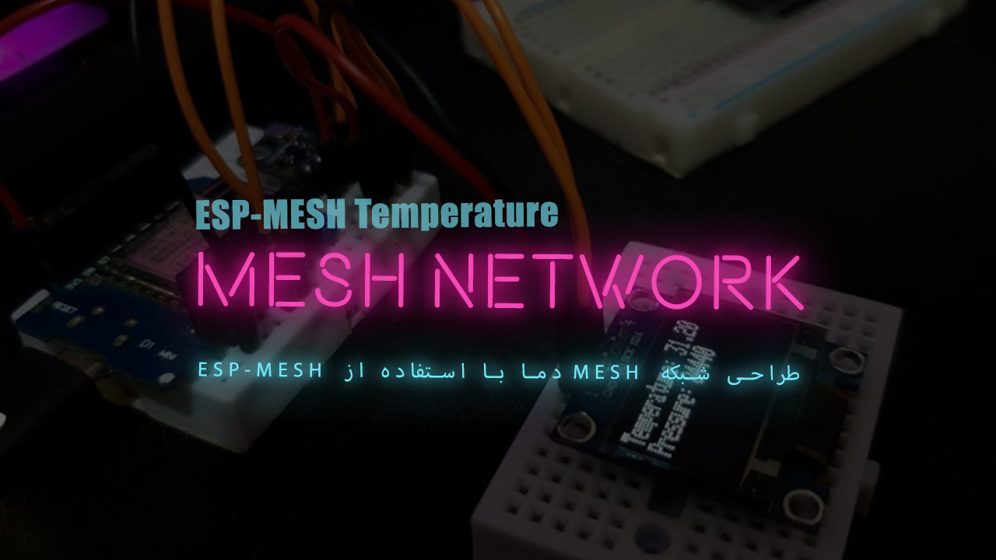

Temperature MESH Network Design Using ESP-MESH

Published On

* June 17, 2021

Category

* [ESP32](https://cifertech.net/category/iot/esp32/), [ESP8266](https://cifertech.net/category/iot/esp8266/), [IoT](https://cifertech.net/category/iot/)

In various projects, we tested the data transfer between ESP boards, but in this tutorial, we intend to test the design of the MESH mesh network along with the data exchange of the opposite sensors. In fact, using this type of connection, all ESP boards in the network They will exchange data with each other and if there is data, values ​​will be received in all nodes. Also in this project, we have placed an OLED display in one of the nodes that uses the BMP180 temperature and pressure sensor to measure the ambient values ​​to make it easier to display the values ​​instantly in the source node. Visit [CiferTech](https://cifertech.net/) for more tutorials, and be sure to follow my [Instagram](https://www.instagram.com/cifertech/) page to support me. ^-^

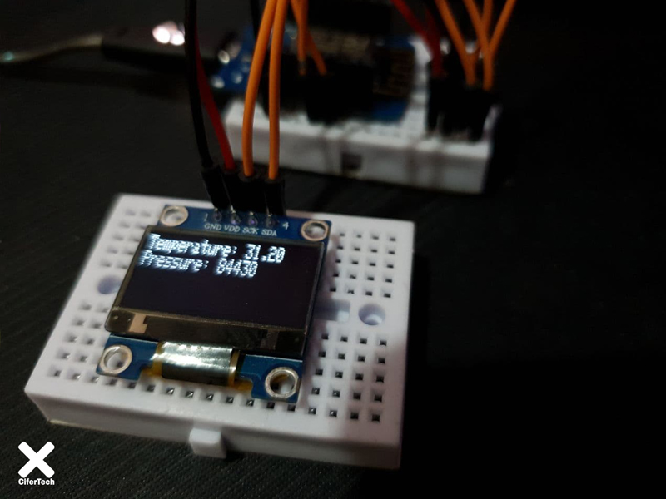

**ESP-MESH network**

ESP-MESH differs from traditional Wi-Fi network infrastructure in that it does not require a central node to connect the nodes. Instead, nodes are allowed to connect to neighboring nodes. The nodes are reciprocally responsible for resetting each other. This allows an ESP-MESH network to have more coverage area because the nodes can still be connected without having to be in the center node. Similarly, ESP-MESH is less prone to load because the number of nodes allowed in the network is no longer limited by one central node.



ESP-MESH is built on a higher level than the Wi-Fi protocol and can be considered as a network protocol that combines many Wi-Fi networks into a single WLAN. In Wi-Fi, stations or STAs are restricted to a single connection to one AP at a time, while an AP can connect to multiple STAs simultaneously. However ESP-MESH allows nodes to act as both a station and an AP. Thus, a node in ESP-MESH can have multiple downstream connections using its softAP interface, while having a single upstream connection using its STA interface at the same time. This naturally leads to a tree network topology with a multi-layered parent-child hierarchy.

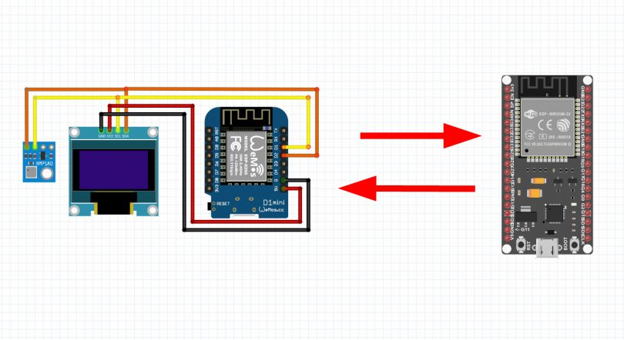

**ESP32 board**

**ESP32 is**  the advanced generation of  **ESP8266**  . One of the differences is its built-in Bluetooth. It also has a 2.4 GHz WiFi core and built-in Bluetooth with **TSMC** 40-nanometer technology   . This module has the best performance in energy consumption, that is, it brings the best results for us with the least energy consumption. If we want to take a closer look at this board, we must say that this is a chip in which the **NodeMCU** platform is   implemented, which is also called System on a chip microcontrollers.

**Wemos**

Wemos board is one of the most popular boards used in the field of iot, one of the advantages of this board compared to boards such as Node MCU is its small size. The Wi-Fi chip used in this board is ESP8266. Another advantage of this board is the existence of different shields for this board, which makes any project very easy and enjoyable for the user, shields such as battery shield, multi sensor, DHT22, relay, oled, a large number The shield has been developed for this board, which will leave you with a good iot experience.

**Project working method**

In the MESH network design project, one of the nodes reads the temperature and pressure values ​​using the BMP180 sensor, and in the meantime, shares the values ​​created in the Mesh network for the other node. Other nodes in the Mesh network will then receive and display these values, which will also be displayed in the sending node by the OLED display. In this project, we will be able to create a large number of nodes with similar applications. In fact, it is possible to create up to 1000 nodes, and we only need to enter a specific node number for each node.

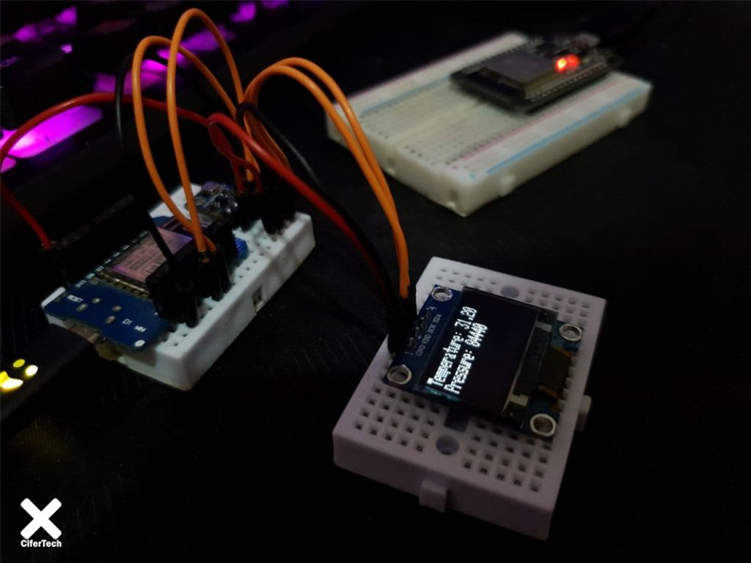

**Items needed**

* Nodemcu board based on ESP8266
* ESP32 board
* Oled display
* BMP180 sensor

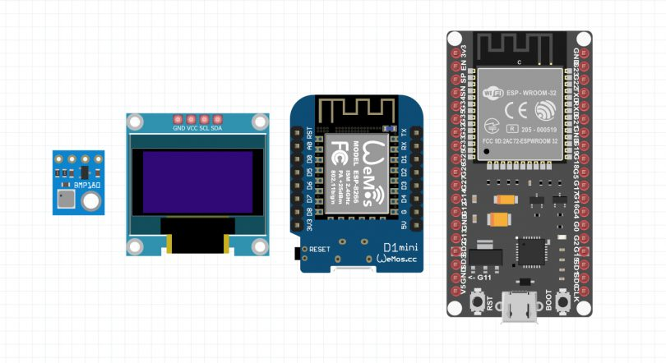

**Library installation**

To design the MESH network, we need the painlessMesh library, which is a temporary, one-of-a-kind network. This means that no central controller or node or router is required. Each system is organized from one or more nodes on its own, in a fully functional network. The maximum mesh size is limited by the amount of memory in the mass that can be allocated to the sub-buffer. Follow the steps below to install the library. This library requires a number of default items that are library dependencies. When you install the library, a new window will appear asking you to install the required items. In this window, select the “install all” option.

1. Follow this path  **Sketch** >  **Include Library**  >  **Manage Libraries**
2. Search for the word painlessMesh.
3. Install the library.

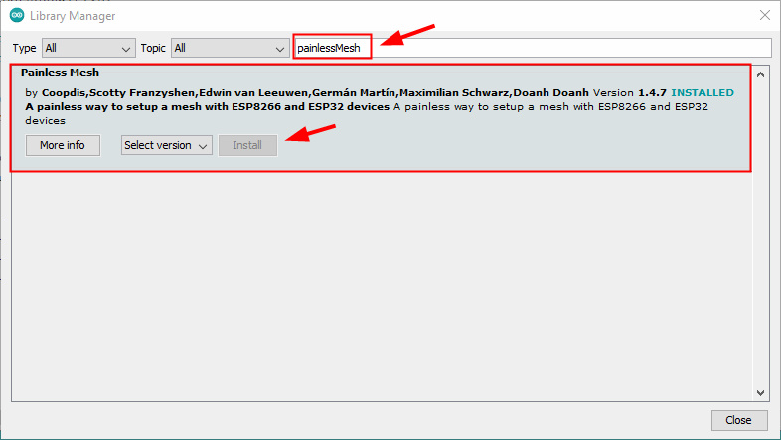

**Schematics and connections**

In this project, we used two components, namely the OLED display and the BMP180 sensor, both of which use the i2c interface, and thanks to this interface, we will be able to control each component with only two SCL pins and the ESDA board ESP8266. On the Wemos and Nodemcu boards, which are based on the ESP82666 chip, these dopins are available via pins D1 and D2.

* In the first step, we will establish the BMP180 sensor connections with the Wemos board. The SCl and SDA pins will be connected to pins D1 and D2 on the Wemos board, and we will also use 5v and GND for power.

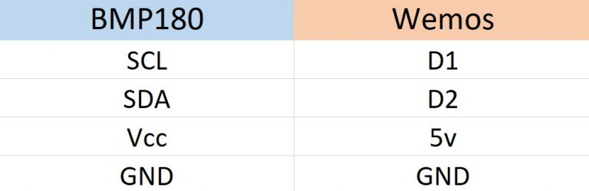

* Next, we will make the oled display connections, which, like the BMP180 sensor, will be connected to pins D1 and D2, as each device supports the i2c interface.

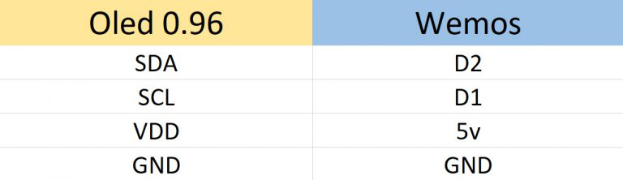

Finally the connections end like this, make sure the connections are correct.

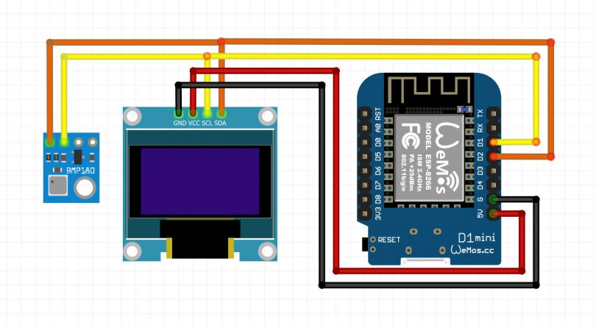

**Code and circuit startup**

In the MESH network design project, we will use two codes for different nodes, one of which will analyze the sensor values ​​and display in Oled as well as in the Mesh network, and the other will only receive these values ​​and send a message . To get the values ​​alone, you can use the code used in the previous project from the ESP-MESH series. Keep this in mind if nodes with more than one node analyze the data and type Are numbered like this project you have to customize the node number value in each code in the related codes.

* In these three lines, a name and password are provided for your mesh network so that they do not interfere with the other node, also the port used in this case is related to tcp / udp.

|  |  |
| --- | --- |
| 1  2  3 | **#define   MESH_PREFIX     "Cifer"**  **#define   MESH_PASSWORD   "DogeCoin"**  **#define   MESH_PORT       5555** |

* In this line we have to change the value of node number if there are similar nodes.

|  |  |
| --- | --- |
| 1 | **int nodeNumber = 3;** |

See the complete code of this project from this section.

|  |  |
| --- | --- |
| 1  2  3  4  5  6  7  8  9  10  11  12  13  14  15  16  17  18  19  20  21  22  23  24  25  26  27  28  29  30  31  32  33  34  35  36  37  38  39  40  41  42  43  44  45  46  47  48  49  50  51  52  53  54  55  56  57  58  59  60  61  62  63  64  65  66  67  68  69  70  71  72  73  74  75  76  77  78  79  80  81  82  83  84  85  86  87  88  89  90  91  92  93  94  95  96  97  98  99  100  101  102  103  104  105  106  107  108  109  110  111  112  113  114  115  116  117  118  119  120  121  122  123  124  125  126  127  128  129  130  131  132  133  134  135  136  137  138 | **#include <Adafruit_BMP085.h>**  **#include <Adafruit_Sensor.h>**  **#include "painlessMesh.h"**  **#include <Arduino_JSON.h>**  **#include <SPI.h>**      **#include <Wire.h>**  **#include <Adafruit_GFX.h>**  **#include <Adafruit_SSD1306.h>**      **Adafruit_SSD1306 display = Adafruit_SSD1306(128, 32, &Wire);**      **#define   MESH_PREFIX     "Cifer"**  **#define   MESH_PASSWORD   "DogeCoin"**  **#define   MESH_PORT       5555**      **Adafruit_BMP085 bmp;**    **int nodeNumber = 3;**    **String readings;**    **Scheduler userScheduler;**  **painlessMesh  mesh;**      **void sendMessage();**  **String getReadings();**      **Task taskSendMessage(TASK_SECOND * 5, TASK_FOREVER, &sendMessage);**      **String getReadings() {**  **JSONVar jsonReadings;**  **jsonReadings["node"] = nodeNumber;**  **jsonReadings["temp"] = bmp.readTemperature();**  **jsonReadings["pres"] = bmp.readPressure() / 100.0F;**  **readings = JSON.stringify(jsonReadings);**  **return readings;**  **}**      **void sendMessage() {**  **String msg = getReadings();**  **mesh.sendBroadcast(msg);**  **}**      **void initBMP() {**  **if (!bmp.begin(0x76)) {**  **Serial.println("Could not find a valid BMP280 sensor, check wiring!");**  **while (1);**  **}**  **}**    **void receivedCallback(uint32_t from, String& msg) {**  **Serial.printf("Received from %u msg=%s\n", from, msg.c_str());**  **JSONVar myObject = JSON.parse(msg.c_str());**  **int node = myObject["node"];**  **double temp = myObject["temp"];**  **double hum = myObject["hum"];**  **double pres = myObject["pres"];**  **Serial.print("Node: ");**  **Serial.println(node);**  **Serial.print("Temperature: ");**  **Serial.print(temp);**  **Serial.println(" C");**  **Serial.print("Pressure: ");**  **Serial.print(pres);**  **Serial.println(" hpa");**      **}**    **void newConnectionCallback(uint32_t nodeId) {**  **Serial.printf("New Connection, nodeId = %u\n", nodeId);**  **}**      **void changedConnectionCallback() {**  **Serial.printf("Changed connections\n");**  **}**      **void nodeTimeAdjustedCallback(int32_t offset) {**  **Serial.printf("Adjusted time %u. Offset = %d\n", mesh.getNodeTime(), offset);**  **}**    **void setup() {**  **Serial.begin(115200);**      **display.begin(SSD1306_SWITCHCAPVCC, 0x3C);**      **initBMP();**      **display.clearDisplay();**  **display.display();**    **mesh.setDebugMsgTypes(ERROR | STARTUP);**    **mesh.init(MESH_PREFIX, MESH_PASSWORD, &userScheduler, MESH_PORT);**  **mesh.onReceive(&receivedCallback);**  **mesh.onNewConnection(&newConnectionCallback);**  **mesh.onChangedConnections(&changedConnectionCallback);**  **mesh.onNodeTimeAdjusted(&nodeTimeAdjustedCallback);**      **userScheduler.addTask(taskSendMessage);**  **taskSendMessage.enable();**  **}**      **void loop() {**    **display.setTextSize(1);**  **display.setTextColor(SSD1306_WHITE);**  **display.setCursor(0, 0);**  **display.print("Temperature: ");**  **display.println(bmp.readTemperature());**  **display.print("Pressure: ");**  **display.println(bmp.readPressure());**  **display.setCursor(0, 0);**  **display.display();**  **display.clearDisplay();**      **delay(100);**    **mesh.update();**  **}** |

**Conclusion**

In the MESH network design project, we received temperature and pressure data values ​​through the BMP180 sensor, and then set up a mesh network between the ESP boards using ESP boards, which in a series of nodes, the code used in this The project was used to analyze the values ​​in this way, display them in the OLED display and then upload them to the created mesh network, or use a simple code to get only the desired values.

